Curriculum Vitae
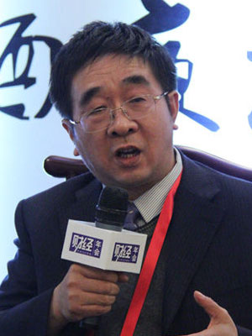
Familiy name: XIONG
Given name: JUN
xiongjun@ssf.gov.cn
+8613601289519
Fenghuyyuan 11, Xicheng district, 100032 Beijing
PHD in Economics,
Current position:
Director of Asset Allocation & Research Department,
National Council for Social Security Fund.

Mainly engaged in pension fund investment management, and research on macro economy and capital market as well.
Has done a very systematic research on pension system reform and pension fund investment and administration in recent years.

