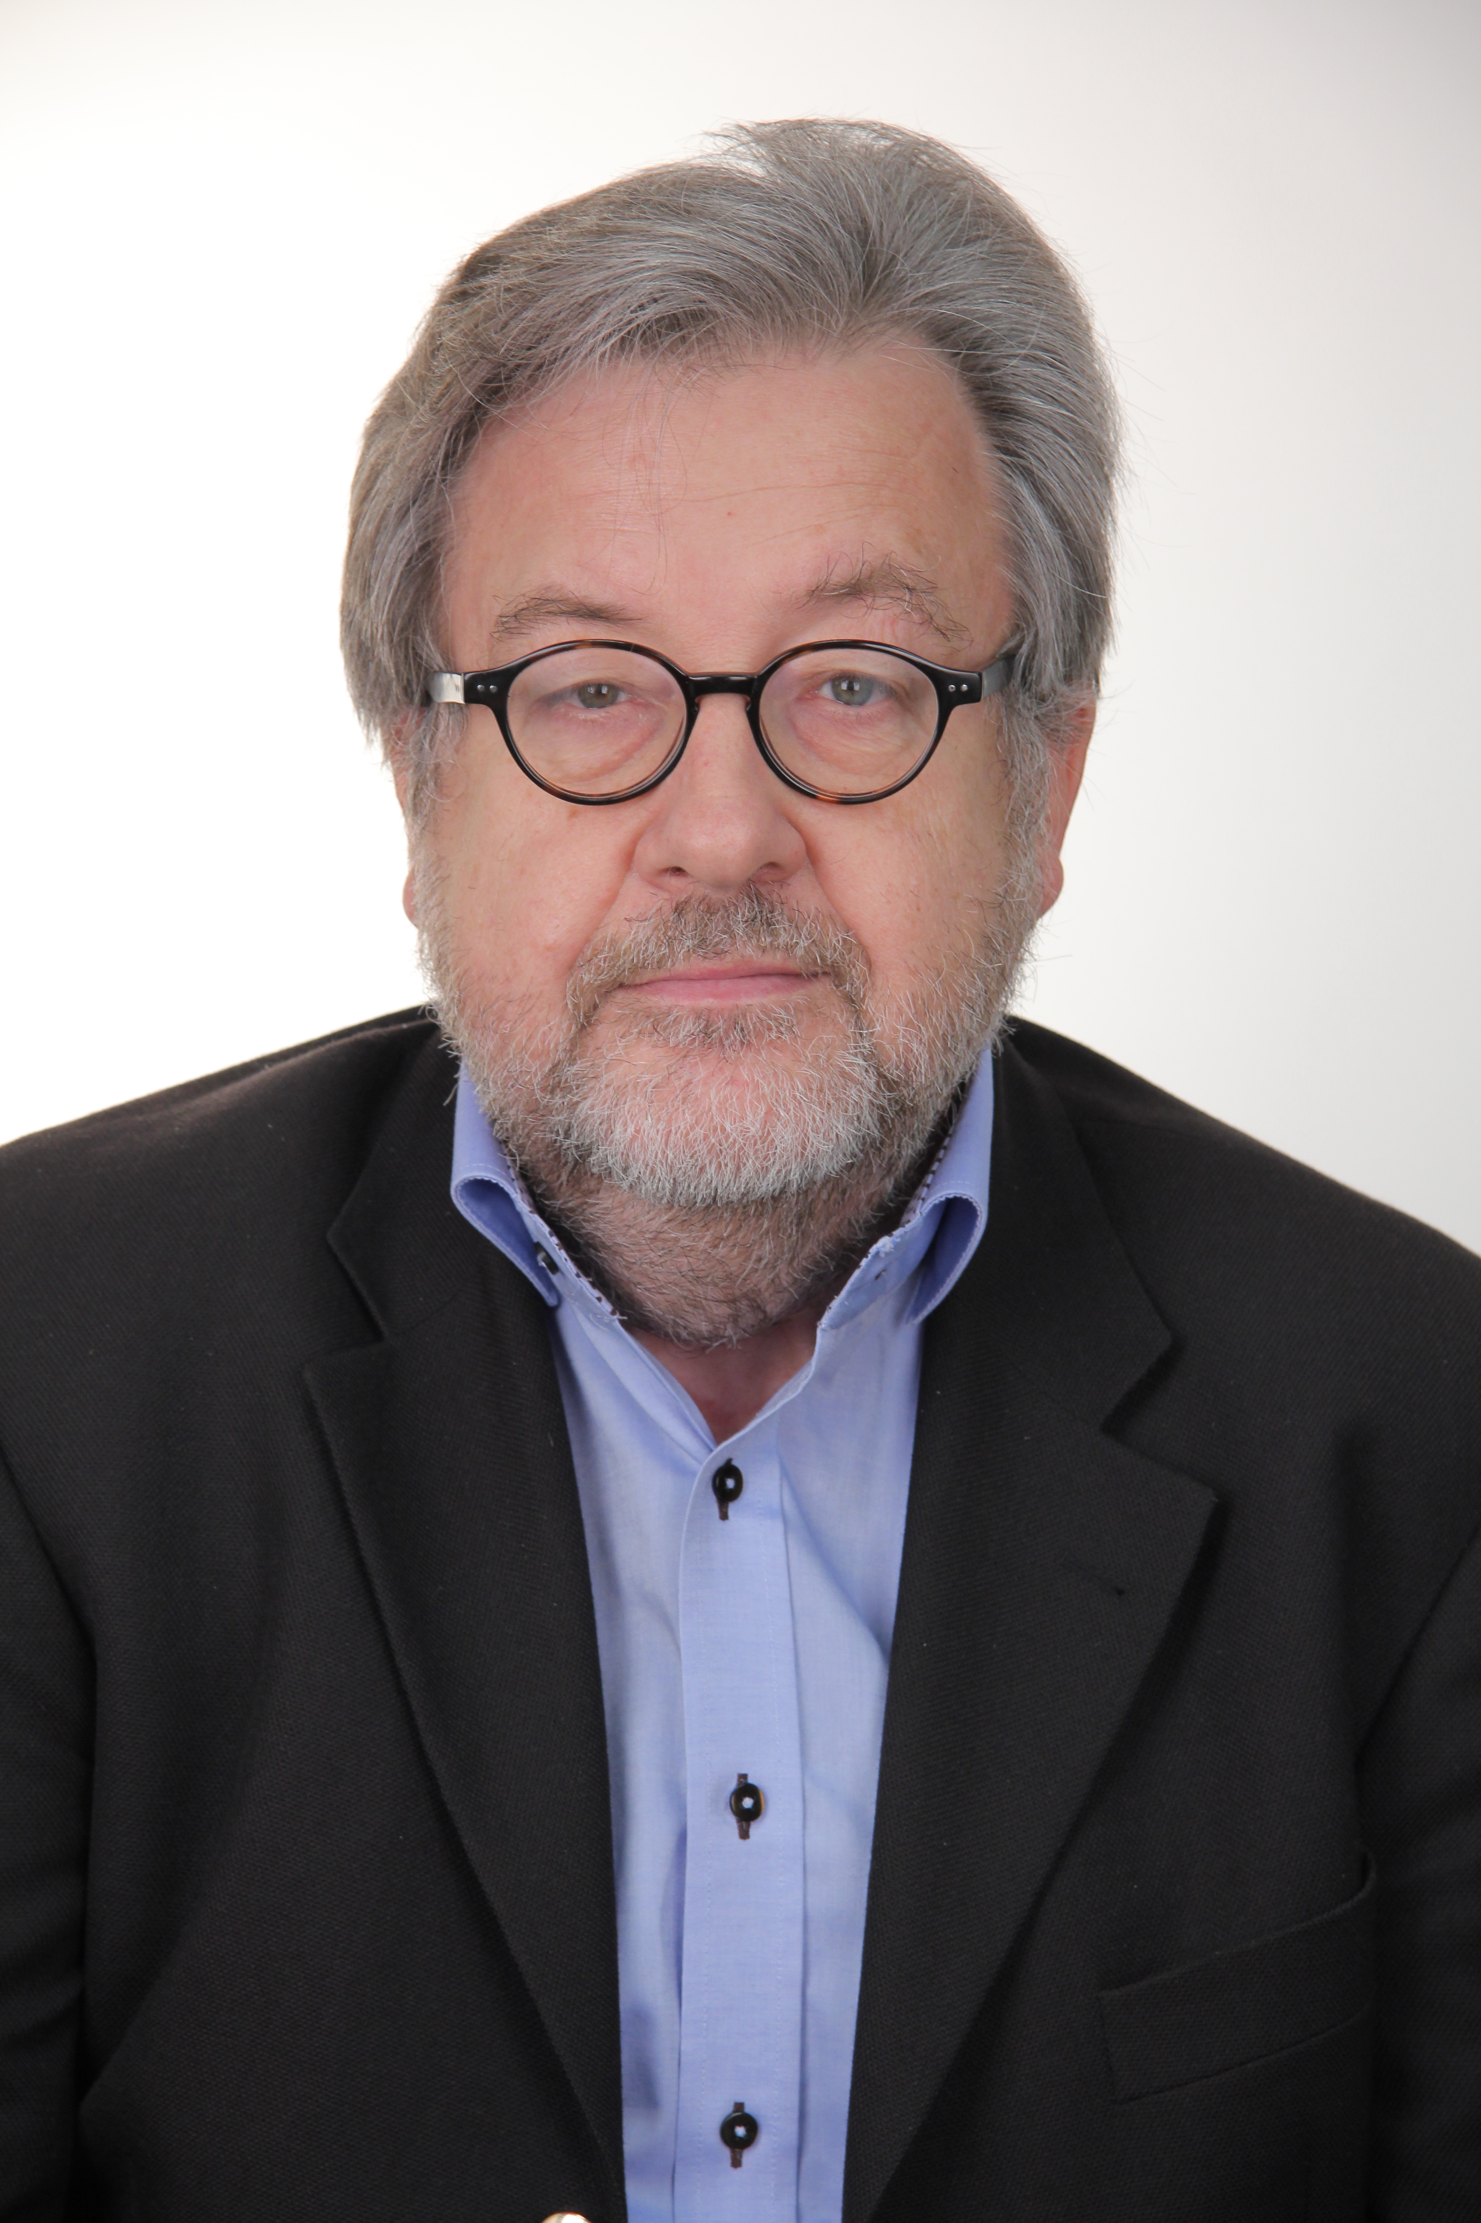
With an academic background as an economist, Wolfgang Scholz started his career with the German Ministry of Labour and Social Affairs, where he occupied the position of Minister-Counsellor, Chief of the Social budget division, before being seconded to the International Labour Organisation (ILO) in Geneva as senior economist for the Social security departments and the Social protection sector.
In 2011, Mr Scholz joined the Geneva-based German Mission to the United Nations and other International Organisations and acted as representative of his Government in the Governing body of the ILO. From 2014, he performed advisory mission related to social security / social protection, as senior adviser and consultant.
Mr. Scholz undertakes in parallel important academic activities. He lectures at the University of Applied Sciences, Bonn-Rhein-Sieg, Germany, “Managing social security reserves” and “Social policy alternatives” within the social insurance master course as well as, since 2010, at the University of Maastricht (UM) on “Simultaneous modelling of pensions and health” within the GIZ/ILT programme for Asian managers. He has occupied academic functions in the University of Lausanne (HEC) within the actuarial master course. Mr. Scholz equally lectured at the University of Mauritius, at the University of Warsaw and at the University of Dortmund on matters related to actuarial sciences and other tools for quantitative analysis in social security.
Mr. Scholz has published numerous articles and books as main or sole author addressing social security or social protection financial governance issues. He has conducted direct advisory missions for Governments in all parts of the world, including China.

