JIN WEIGANG 金维刚博士 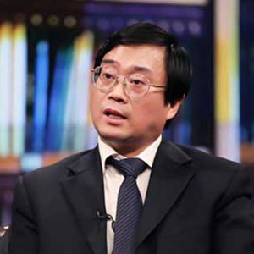

Director, Social Security Institute, Ministry of Human Resource and Social Security, People’s Republic of China
北京大学社会学博士，中国人力资源和社会保障部社会保障研究所副所长
EDUCATION • 07/1993 Department of Sociology, Peking University, Doctor • 07/1989 Department of Sociology, Peking University, Master • 07/1982 Department of Mathematics, Jiangxi University, Bachelor PROFESSIONAL EXPERIENCE • Statistician, Statistic Bureau of Jiujiang City, Jiangxi Province • Research Assistant, Sociology Institute of the Social Science Academy, Jiangxi Province • Deputy Chief, Division for Labour Force Research • Deputy Chief, Division for Development Strategy Research • Deputy Chief, Council of Academic Research, Labour Science Institute, Ministry of Labour of PRC • Director, Comprehensive Division, Department of Labour & Wage, Ministry of Labour and Social Security • Deputy Director, Social Security Institute, Ministry of Labour and Social Security
Numerous research and publications in the field of social security reform

