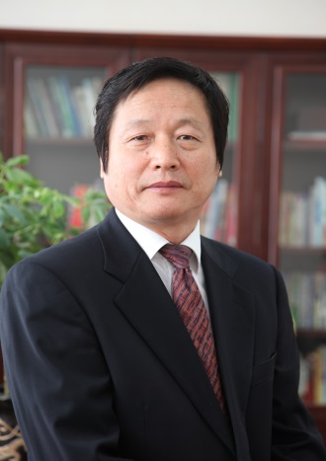

中国就业研究所所长曾湘泉

Zeng Xiangquan
Director, China Institute for Employment Research, Renmin University of China

1987年毕业于中国人民大学并获经济学博士学位。1994年任中国人民大学劳动人事学院教授。2000年至2014年担任中国人民大学劳动人事学院院长。2004年起先后任中国人民大学中国就业研究所所长。中国劳动学会副会长、劳动科学教育分会会长、中国人力资源开发研究会副会长。美国富布莱特项目高级访问学者、德国劳动研究所研究员。国家教育部“长江学者”特聘教授。

Mr. Zeng Xiangquan graduated from Renmin University of China in 1987, and got his doctorate in economics. Mr. Zeng served as a professor of School of Labor and Human Resources at Renmin University of China in 1994, and dean of School of Labor and Human Resources during 2000 to 2014. Since 2004, he has served as The Director of the China Institute for Employment Research, Renmin University of China, vice-president of the China Association for Labor Studies, Director of its Labor Science Education Branch and Vice-president of the Chinese Human Resource Development Association. He is also the Fulbright Visiting Scholar in US, Research fellow of German Labor Institute and the Yangtze River Scholar Distinguished Professor.

