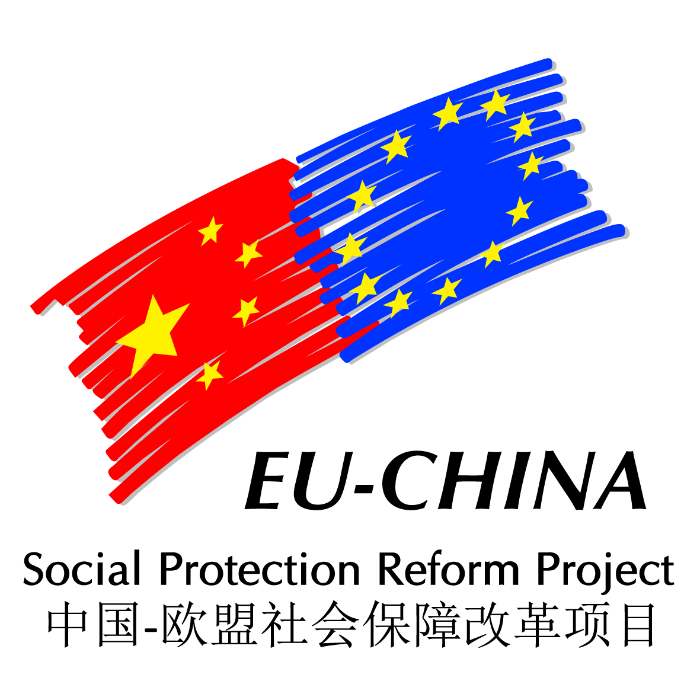
EU-CHINA SOCIAL PROTECTION REFORM PROJECT SPRP
HIGH LEVEL EVENT 2016
« PERSPECTIVE OF EMPLOYMENT POLICY AND SOCIAL SECURITY REFORM – 2016 TO 2020 »,
BEIJING 28 TO 29 SEPTEMBER 2016
COUNTRY PROFILE Czech Republic

1. MACRO-ECONOMIC SITUATION DURING THE PERIOD 2016-2020

The Czech Republic economy has recovered from the impact of the crisis which hit our country in the end of 2008. Due to conservative strategies implemented before 2008, there was no financial crisis and financial sector remained stable and sound. Economic downturn was caused mainly by fall of demand abroad and consequently, decrease in the domestic demand.

Currently, the Czech Republic experiences a solid economic growth coupled with decrease in unemployment. Atypical feature of this trend is low inflation (below 1 %) which is caused by fall in prices of raw materials, especially oil.

The Czech Republic as an open export-oriented economy is likely to copy trends in major economic partners (mostly the Euro Area countries). Moreover, the Czech economy has a large share of car manufacturing industry. This makes it vulnerable to shocks in that particular area.

The volume of investments experienced in 2015 was unique for several reasons and is not likely to be achieved again soon. It is also expected that the growth of public investments will be faster than growth of private investments after 2020. Due to increase of proportion of household consumption, the economic growth should be more balanced after 2016. This trend would likely push inflation to 2 %, which is the target set by the Czech National Bank.

However, as the Economic Outlook of the Czech Republic prepared by the OECD indicates, there is stagnation of labour productivity in Czech Republic. There seems to be a structural cause based in skills mismatch in the labour market (plus remaining structural unemployment in areas where mining and heavy industry had been concentrated before 1990, i.e. northern Bohemia and Northern Moravia). Although there is a high number of people attaining tertiary education in the youngest cohorts there is lack of people educated in technical fields. There is also lack of people of certain professional qualifications (craftsmen, i.e. secondary education).

GDP growth since 2008

2008 | 2009 | 2010 | 2011 | 2012 | 2013 | 2014 | 2015
+3.1 % | -4.5 % | +2.5 % | +1.8 % | -1.0 % | -0.9 % | +2.0 % | +4.3 %

The current Czech Government, whose mandate will end in October 2017 has – inter alia - adopted or prepared measures to fight corruption. A new Public Procurement Act was prepared and is to entry into force on 1st October 2016. Further legislative changes now discussed by both Parliament chambers are an amendment to Act on Conflict of Interests or amendment to Act on Organizing in Political Parties can be mentioned. Those and other measures have improved the results in the CPI Index (indicator based on the perception of corruption) from 53rd to 37th place in the world.

In early 2014, the position of Deputy Prime Minister for Science, Research and Innovation was created. The aim was to centralize the coordination and responsibilities in the Research and Development field under single central body. Steps related to introduction of coordination in the Research and Development are to be followed by steps aimed at strengthening the link between research and business (2017-2018) and establishment of centres for applied research (2020).

A new legal regulation (proposal was submitted to the Government in April 2016) aims at increasing the attractiveness and prestige of teachers’ profession. New rules are to be set for competencies of the teachers, their remuneration, education (and examinations) etc. Introduction of the new rules is to be accompanied with increase in teacher’s salaries.

Areas for reform:
- Economic growth is largely determined by the output of car manufacturing industry;
- Reduction of the administrative burden for businesses;
- Research, development and innovation policy and investments;
- Structural limitations in the labour market (skills mismatch, limited geographical mobility), better linkage between the labour market and education system;
- Pension scheme relies heavily on the first pillar;
- Take further steps to fight corruption;
2. LABOUR MARKET POLICIES
The positive development led to improvement of the labour market situation. In terms of unemployment, the Czech Republic approaches the numbers experienced before the crisis and the trend remains positive. As of 31st July, there were 392,667 unemployed people and 135,758 vacant jobs registered by the Labour Office of the Czech Republic. Of the unemployed, 53.8 % were women (211,150 persons), 4.1 % (15,925 persons) were young people and graduates and 14.2 % were people with disabilities (in absolute numbers 55,850). According to the latest EUROSTAT data (of June 2016), the unemployment rate in the Czech Republic was 4.1 % (for the whole EU, the indicator was 8.4 %). The national indicator – share of unemployment, comparing the number of the unemployed against the whole population in age group 15 – 64 was 5.4 %.

With regard to employment, the Czech Republic has a large proportion of secondary sector (industry and construction), which represented 38.0 % of employment in 2015. The tertiary sector (services) had 59.1% share and the primary sector (agriculture, forestry) accounted for 2.9 % of employment in the same year. The employment rate for age group 20-64 was 74.8 % in. In absolute numbers, there were 5,041,900 thousand people carrying out a gainful activity (employment, entrepreneurship) of which 4,167,700 (82.7 %) were employees and 874,300 entrepreneurs, majority of which are the self-employed persons (666,200). The number of economically active people (including jobseekers) was 5,309,900 in 2015.

A major reform was made in 2011 when the structure of public employment services was revised. Before 2011, there were 77 Labour Offices on the level of districts. In 2011, these were merged into single authority, the Labour Office of the Czech Republic. The Labour Office of the Czech Republic is a central body with headquarters (Directorate-General) in Prague and with Regional Branches in each of the 13 regions and in Prague. To provide accessibility, the Labour Office has several hundred contact centres. This step was to streamline the functioning of the whole apparatus as well as unifying the methodology. Moreover, the Labour Office of the Czech Republic became the authority responsible for all non-contributory social benefits, i.e. it accepts the applications, decides upon them and pays the benefits. Before 2012, the Labour Offices/Labour Office of the Czech Republic have been responsible for family benefits (other benefits have been administered by municipalities).

Employment targets
 | Target for 2020 (EU 2020 Strategy) | Value attained in 2015
Employment rate for population in age 20-64 | 75 % | 74.8 %
Employment rate of women in age group 20-64 | 65 % | 66.4 %
Employment rate for older workers (age group 55-64) | 55 % | 55.5 %

Since 2010, several measures were introduced in the Employment Act in order to motivate jobseekers to cooperate with the Labour Office of the Czech Republic and to accept and keep a suitable job:
- Unemployment benefit is lower if the jobseeker left his or her previous employment by giving notice himself/herself without a serious reason;
- If a jobseeker does not cooperate with the Labour Office of the Czech Republic or refuses a suitable job without having serious reason to do so, he may be exempted from the jobseekers’ registry for 6 months. That means the loss of entitlement to unemployment benefit as well as the assistance from the Labour Office of the Czech Republic. Moreover, such person must pay social security contributions and health insurance premiums by him/herself (registered jobseekers have those paid by the state). Similar sanction is due to a person who was given immediate notice for serious breach of legal regulations pertaining to his/her work.

In 2015, the conditions for providing investment incentives – financial support to creation of new jobs – were loosened. Currently, the support may be provided in regions where the share of unemployment is 25 % higher than national average (previously, the condition was 50 % higher share). In regions with share of unemployment 25-49 % higher than national average, the support may reach CZK 100,000 per one job created. In regions with share of unemployment 50 or more per cent higher than national average, the support may be up to CZK 200,000 per new job. In advantaged industrial zones, the amount may reach CZK 300,000 per new job.

Nowadays, a new active labour market policy measure is being prepared – regional mobility allowance for those jobseekers who accept a job outside their place of residence (other conditions must be met as well).

The Czech Republic also implements projects aimed at anticipation of labour market needs in terms of qualification and skills. Following on previous projects, the current project KOMPAS strives to create comprehensive predictive system which would engage public employment services as well as other partners (including the employers), especially on the regional level.

This year, a legislative proposal concerning social entrepreneurship was prepared. The law would set definitions of social enterprise – an enterprise which integrates people with health or social disadvantage while operating on the open market (i.e. it is still an enterprise with the aim to make profit).

The current government made the effort to promote reconciliation of family and working life. The impact of maternity on the employment rate of women is the largest in the OECD. In more than 98 % of cases, it is the woman who stays at home with the child. Usually, the length of absence from work is 3 years (maternal and parental leave combined). One of the obstacles is insufficient supply of childcare facilities for children under 3 years of age. Another obstacle is the limited possible of flexible working arrangements such as part-time jobs or home-office of flexible working hours.

The lack of childcare capacity was addressed by introducing a new type of childcare facility – children’s group. In 2016, the Ministry of Labour and Social Affairs starts a project within which a new type of childcare facility for small children from 6 months of age (so called micro-nurseries) will be piloted.

Also the capacity of existing kindergartens was increased. An amendment has been discussed in the Parliament which would oblige the kindergartens to accept children older than 4 years of age in 2017. In 2018, the threshold would be moved to 3 years of age and in 2020 to 3 years of age for kindergarten founded by a municipality or an association of municipalities. Furthermore, kindergarten attendance will be changed from voluntary to mandatory after reaching 5 years of age (this should help integration of children from disadvantaged environment). The amendment is expected to come into force during 2017.

The rules for drawing of the parental benefit, which often determines the length of the parental leave, are to be made more flexible soon if the relevant amendment is approved. The parent drawing the benefits has a target amount of CZK 220,000. So far, the monthly amount could be chosen by the parent between CZK 3,800 and CZK 11,500. The upper limit is proposed to move to CZK 33,000 to enable faster exhausting of the whole amount, possibly in 6 months.

The current government currently considers another increase in the amount of minimum wage. The minimum wage was unchanged from 2007 till 2013 when it was CZK 8,000 per month (reduced rate is applicable to persons with disabilities). In 2013, increase to CZK 8,500 was decreed by the Government of Mr Jiří Rusnok. The current Government followed with two increases so far, to CZK 9,200 and later to CZK 9,900 per month (effective since 1 January 2016). The target laid down in the Government’s Policy Statement is to set the minimum wage close to 40 % of the average wage. Discussion on further increase and possibly on setting a clear mechanism of minimum wage indexation is underway between the Government and the social partners (employees’ organizations propose further increase in minimum wage, employers are not in favour of simple increase and propose setting an automatic indexation mechanism r fixing the minimum wage as a rate of another indicator – such as certain percentage of average wage or other).

3. UNIVERSAL COVERAGE AND ADAPTATION TO MOBILITY
The Czech pension system is based on the first pillar which is run by the state and based on the pay-as-you-go principle. It is also defined by benefits system. Participation in the first pillar is mandatory for all employees as well as other people economically active in the Czech Republic. The system has virtually 100 % coverage.
The first pillar is a part of the state budget (i.e. contributions are on the income side, pensions paid are part of the state budget expenditure. The contributions are collected by the Czech Social Security Administration (CSSA), which also pays the pensions. The CSSA is under the umbrella of the Ministry of Labour and Social Affairs.
The calculation of benefits is based on solidarity principle, i.e. the replacement rate decreases for persons with higher income. The benefit is based on a formula taking into account the previous income (indexed) and length of contributions period(s). There are two reduction limit which are used when calculating the personal assessment base from the previous income. Amount below the first reduction limit (CZK 11,883 per month) is calculated fully. The amount between the first and second reduction limit (CZK 108,024) is reduced to 26 %, the amount above the second reduction limit is not taken into account at all.
Average old-age pension in 2015 was CZK 11,331, average gross wage CZK 26,467, i.e. the ratio was 42.8 %. However, the old-age pension is not subject to taxation or other contributions as wage is.
There is a voluntary third pillar – supplementary pension savings run by private pension funds. However, role of the third pillar is negligible due to low contributions.
As for the employees, the pay 6.5 % of their gross wages, contribution of the employer is 21.5 %. Premiums are being paid to the Czech Social Security Administration by the employer (the employee does not have to administer his/her contributions, it is the responsibility of the employer). Self-employed persons pay the same percentage rate (28 %).
The unemployed as well as mothers on maternal leave and parents on parental leave are also covered. The time spent in the jobseekers’ registry/on maternal/paternal leave is being calculated in the contributions history (but it is not taken into account when determining the pension amount in order not to dilute it).
The entitlement to pension is conditioned by reaching the retirement age and the required number of contribution years. The retirement age has been increasing gradually since 1995. Retirement age for men increases by two months each year. For women, the tempo is 4 months a year as the retirement age for women was set lower (the more children a woman reared, the lower the retirement age was). The target retirement age is 67 years for all men and women (i.e. the differentiation of retirement age based of reared children is being phased out). In 2016, the retirement age is 63 years for men, 62 years and 4 months for childless women, and decreases by 1 year per each reared child (maximum limit is 5 children, the corresponding retirement age in 2016 is 58 years and 4 months).
At the same time, the required number of years in insurance is increasing to target of 35 years (including supplementary periods such as sickness leave, unemployment, maternal and/or parental leave etc,) in 2018. Person, who has accumulated 30 or more years of insurance without having to calculate also supplementary periods (i.e. through employment or entrepreneurship) is also entitled to old-age pension.
As for migrant workers, large majority of them are EU or European Economic Area citizens that have free access to the Czech labour market and are also covered by EU legislation on coordination of social security. The Czech Republic has also concluded bilateral social security agreements with many countries of origin and negotiates with other (with China, the negotiations started in 2012). The aim is to cover the countries with significant number of citizens residing or working in the Czech Republic or vice versa. The complete list may be found at www.mpsv.cz/CS/1275 (in Czech).

4. SOCIAL EFFICIENCY AND INCLUSIVE GROWTH
The Czech social protection system is relatively cheap. The costs are close to 20 % of GDP while the income poverty rate is among the lowest in the world. The share of people whose income is below 60 % of mean income is below 10 % in the long-term. The main reasons are the social transfers.

Poverty rate and social protection related expenditure
Year | 2005 | 2006 | 2007 | 2008 | 2009 | 2010 | 2011 | 2012 | 2013 | 2014
Poverty rate in the Czech Republic (%) | 10.4 | 9.9 | 9.6 | 9.0 | 8.6 | 9.0 | 9.8 | 9.6 | 8.6 | 9.7
Social protection expenditure in % of GDP | 18.4 | 18.3 | 18.2 | 18.3 | 20.2 | 20.1 | 20.1 | 20.4 | 19.4 | 19.1
Poverty rate in the whole EU | 16.4 | 16.5 | 16.5 | 16.6 | 16.4 | 16.4 | 16.8 | 16.8 | 16.6

In terms of another EU indicator, the risk of poverty and social exclusion, the situation in the Czech Republic very good – the relevant indicator stood at 14.8 % (1,532,000 people) in 2014 while it was 15.3 % in 2008 – before the crisis. The rate for the whole EU is 17.2 %.

Because of the positive development, the Czech Republic revised her target within the EU 2020 Strategy. Originally, the Czech Republic made the commitment to decrease the number of people at risk of poverty and social exclusion by 30,000 in comparison with the year 2008. This was achieved in 2013. Now, the target is to decrease the number by 100,000 people.
While having extremely effective social transfers in cash, there is much to improve in social services and social work area. Social Services Act adopted in 2006 introduced many modern features in the welfare system. However, 10 years of experience revealed many issues which need to be addressed. The Ministry of Labour and Social Affairs is preparing a major amendment to the Social Services Act to reflect the 10 years of experience as well as the new trends in the social services area. The aim is to streamline and simplify thy system of social services and clarify some moments where different interpretations are now possible.

One of the issues insufficiently covered is the area of social work. A clearer distinction between the social work and social services must be made. The Ministry of Labour and Social Affairs has prepared a legislative proposal to regulate the social workers profession (including the definition of a social worker, the requirements and conditions for the profession etc.). After inter-departmental discussion upon this intention, a legislative proposal is to be submitted in September.

Another gap in the Czech social protection system is the lack of policy regarding social housing. Social housing is now fully in the competence of the municipalities. That means that each municipality has different criteria for provision of social housing.

So far, the state provided social benefits related to housing (supplement for housing and housing allowance). However, the experience showed that the benefits, which in theory could enable a family to rent decent housing, helped create so called “business with poverty”. Many families thus live in residential hostels and the costs are being paid by the state through the housing benefits. The hostels thus increased the prices, often to the level for which a larger flat could be rented in the same town.

Therefore, the Ministry of Labour and Social Affairs is now preparing a bill on social housing following on the Social Housing Concept 2015 – 2020 approved in 2015. The legislative proposal is now being finalised at the Ministry and will be soon sent to other Government bodies within the interdepartmental comments procedure. The new law should set the framework for social housing – set the standards and define the groups eligible to social housing. Social housing is to be combined with social work, social services and with the housing-related social benefits.

Concerning the inclusion of disadvantaged children, an amendment to the Education Act of approved in 2015 brought several changes towards keeping children with specific educational needs within the mainstream education. Supportive measures were also introduced and promoted. The changes and new methodology will be implemented since September 2016, i.e. the start of the new school year.

5. SUSTAINABILITY AND FINANCIAL REFORM
Deficit of the state budget is a long-term feature of the public finance sector of the Czech Republic. In 2015, the deficit of the state budget was CZK 62,8 billion, i.e. 1.4 % of GDP. The government debt was 41.1 % of GDP (CZK 1,863 billion) in 2015. In 2014, the government debt stood at 42.7 % of GDP (the hitherto highest value in terms of % of GDP was in 2013 – 45.1 %). Since 2013, the Czech Republic has met both Maastricht criteria (government debt under ž0 % of GDP and state budget deficit below 3 % of GDP).

The Government strives to decrease the deficit and the government debt (at least in the terms of % of GDP). It has been successful so far in both of those aspects. The current economic growth provides room for manoeuvre by increasing the income of the state budget. Nevertheless, to increase tax revenues, the Government strives to increase the efficiency of tax collection especially the VAT.

Around 80 % of state budget expenditure is mandatory. Large share of the expenditure is on pension benefits. Revenues from pension insurance are lower than expenditure. The Czech society is ageing fast, therefore the deficit is likely to grow which increases pressure on public finance. The current expenditure of 9.0 % of GDP is expected to increase to 9.7 % of GDP by 2060.

The Government decided to join the EU Fiscal Pact in 2014. The Government has submitted the relevant legislative proposals aiming at strengthening of the national budgetary framework in early 2015. However, the Chamber of Deputies has not decided upon the proposals yet

When joining the EU in 2004, the Czech Republic accepted the obligation to join the Euro Area. However, there is no plan nor timetable for it.

The previous government led by Mr Petr Nečas introduced a second-pillar of the pension scheme. It was funded pillar with 11 pension funds participating in The opt-out from the first pillar was voluntary and the person which opted for the second pillar transferred 3 percentage points of his/her social security contributions to the second pillar and was obliged to pay 2 percentage points more. However, the number of participants in the second pillar was much lower than expected and perhaps only one pension fund would have enough clients to be viable. The current government has abolished the second pillar.

In 2014, the Czech National Bank decided to intervene and set the CZK/EUR exchange rate to CZK 27/EUR 1 (the rate then was around CZK 24/EUR 1). This target is still being pursued. The rationale for this step was to promote the Czech export. When and how will this measure be phased out is still unclear.

Annex: Overview of the progress toward national targets set in EU 2020 Strategy

Area | National target | Referrential value (year) | Progress by the latest data
Employment | Increase general employment rate of persons from 20 to 64 years of age to 75 % | 70.4 % (2010) | 74.8 % (2015)
Employment | Increase employment rate of women (20-64 years) to 65 % | 60.9 % (2010) | 66.4 % (2015)
Employment | Increase employment rate of older workers (55-64 years) to 55 % | 46.5 % (2010) | 55.5 % (2015)
Employment | Decrease unemployment rate of young persons (15-24 years) by one third | 18.3 % (2010) | 12.9 % (3Q/2015)
Employment | Decrease unemployment rate of persons with low qualification (ISCED 0-2) by one quarter in comparison with 2010 | 25 % (2010) | 21.9 % (3Q/2015)
Poverty and social exclusion | Decrease in number of persons at risk of poverty, material deprivation or living in households with very low working intensity by 100,000 | 1,566,000 (2010) | Decrease by 34,000 (2014)
Education | Decrease in number of people leaving education early to 5.5 % | 4.9 % (2010) | 5.8 % (2015)
Education | Attain at least 32 % share of people with tertiary education in population in age 30-34 years | 20.4 % (2010) | 29.5 % (2015)
Research, development and innovations | Increase public expenditure on science, research and development to 1 % of GDP | 0.62 % /2010) | 0.66 % (2014)
Climate and energy policy | Decrease greenhouse gas emissions – maximum possible increase of emission outside EU ETS system by 9 % | + 1.3 % (2005) | - 0.9 % (2010
Climate and energy policy | Increase the share of renewable energy resources in final energy consumption (13 %) and the share of renewable resources in transport (10 %) | 6 % (2005)  0.5 % (2005) | 13.4 % (2014)  6.1 % (2014)

Exchange rate August 2016: 1 euro = 27 Czech korun (CZK). 1czk = 0,278 RMB yuan

