OVERALL VIEW OF THE MOBILITY WITHIN THE EU.

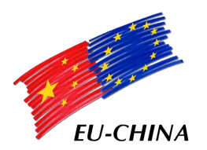
Social Protection Reform Project
中国-欧盟社会保护改革项目

Contents
1. Legislation 3
2. Free movement EU Nationals.
3. Family Members.
4. Non -EU Nationals
5. Posted Workers.

- Legislation.
- Free Movement of Workers.
- Enlargement 2004.
- Enlargement 2007. Bulgaria and Romania.
- Enlargement 2013. Croatia.

- Free movement-EU Nationals.
- Who can benefit from this freedom?
- What restrictions are there?
- Croatia. Transitional arrangements.

- Family Members.
- The right to reside.
- The right to work.
- The right to education.

- Non-EU Nationals.
- Iceland, Liechtenstein and Norway.
- Switzerland.
- Turkey.
- Other countries that have an agreement with the EU.
- Countries with no agreement.

- Posted Workers.
- What is posting?
- Which areas are covered?
- What terms and conditions of employment are covered?
- Legislative initiatives.
- Implementation reports.
- Studies.

