COMPONENT ONE

Key dates of the law for Vocational training in France
and its influence on its evolution on the ground

René Bagorski
Véronique Dunand

Association for Adult Vocational Education
AFPA

September 2018

FRANCE COUNTRY BRIEF
Key dates of the law for Vocational training in France
and its influence on its evolution on the ground

The key dates of the law of adult education in France

First definition in 1792, Condorcet in his report on the general organization of public education states what constitutes the first explicit definition of adult education: "We have observed that education should not abandon anybody when they leave school, that it must embrace all ages; and that there was none where it was no longer useful and possible to learn, and that this second instruction is all the more necessary, since that of childhood has been narrowed within narrower limits. “
1946: the right to vocational training is included for the first time, as is the right to social security, in the preamble to the Constitution of the Fourth Republic
1949: creation of the AFPA (Association for Adult Vocational Training) to participate in the reconstruction of the country after the Second World War.
Actually It is on November 9, 1946 that Ambroise Croizat by decree federates under the supervision of the Ministry of Labor, vocational training centers, prefiguring what will later become Afpa. The Afpa was created on January 11, 1949 under the name ANIFRMO (National Interprofessional Association for the rational training of manpower) It’s role was then to train adults quickly to bring them to a first level of qualification in construction and metallurgy. In 1966 the organization changed its name to Afpa.
January 2017 Afpa changes status and becomes EPIC – Public body in the Industrial and Trade sectors.

Afpa : National agency for adult vocational Training
Afpa, the leading vocational training organization for professional integration and skills development, assists job seekers and those already in employment throughout their professionnel lives to enable their access to long –term employment via certified training courses.
Afpa facts and Figures (2016)
- 1 billon € as operating budget (845M€ public revenue + 155 M€ private revenue) and 100 M€ of annual investment
- 7.500 employees
- 300 OOO guidance services
- 151 000 admissions
- 65 million training hours
- Success rate : 81% of trainees have been awarded certificates at the end of their training
- Employment rate: 69% of trainees find a job within 6 months after their training.
- 113 Vocational centers all over France.

AFPA has a Comprehensive expertise and quality approach
. Afpa a true generalist, brings a broad range of skills for employment, including services such as guidance, qualification, certification, assistance, training course design and advice.
. Afpa has seven Research Departments (Construction sector/Industry sector/services sector/ Distance learning/Resource Center for persons with disability/Vocational Guidance/ Training for Trainers) dedicated to analysing the employment market as well as the management of career changes, skills and training standards according to the evolutions of various professional sectors.
. Afpa mobilises a range of partners both nationally and internationally.
. It presents a vast internal network of professional who covers all sectors of activity.

AFPA European and international teams develop Afpa’s vocational training activities and expertise in many European countries and throughout the world.
They supply services in all their skill sectors, focusing on four main areas:
- Assistance to entreprises in all regions of the world
- Bilateral agreements mainly in Mediterranean basin countries (manpower agreements in Morocco and in Tunisia) and in Central and Eastern Europe.
- Participation in invitations to tender and institutional twinning agreements.
- European programmes

- Within this scope, Afpa is associated with other players contributing to a strategy of exchange programmes, joint actions and the pooling of potentials
- Afpa is a member of :
- GIP Inter (Development of Technical Assistance and International Co-operation) which brings together the services of the Ministry of employment and Work as well as other organizations entrusted with employment and vocational training.
- The European Vocational Training Association (EVTA), which brings together the public bodies charged with vocational training in the different countries in the European Union.
- Afpa’s other European and International Partners: Ministries (Employment, Foreign Affairs, Industry, Commerce, etc..); entreprises, consulting firms, training bodies, Professional branches, social partners, universities, research and study centers.

- The European and international teams design, develop and implement a range of services for the benefit of their international client according to their specific needs.
- They carry out the following actions :
- analysis of local policies and strategies in the employment and vocational taining sector.
- analysis of needs of entreprises regarding the qualification and training of their personnel.
- design, preparation and implementation of pedagogical products adapted to the public targeted.
- selection and training of trainers and tutors
- Technical assistance and sectoral training
- Training of foreign nationals in Afpa centers
- Guidance/Recruitment Afpa offers its assistance to the analysis of the industry catchment areas, the knowledge of the public targeted and job profiles, the organisation of recruitment and the implementation of the appropriate courses. Under an international project, Afpa proceeds with a skills assessment of the personal recruited.
Recent Achievement: Study of the local context, design of interview and recruitment guides for trainees appropriate for job profiles, on behalf of OGER international and Saudi OGER in Saudi Arabia.
- Validation /Certification Afpa develops accreditation of prior learning to enable people with experience, but without qualifications to gain recognition for the skills they have acquired during their professional life.
Recent Achievement: Adaptation of an APL scheme in Russia on behalf of GIP Inter.
Training of Trainers
- Afpa supplies specific training courses to qualify local actors of vocational training. Under an international project, the trainers, trained on site or at Afpa centers, must eventually act in relay with French contributors to the benefit of the local production sytem.
. Sectorial Training
. Afpa offers certified training courses in more than 300 professions in the construction, industry and services sector, from skilled operator to senior technician level
Recent Achievement : Assistance in the establishment of a PSA Peugeot-Citroen production unit at Trnava in Slovakia
- Training course Design/Expertise
- After analysing the environment and the employment profiles, Afpa experts design and implement tailor-made training programmes.
Recent Achievement : Assitance in the recruitment and training of heavy plant drivers for AREVA in Niger.
You want to know more: Visit our virtual training center
https://www.afpa.fr/visites-virtuelles
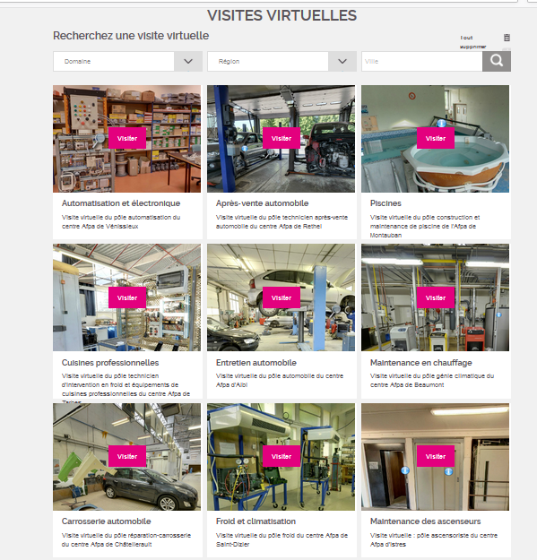

Véronique DUNAUD et René BAGORSKI
September 2018
.

