Provincial Training seminar on migrant workers’ social security rights
– portability, financing, procedures

As part of the project Component 1 2016 programme of activities for pilot sites, a training and exchange seminar was held in Foshan – Guangdong Province – on 27 and 28 April 2016. Twenty-six persons attended the event, with participants coming from Development Reform Commission and Social security administration from various government levels in Guangdong and Sichuan Provinces.
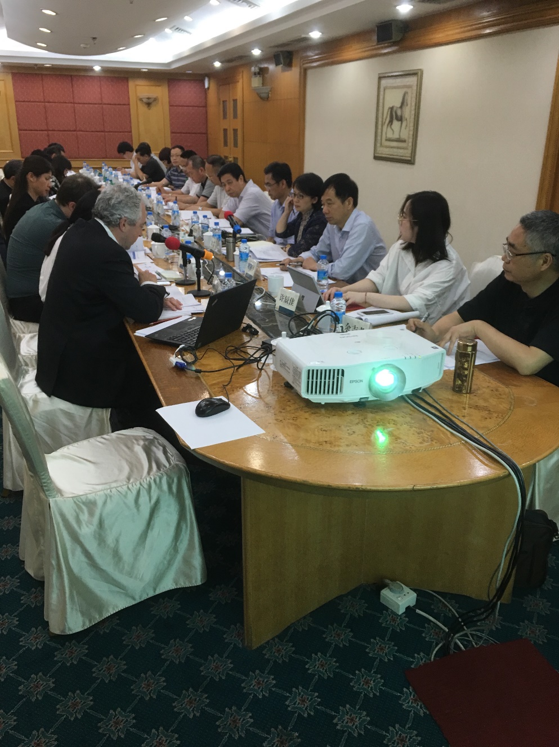
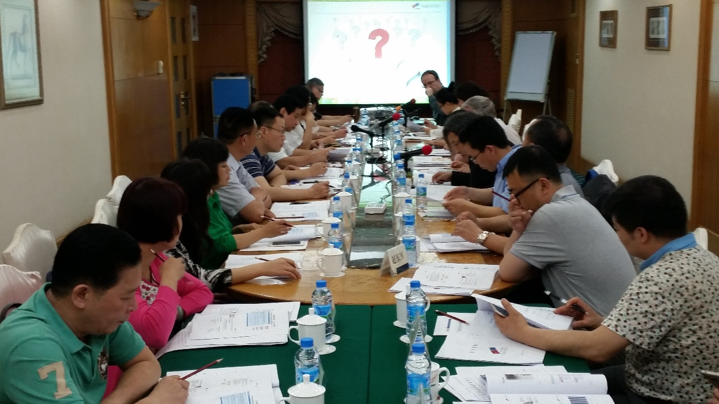
The first part of the event starts with the opening address by Mme. Tang Ling, Division Director, Department of Employment and Income Distribution, NDRC. She reinstates the four major objectives of the project including the top-design of pension reform. She further introduces that in addition to activities and collaboration at the central level, there have also been pilot sites activities in three different locations under C1 component of the project. There are various ways in which the local level can participate in the project, including the experience of pilot sites, which can be included in the HLE in September, as well as the research on key topics, which can be carried out by local agents. Another way is to get involved is the overseas study and training visit to Spain in July. The discussions and comments from provincial delegations are more than welcome, especially the perspectives on the recent initiative to reduce the social insurance contribution level.
As the Resident expert for Component 1, Mr. Gruat emphasizes the indispensable contribution to the project from the provincial level, which has shaped the designs and frameworks of the activities and the events. The project seeks the sharing of experiences and practices. The combination of expertise consisting of both Chinese and European experts is crucial in ensuring that the exchanges and communications are substantial and relevant.
Session 1 focuses on Introduction on the Transfer and Continuation of Pension rights at local level, and is chaired by Mr. Jean -Victor Gruat，C1 Resident Expert.
First speaker, Mr. Yang Jianhai, Division Director, the Department of Human Resources and Social Security of Guangdong Province, provides an introduction on the situation of pension transference of the migrant workers in Guangdong Province. He starts by addressing the features of pension system in Guangdong, which include the relatively broad coverage, special calculations and payment of benefits which are adapted to the specific condition of Guangdong Province, the innovative means of fund investment which has been proved to be effective and gained acknowledgment on the central level, as well as the information platform which allows enterprises to process the application online. The focus is on the transference and continuation policy in Guangdong. The fundamental principle of the administrative procedures are favorable to migrant workers. In Guangdong, the benefits are calculated by sections, which emphasizes the importance of shared responsibilities in respect of payments. One innovative initiative is to define that the workers can receive the benefits from where they have made the final contribution, which is different from the state policy in this regard. This has removed the entry barriers to benefit reception, which will facilitate the mobility of labour. However, in spite of these innovative measures, there are still several obstacles to be dealt with. First there is a lack of policy support at the central level, and the procedures are overly elaborate and complicated. Section-based calculation is not yet fully addressed or acknowledge in the policy on the central level. Due to the imbalanced share of responsibilities, the transference between regions and systems will inevitably incur losses of interests for some of the stakeholders, which creates disincentives for the handling of cross-region transference and continuation.
The delegation from Luzhou, Sichuan, Mr. Li Shubo, first introduces the transference and continuation procedures on the provincial level. One highlight is the digitalization of the procedure. Under the information system, what is being transferred is not the relationship but rather the access to and the management of data. This is more efficient, and ensures the accuracy of data. Within the Luzhou city, there is no longer such a thing as ‘transference’ per se. He also points out, in resonance with the point made by Mr. Yang about the loss of interests during the transfer, that there is a huge gap between the immigration and the emigration (inflow and outflow). The amount of monetary influx, which is much greater than the outflow, indicates the pressure on expenditure in the future, since the part being transferred is only the individual account. For the same level of contribution, immigrants are entitled to higher benefits, the discrepancy of which is to be burdened by the receiving provincial units. Moreover, it is very important to have national overall planning on the pension. All contribution and payments should be maintained on the national level, and the provincial units only function as the transition. Also the universal information platform should be put in place, and should be mandatory for all provincial units, so that the postage of hard copies of documents shall be discontinued which will increase the efficiency of administration profoundly. The transference and coordination for one-off contribution, which is not possible now, should be researched in depth.

Next Mme. Xiong Jing, Division Director, Guangdong Provincial Development and Reform Commission, moderates on the discussion of Comparison between China and EU on the Transfer and Continuation of Pension System for Migrant Workers.
Mr. Fang Lianquan opens the session with his Research on the Issue of Urban and Rural Pension System Integration. He first offers a brief introduction on the pension system, and points out the diversity and inconsistency within the system on various levels, including the institutional design, levels of contributions and benefits, as well as the confusions on the administration. In this regard, ‘integration’ is necessary to address these various discrepancies. However, it is worth noting that the notion of ‘integration’ assumes different definitions and implications in different contexts. Several policy initiatives have been enacted to address the inconsistency of the system. But many problems are nevertheless prominent including the issues of fragmentation, low portability, limited incentives, and high costs due to high contribution level, which might result in the loss of mobility and the lack of mobile workers, regional imbalances, and financial burden. The current institutional set-up of the pension system has created the ‘morality risks’ by which the wealthy regions tend to hold on to the funds whereas the less affluent localities seek the fair shares. This means that there is a potential financial burden, which neither the central state or the local government would be willing to take up. This is one of the obstacles for pooling on the national level. Having said that, better integration on the central level is essential. He provides several approaches to achieve this point. In the long run, the universal system should be put in place, through structural reform as well as parametric reform, which is effective in resolving the regional disparity in social salary. In the near future, the transfer policies should be improved: the pooling levels should pushed up, the specific measures of transfer and continuation be totalised and the information system and administration be well integrated.
This is where the EU experiences and practices become especially relevant and useful. Mr. Xavier Coyer, Advisor for Social Affairs, Social Protection & Employment Department, Expertise France, highlights the common concerns in his presentation on Pension Transference in the EU Member States. He first points out that migration within Europe has been long in history and great in intensity. In the post-WWII period, migration was on a large scale. Even though back then the social security system was not as complete and sound as today, the fundamental feature of the migration of that era was the absence of discrimination based on nationality. Although back than the disparity between urban and rural was evident, but the issue have been fixed and no longer presents itself as a problem for the system. Despite the differences, one shared objective is the establishment of an efficient, sustainable, equitable system, and common concern also exists in terms of the practical issues of administration. According to Mr. Coyer, the 28 member states, although have very different and particular systemic arrangements, but share the common references about social security, which enables the coordination. The change of notions from migrant workers to mobile workers serves to further remove the discrimination against ‘mobility’, and also captures the increasing phenomena of workers moving around and settling in any work place rather than returning back to the hometown. In this context it is essential to have better coordination on social security. However, this does not mean harmonization and homogenization, or that all states should follow the same rules or guidelines. In this regard, it might be more appropriate to speak about cooperation rather than coordination between social security systems. One interesting principle ‘only one country’s law’, which involves practical issues, is of particular relevance to the Chinese context, but is often misunderstood. It requires that at one time an individual can only participate in one system. But they can contribute to different systems at different stages of life. When they retire they can receive the benefits from all systems they have participated, based on the aggregation of periods of insurance, residence or employment. The contribution and benefits are also highly portable, anyone can receive the benefits wherever they choose to retire and withdraw from the labour market. For instance, France has a huge number of migrant workers from Northern Africa, who tend to go back to their home countries for retirement. Every year the French government transfers huge amount of funds to these country as payment of benefits for the people who have once contributed to the French insurance scheme. There is also the risk of fraud and mismanagement, which is an issue to ponder upon. As for the empirical aspect, one key practice in EU is the liaison bodies established in all EU member states, sometimes even several liaison bodies within 1 state, to make sure of the implementation of social security agreements on EU level and also on international level. They are also responsible in processing very complex individual cases. Within the health care system, a very important progress is the application of European health insurance card EHIC. The card makes it possible for EU citizens to have access to the local health care, with the equal entitlements as the national citizen of the country. In the meanwhile, the Electronic exchange of social security information EESSI is under way, to switch from paper to digital data. It will be beneficial for the participants, who will have their benefits on time and in time, but also advantageous from the administrative perspective.
The discussion session is highly dynamic and interactive. First, Mr. Yang Jianhai complements to the Mr. Coyer’s presentation, by introducing some of the difficulties experienced on the national level that have been resolved within Guangdong. The prominent aspect is the emphasis on the sharing of responsibilities through the sectional calculation. Mr. Li Shubo proposes the question regarding the specific procedures of French legislation on social security among mobile workers: is there a upper limit in terms of the period of contribution and the amount of benefits a foreign worker are entitled to. Mr. Coyer introduces the calculation of benefits, which is founded on the mechanism of ‘best salaries’ and highly elaborate. This promises a minimum level of pension support for all citizens, which is linked with the minimum wage level and guarantees the basic subsistence More importantly, there is no difference between the nationals and the foreigners. The most discussed issue, which also attracts the interests of most Chinese delegations, is around the specific calculations of the benefits that can be received. In elucidating the process, it is also clear that due to the complexity of the reality the system can be very elaborate and sophisticated.
Mr. Vleminckx participates in the discussion by bringing to the fore a prominent disparity between EU and China. EU has never aimed at building a universal social security plan and as a result compromised at the current system underpinned by extreme complexities. In this regard, China as a sovereign country has the advantage. He further proposes the question whether social dumping and welfare tourism are also the concerns for China. Mr. Yang acknowledged welfare tourism as quite relevant in Guangdong, especial in the past. When migrant workers moved into Guangdong they were subject to administration charges under different nominations. Currently under the new policy framework, all rural and urban residents are required to participate in the pension programme for residents without any additional charges. In general the entry barriers have now been removed for migrants to switch to the social security schemes in Guangdong.
Mr. Lei Wencai, Deputy Director, Luzhou Municipal Development and Reform Commission, comments that the pooling on the national level is necessary not from the perspective of social security but also on a moral ground of fairness and justice. The development and prosperity of the East is built upon the contribution of all other regions, so the fruit should be equally shared by all citizens. In this regard, the national pooling is indispensable for a fairer social security system. Mr. Yang responds with several aspects in which Guangdong has significantly contributed its wealth to the balanced development in the country. He also emphasises a clearer definition of shared responsibilities on different levels and for different agencies.
The training resumes on the morning of 28 April, with Mr. Zhang Guoqing, main C1 Chinese Expert chairing the third session on Social Security Administration Service and Information Construction.
Mr. Koen Vleminckx, Director, Federal Public Service Social Security, Belgium talks about EU Social Security Administration and Information Construction. He emphasizes the importance of understanding that the essence of social security is the redistribution of income on various dimensions, e.g., between regions, population groups and even different life stages. The calculation of contribution is similar to commercial insurance. However commercial insurance may not always function well. For one thing, the investment tends to prioritize people with lower risks, rendering high-risk groups unattended. Another issue concerns with moral hazards in terms of frauds, which could be better regulated by the government rather than the private sector. Hence social insurance is very essential. In terms of the expenditures, there is a good mix between the private and the public. But the allocation across the insurance items differs from country to country, for instance Belgium has most expenditure on pension and health care, since it prioritizes the coping strategy of demographic ageing. Part of the social expenditure on social security is clawed back through the tax systems, since the benefits are taxable. There are also various ways in which social security is funded. One issue with indirect taxes is that they are regressive, since the poor people tend to pay more proportion of income for taxes than wealthy people. This is because that rich people tend to save more than the less better-off. The implication is that the redistribution through VAT might incur unfairness between the wealthy and the poor. In terms of the types of receipts, the sources are very diverse. For instance Belgium has a mixed financing system consisting of subsidies, which are to make up for the shortages and to lower the impact on the labour cost, alternative funding, earmarked receipts, external transfers, etc. The management of social security fund, the estimation of expenditure should not only be based on accurate prediction of the number of beneficiaries and the level of benefits, but also other factors including demographic and economic environments as well as the performance of governance. The budgeting process can be organised in two manners, namely global financial management and financial management by scheme. Previously the practice was separate funding of social security branches, but the imbalanced allocation came about as an issue by which some branches were underfunded whereas others had surpluses. In this regard, global funding was introduced, with an independent agency handling all the funding and the allocation of funds to different branches.
Mr. Vleminckx goes on to introduce the progresses in the computerization of the administrative processes in Belgium. The system manages through unique identification of citizens and enterprises, and operates by means of electronic declaration, the data of which are shared and transmitted on the information platform DIMONA (“Immediate Declaration”). He also elaborates on the combination of social security card and national identification card, which enhances the flexibility and efficiency. With regard to the prevention of frauds, Belgium has established the GENESIS (“Gathering Evidence from National Enquiries for Social Security Inspection Services”) database for inspection on the contribution of employers, since all the contributions are paid through employers. The integrated access to diverse electronic databases in various aspects of business on the national level also render it very costly for enterprises to maintain their frauds.
Then the impacts of population ageing are dealt with in detail. It is important to be aware of the specific factors contributing to the phenomenon, including the temporary factors such as the baby boom in Europe, and the increase in longevity, which has long-term effects worldwide. This means the financial pressure on the funding of social security. Various ways have been attempted including raising the retirement age, etc. Another source of pressure comes of health expenditures. This is especially tricky since it involves various stakeholders. One important principle is to share the responsibility among different actors. Belgium has implemented initiatives to dissuade the patients from pursuing too expensive treatment too quickly, and also to make doctors more responsible by providing template treatments for major diseases as reference without hampering the free choice of treatment of doctors.
In the Q&A session to follow, Mme. Tang raises several practical questions about the operation of GENESIS regarding the frequency and regularity, as well as the forms of penalty. Mr. Vleminckx clarifies that certain regular preparation for specific regions while remain reasonably random and unpredictable for the employers. Dr. Fang highlights the merit of Crossroads Bank for Social Security, which is essentially the national data network that combine and integrate all data and information from various departments. This is very enlightening for China. Mr. Yang raises the question about the calculation of contribution levels. In response, Mr. Vleminckx points out that it is indeed possible to calculate the contribution rate scientifically, but it has to be based on real data rather than the nominal ways. Mr. Hong Wei, Deputy Division Director, Division of Vesting and Entitlement, Chengdu Municipal Bureau of Social Security, asks about the fundamental philosophy regarding the responsibility of old-age care in EU, and the suggestion on the proper distribution of responsibilities among the society, the state, and the households in China. Mr. Vlemincks introduces that in Belgium the shared responsibility provides the basis of social security, but the government is presumed to have the greatest responsibility in the prevention of poverty.
The final panel is led by Mme. Tang Ling, themed around “13th Five-Year Plan” and the Outlook of Social Security Policy for Migrant Workers.
In this session delegations from various localities bring in their experiences and practices, providing various interesting facts and perspectives on the proceeding of the pension reform in the 13-5 period. These presentations are also deemed as engaging and thought-provoking for all the experts.
Mr. Fang concludes that social security in China is very unique, and whether this should be retained or altered is still unsettled. But still in terms of the administration process, there is still room for greater national pooling and integrated management, and EU provide a useful reference point in this regard. The project provides intensive contribution in this respect, as it brings a lot of perspectives and possibilities on the national. Mr. Yang expresses the gratitude for the training, which provides interesting inspirations for the development of social security in Guangdong. He also suggests that the urgent issue to be tackled regards the technical processes, and it might be beneficial to associate more closely with the EU practices and experiences. The project has done a lot in the area, and the research products can be shared and circulated on the provincial and local levels through various means. Mr. Coyer concludes that it is crucial to reform on the conceptual level the understanding of social security not as a burden but as a potential asset for the nation. On the practical level, it is intensively discussed that the administration and management should be modernized so as to increase the flexibility and efficiency. In this regard, a comparative perspective is crucial as it allows us to refer to and learn from the experiences elsewhere. Mr. Vleminckx also dedicates his appreciation as he also has gained a lot of insights, particularly into the dynamics on the practical aspects of social security. He suggests that it is essential for China to switch from the investment-based economy to the consumption-based economy, and to emphasize the regional cohesion and solidarity, which are also intimately linked with the system of social security. So the project allows both sides to communicate and exchange on the common concerns and challenges.
The training ends with the concluding remark by Mr. Jean-Victor Gruat. He first introduces that the contents of the exchange are based on the needs and demands on the local level, and the topics are interrelated and discussed in the general context. He also acknowledges that It is good that the presentations from EU are very relevant to the Chinese practices, which speaks of the commonality between the two sides, including the coordination, reliability. It is also important to bear in mind the bigger picture, for instance social security of migrant workers is part of the social security system which is also an essential element of the national socio-economic system. Another thing is that the disparities are still resilient despite various commonalities which necessitates the exchanges and communications. Social security is a man-made creation, hence should achieve what it is intended to accomplish. The sustainability of the system is closely related to the affordability. Whether understood as a cost or an investment, social security is without doubt contributive to the accumulation of human capital. But a delicate balance should be sought in between, to avoid under-delivery and over-promise. If the benefits are provided below the expectation, individuals lose interest in the social security and the responsibility goes back to the enterprises as it did before. As a final remark, social security is a social issue, and should be thought about not simply from the accounting perspective.

XU Chenjia,
Jean-Victor Gruat
4 May 2016

