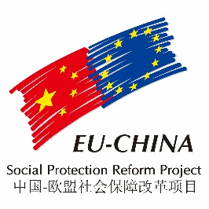
COMPONENT TWO – SUMMARY OF 2017 ACTIVITIES

PANEL DISCUSSION MEETINGS
A) An integrated system for the coordinated management of the social assistance system
The first panel was held on 29th August in cooperation with the Dibao Division of the MoF. It was devoted to a theme that is becoming very crucial in a phase in which China is confronting new socioeconomic challenges connected with aging and the entrance in the phase of normal economy: to improve the organizational arrangements of social assistance in order to improve its efficiency.

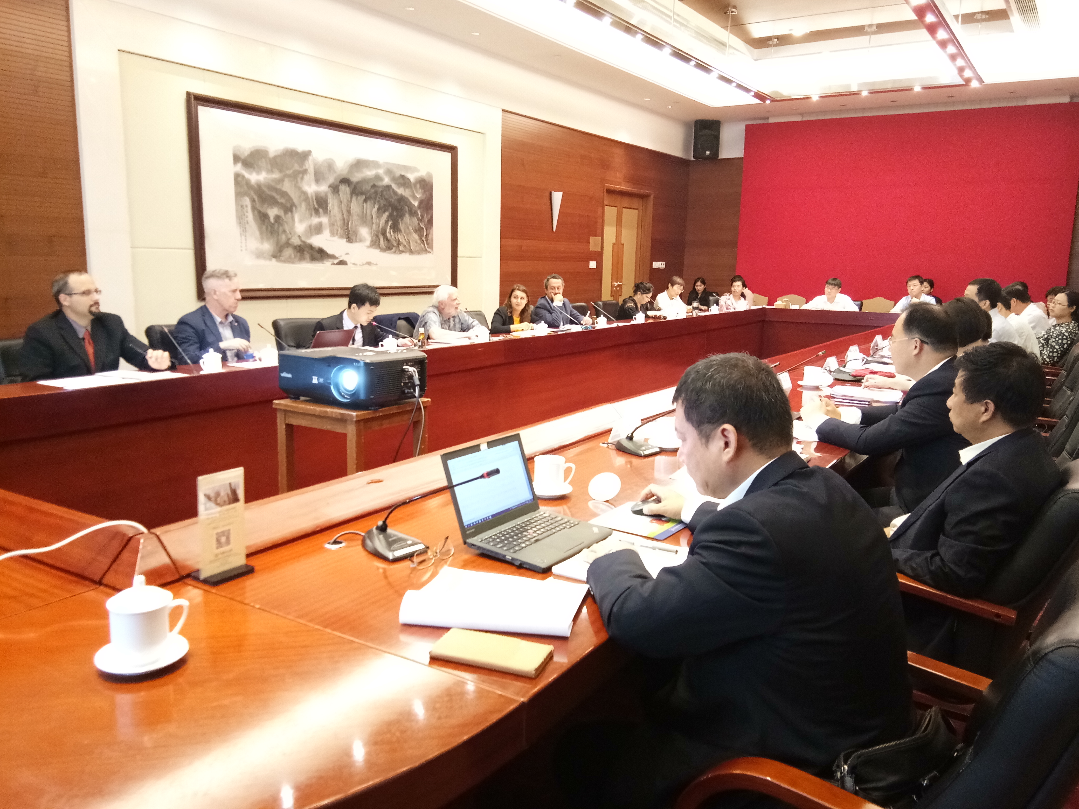
In the morning session, Prof. Jiang Zhen introduced the discussion describing the existing situation and defining the main challenges faced by China in order to build a coordinated system of social assistance. He recalled that the Chinese system evolved in accordance with the establishment and improvement of the socialist market economy and plays the essential role of “safety net” and “shock absorber”. However, the system is still confronted by a series of serious challenges (functional segmentation and dispersion of relief resources, poor coordination between social assistance and poverty alleviation, welfare bundling, insufficient capacity to keep track of the changes of the economic conditions of the beneficiaries, etc.) that need to be confronted as soon as possible, also by taking advantage of local experiences.

China needs to develop a better and more relevant framework of laws and regulations, to coordinate the use of funding, to integrate the management of relevant department as well as key information and eventually improve the allocation of social assistance resources. Prof Jiang Zhen did therefore suggest a series of specific policy suggestions aimed to reach the previous goals.
EU countries have chosen different solution for creating a well-coordinated and efficient system of social assistance. In the second part of the morning session, Mel Cousins outlined the solution proposed by UK, Sweden, and the Netherlands, Pavel Janeček illustrated the Czech Republic model, while Renzo Turatto and Alessandro Longhi introduced the Italian case.

In China decisions are taken at the central level, but historically important suggestions often came from the local level that very often play the role of laboratory and testing ground of new ideas.
For this panel C2 and MoF had therefore decided to devote the afternoon session to the presentation of relevant initiatives taken by the provinces of Hebei, Shandong and Hanui in order to effectively improve the management of the local Social assistance system. The presentations were represented respectively by Wenzhou Liu, Wei Song and Meimei Sun.

The panel was attended by around 25 participants, including representatives from Dibao and Actuarial Divisions of the Ministry of Finance, China International Economic Exchange Center, National School of Administration, Chinese Academy of Social Sciences, the EU Delegation to China and Mongolia, and the UK Embassy.

B) The development of Long Term Care system and old age services
The second panel was held just a few days later, on 5th September 2017, in cooperation with the Medical Insurance Division and Veteran Benefit Division of the Ministry of Finance. The Division Director Mr. Jiang Yu chaired the meeting.

The first paper covering the Chinese context, illustrating the main challenges and proposing a first set of policy suggestions was delivered by Prof. Tang Jun. Prof. Tang Jun started his presentation outlining the main characteristics of the aging process that is affecting China and that, according to the last Chinese forecasts, is expected to accelerate in the near future; in his opinion, the aging process is irreversible, but its consequences will not be so dramatic as sustained by Chinese media and some foreign researchers.

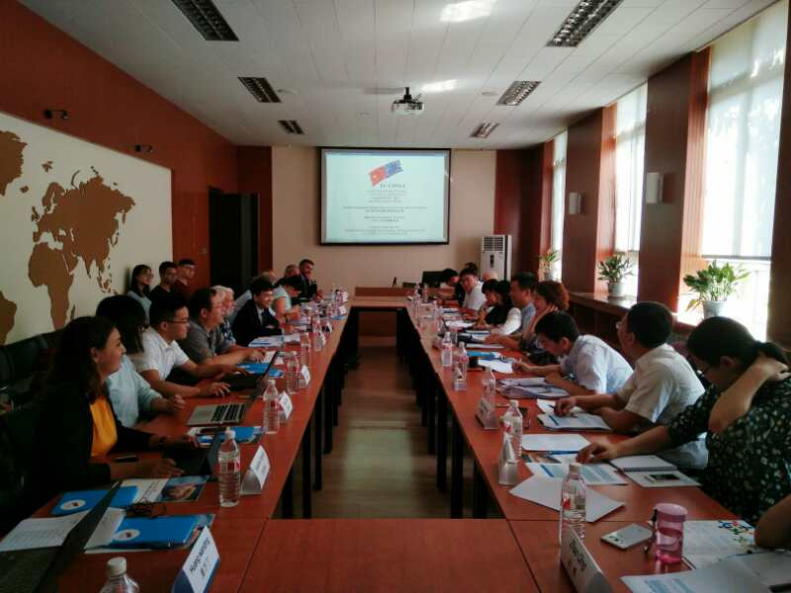
The second part of the presentation was devoted to define LTC and old age services as well as the concepts of successful aging, healthy aging, and active aging. Learning from the experiences of more developed countries Prof Tang Jun stressed that LTC should adhere to the three principles of “continuity, self-decision, and autonomy, and include daily life assistance, medical care, nursing and rehabilitation. As a consequence of their different socioeconomic developments, historical and cultural traditions different countries adopt different models of LTC.
From the financing perspective, we can distinguish between welfare models, financed by taxes, and insurance models financed by insurance premiums. A mixed model, financed by both insurance contribution and tax, and administered by local governments has been adopted by Japan. Prof Tang Jun did then suggest that: LTC insurance should be an independent social insurance program, separated from medical insurance; should cover both daily life needs and rehabilitation, initially should target only the function-reduced old people.
There is no doubt that during the 12th Five-Year Plan, the problem of LTC and old-age services had made great progress and more importantly a general consensus has been reached on developing an old-age service system based on home care, supported by community care and supplemented by institutional care. It must however be recognized that some wrong choices have been made like putting attention on increasing the number of beds but not to their effective use, considering more the potential demand than the effective demand, while the large amount of legislation that has been enacted has however missed some key points.

Finally, starting from the proposal of Xi Jinping to "implement policies to support the development of old-age services", and establish “a long-term care system that articulates relevant insurance, welfare and social assistance schemes” Prof Tang Jun started to outline some policies proposal that will be formalized, in cooperation with the EU experts and the C2 RE and presented in the workshop to be held in January.

The rest of the meeting was devoted to the EU experiences. The first intervention was made by Marcello Morciano that provided an overview of EU LTC. After presenting the future trends in the demand for care and support for older people in Europe, he examined the coverage of publicly funded LTC, its intensity and the range of options adopted by EU member states in the financing, management and organization of their LTC programmes. Then he summed up the differences by defining five different clusters of EU countries. He concluded his intervention by outlining the main challenges that the European LTC systems face, the recent reforms implemented and the current policy debate in a broad range of EU member states.

Building on the general framework presented by Morciano, Jean-Yves Hocquet presented the French system, Renzo Turatto the Italian system, while Michele Bruni illustrated the German model on the basis of a paper written by Monica Gabanyi, who could not attend the seminar. Also the second panel was attended by around 30 participants, including representatives from the Medical Insurance Division, the Veteran Benefit Division and the Actuarial Division of the MoF, the Chinese Academy of Social Sciences, the Renmin and Wuhan Universities, the Italian Embassy.

TRAINING COURSE- FRANCE “Social Security in an Ageing Society: EU Practices Responding to the Demographic Challenge”

The training program was held in France from 10th to 24th September 2017, the first 10 days in Paris and the last three in Marseille. The course was attended by fourteen officials from the Social Security department of the Chinese Ministry of Finance (three from the central government and eleven from provincial offices). The delegation was led by Mr. Fu Jinling, Deputy Director-General of the Social Security department of the Ministry of Finance.

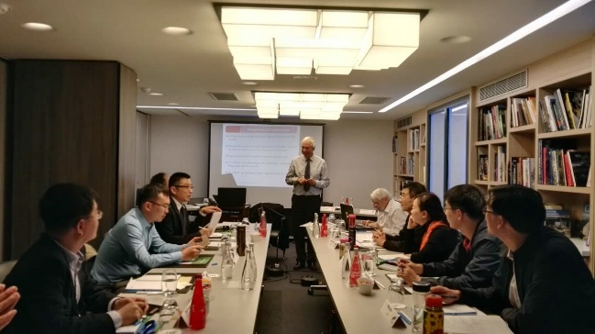
The training was organized in strict cooperation by ty the Italian Institute of Social Protection (INPS), the Italian National School of Administration (SNA), the C2 Beijing office, with the logistic support of Expertise France and SISPI Italia Previdenza.

The content of the course was in line with the policy priorities of the Chinese Government, which is currently trying to cope with the rapid ageing of the population and to define adequate policies in the social protection field.
The main objectives of the course were: 1) the assessment of the European situation on structural problems such as population ageing, on the sustainability of public pensions and health care vis-à-vis ageing, and on long-term care; 2) the analysis of the EU member countries policy responses to the impact of population dynamics on pension systems, healthcare and long-term care, including the role of financial markets; 3) to discuss and deepen the understanding of the main lessons coming from EU experiences on the interplay between ageing and societies’ well-being 4) to draw, when possible, comparisons between the European and the Chinese situations and derive suggestions that could inspire the Ministry of Finance to design and propose effective new policy measures.
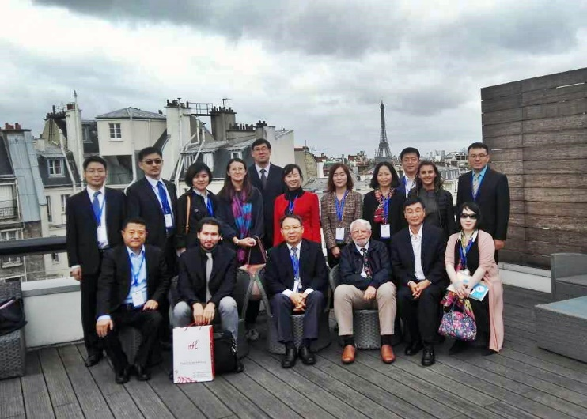
Coherently the broad program of the training included four main parts. The first was devoted to the demographic trends in EU and China and their impact on the sustainability of the pension, healthcare and long-term care systems. The second mainly focused on the financial management of pension funds, investment strategies, risk control methodologies, and the role of private pensions to guarantee the financial sustainability of the pension system in aging societies. The third analyzed the Long-term care systems of some EU member countries as well as their financial sustainability; it did also focus on the relevance of technology and information platforms, while discussing the relative role of the public sector and of the market, including the third sector. Local experiences were at the center of the fourth part of the training program in which public officials of the regional administration of Lazio (Italy) and of the municipality of Marseille (France) presented their experiences in providing and managing services for the elderly and disabled people.

Overall, more than 25 international experts (academicians and public officials) from Italy, France, Germany, the Czech Republic and UK were engaged in the training that included both lectures and visits to leading institutions involved in social assistance. In each occasion, the trainees had the time to engage in lively debates that did guarantee a better understanding of the EU experiences, while giving the possibility to appreciate their relevance for the challenges faced by China.

