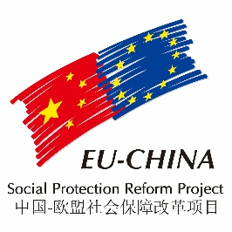
COMPONENT TWO – SUMMARY OF 2018 ACTIVITIES

WORKSHOP on 2017 TOPICS
On 26-27th February 2018, the EU-China Social Protection Reform Project- Component 2 held a Workshop in cooperation with the Social Security Department of the MoF on the three topics studied in 2017, namely: “Investment strategies of social funds and risk control methodologies”; “An integrated system for the coordinated management of the social assistance system”; and “The Development of Old Age Services and Long-Term Care System”.
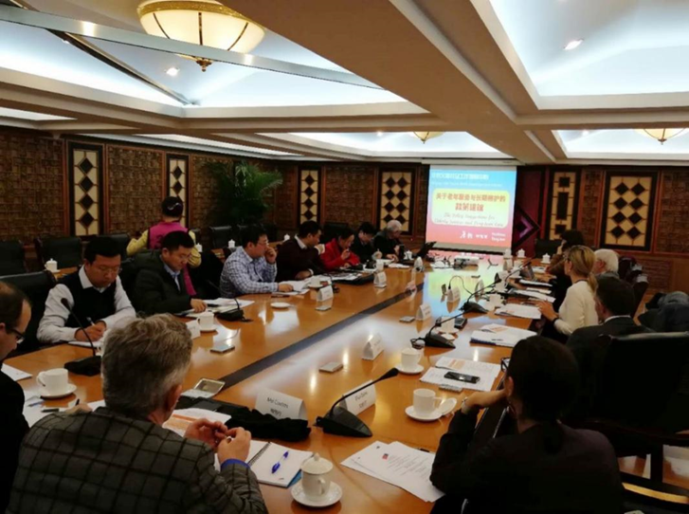
During the Workshop, organized in three half-day sessions, Chinese and European experts presented the policy suggestions elaborated after the panel discussions held in August and September. The proposals were discussed by EU and Chinese guests, who contributed with additional insights and personal experiences. Overall, the Workshop was attended by around 40 participants, including representatives from the Ministry of Finance (Actuarial Division, Dibao Division, General Office, Medical Insurance Division, Veteran Benefit Division), from the academia (Chinese Academy of Social Sciences, Renmin University, China University of Political Science and Law, University of International Business and Economics, Chinese Academy of Governance, Beijing Normal University, China Center for Scientific Research on Aging), from the European Delegation to China, the Italian Embassy, Generali Group, and the project team. The policy proposals presented and discussed at the Workshop were formalized in a document submitted to the Ministry of Finance.

PANEL DISCUSSION on 2018 TOPICS
On 14-15th June 2018, the EU-China Social Protection Reform Project- Component 2 held a Panel Discussion in cooperation with the Social Security Department of MoF on the three topics that are object of the 2018 activity plan, namely: “Alternative policy measures to cope with the impact of ageing on the financial sustainability of the social security system”; “Social contribution collections: toward a unified system”; “The role of public finance and enterprise annuities funds in the Chinese social security system”.

During the Panel discussion, organized in three half-day sessions, Chinese and European experts presented the assessment of the Chinese situation and EU practices on the respective fields. The discussion sessions involved MoF officials, EU and Chinese experts and scholars, allowing broad and lively exchanges among all the participants.

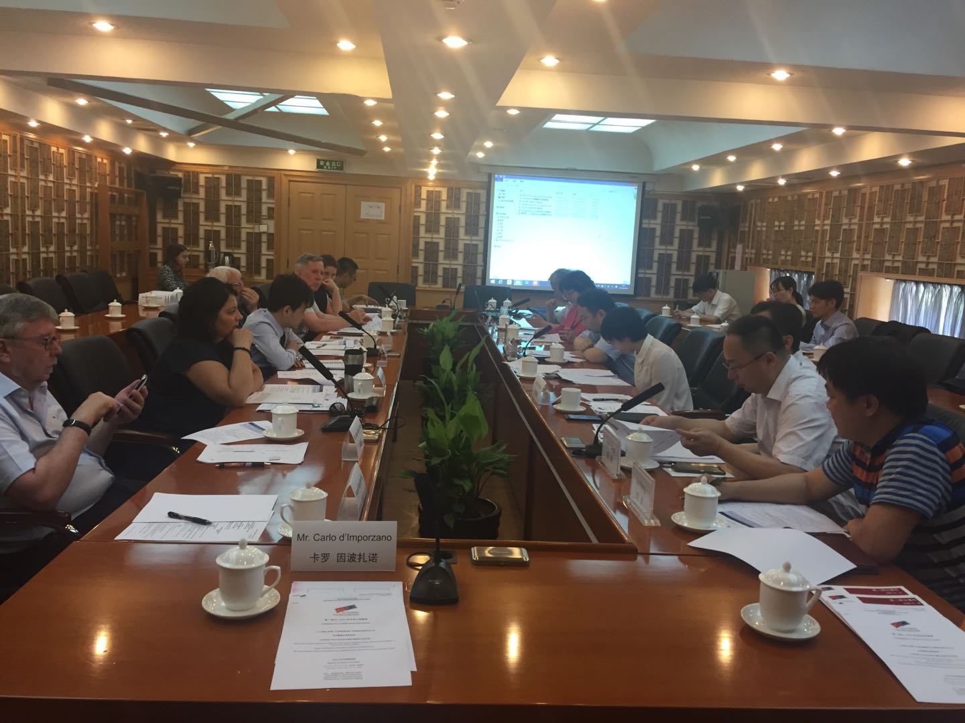
In the next phase, the in depth analyses will lead to the elaboration of policy proposals by EU and Chinese experts, to be finally delivered to the MoF. Overall, the Panel was attended by around 25 participants, including representatives from the Ministry of Finance, from the academia (Renmin University, Chinese Academy of Social Sciences, Capital Normal University, China University of Political Science and Law), from the Ministry of Labour and Social Affairs of the Czech Republic, the Italian Embassy to China, Generali Group, and the project team.

MoF TRAINING COURSE IN ITALY
As part of the EU-China Social Protection Reform Project Component 2 work plan for the year 2018, a delegation of 18 MoF national and provincial officials, led by Mr. Wang Xiong, Division Director of the Urban and Rural Minimum Income Benefit Division, Department of Social Security, undertook a two weeks training in Italy (first in Rome and then in Milan) from 1st to 15th July 2018.

The general aim of the course was to increase the participants’ knowledge and understanding of the EU practices in the areas covered by the Social Protection Reform Project, as well as their skills in designing and implementing social protection policies.

The training programme, titled “Financing the social security system in an ageing society: the role of public finance and private supplementary funds”, was organized by the C2 Beijing team, the Italian Institute of Social Protection (INPS) and the National School of Public Administration (SNA), with the logistic and administrative support of SISPI Italia Previdenza (C2 Secretariat).
The lectures were delivered by around 30 experts coming from Italy and other EU countries. The first group of lectures was devoted to the analysis of the social protection system in Italy and other EU countries, of their evolution in response to the ongoing ageing process, as well as of the various financing models and contribution collections methodologies.

A full day was dedicated to the theme of active labor market policies, welfare policies and the role of the third sector. The problem of sustainability called for the discussion of the second and third pillars, and of the issue of fund portfolio management.

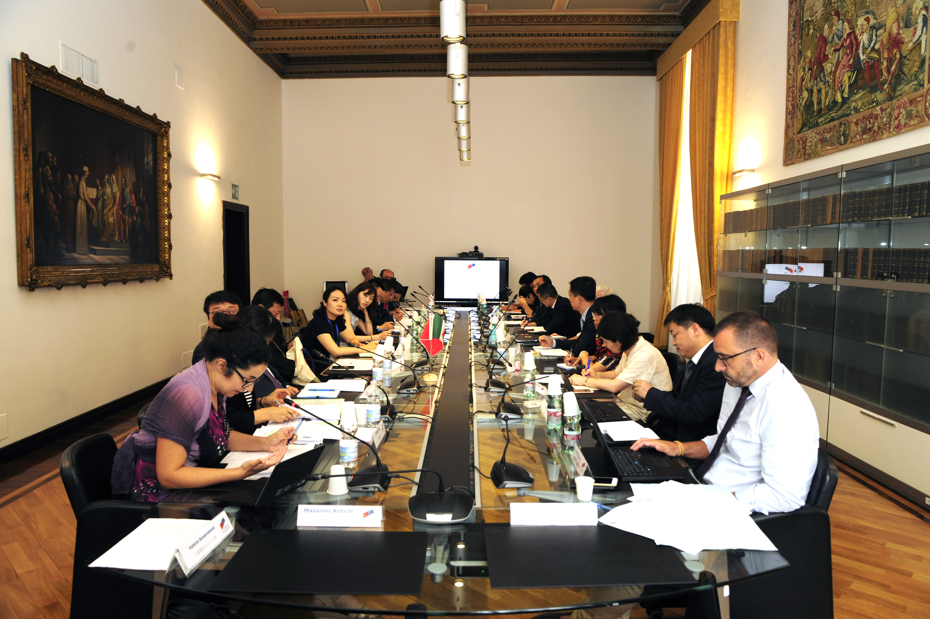
The ageing process in China will progressively accelerate in the next years and the Long Term Care experiences of EU countries, more advanced along the path of the demographic transition, were presented in a series of lectures and institutional visits that addressed also the topics of technology, occupations and training.

Visits to institutions and local organizations played a very important role in the training, allowing the trainees to increase their specific skills by discussing with their colleagues of Italian institutions work procedures, tools and technology and compare the solutions adopted in the two countries. The trainees visited:
-  The Ministry of Economy and Finance, where they received an overview of the role of the public finance in subsidizing the social security system in an ageing society;
-  The Bank of Italy to analyze the financing mechanism of the pension system;
-  The Caritas (NGO), where they learned about the role of the third sector in the provision of elderly care services;
-  The Ministry of Health to learn about the Italian National Health Service and the role of the Ministry of Health, as well as the National Chronicity Plan;
-  INPS territorial headquarter in Milan, where they had the possibility to explore the functioning and organization of a provincial office, as well as to witness the way the relationship with the central directorate and customer service are dealt with;
-  The Municipality of Milan, where they received an overview of the role of public administrations in the management of the elderly care services;
-  The Institute for the Elderly “Piero Redaelli” to analyze the practices of formal LTC.

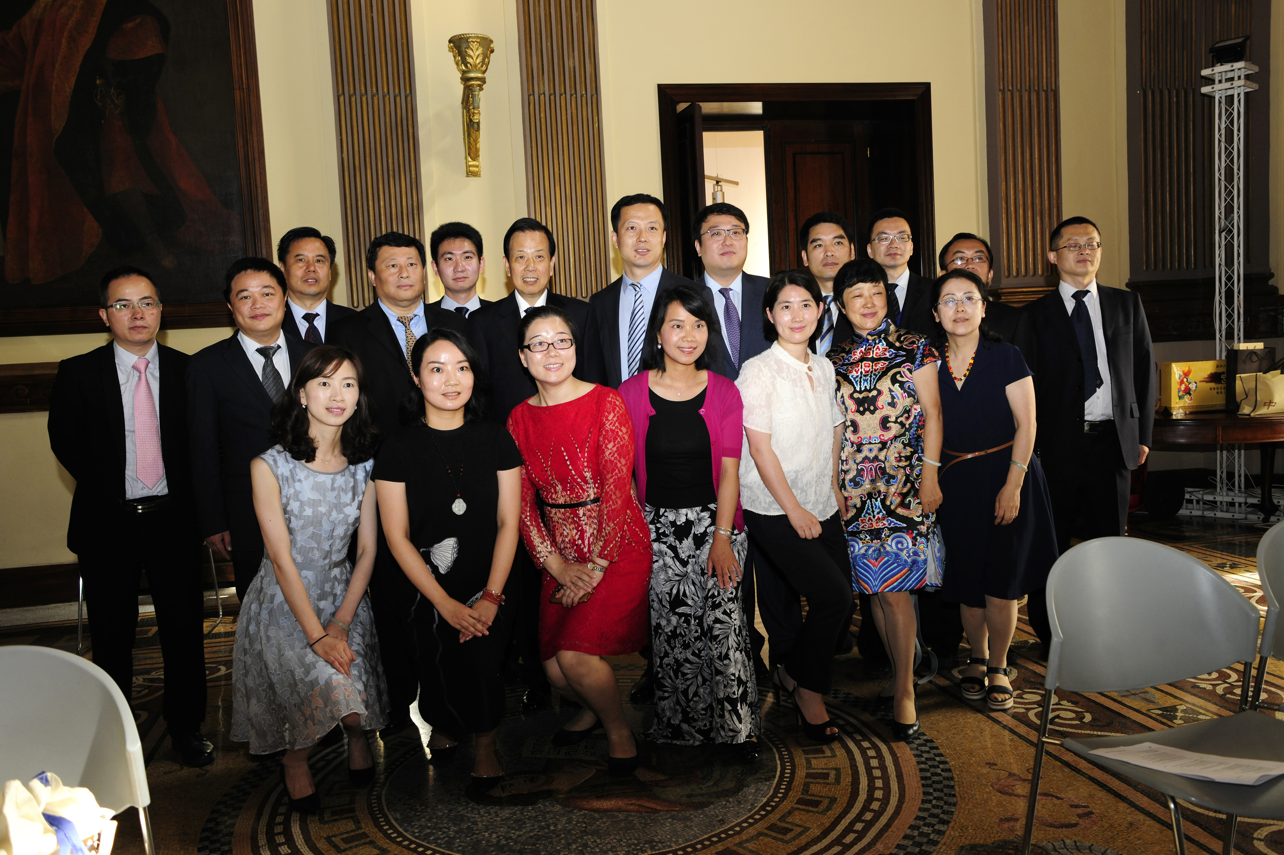

EU-China SPRP Conference on Population Ageing: Impact and Policy Scenarios
On September 19, 2018, the EU-China Social Protection Reform Project (SPRP) held a conference on “Population Ageing in China: Impact and Policy Scenarios” which was held at the Kuntai Royal Hotel, in Beijing.

The conference was organized on the occasion of the 2018 International Day of Older Persons, which is commemorated annually on 1st October, to highlight the important role that older persons play in society and raise awareness of the issues and challenges of ageing, which are common both to China and Europe.

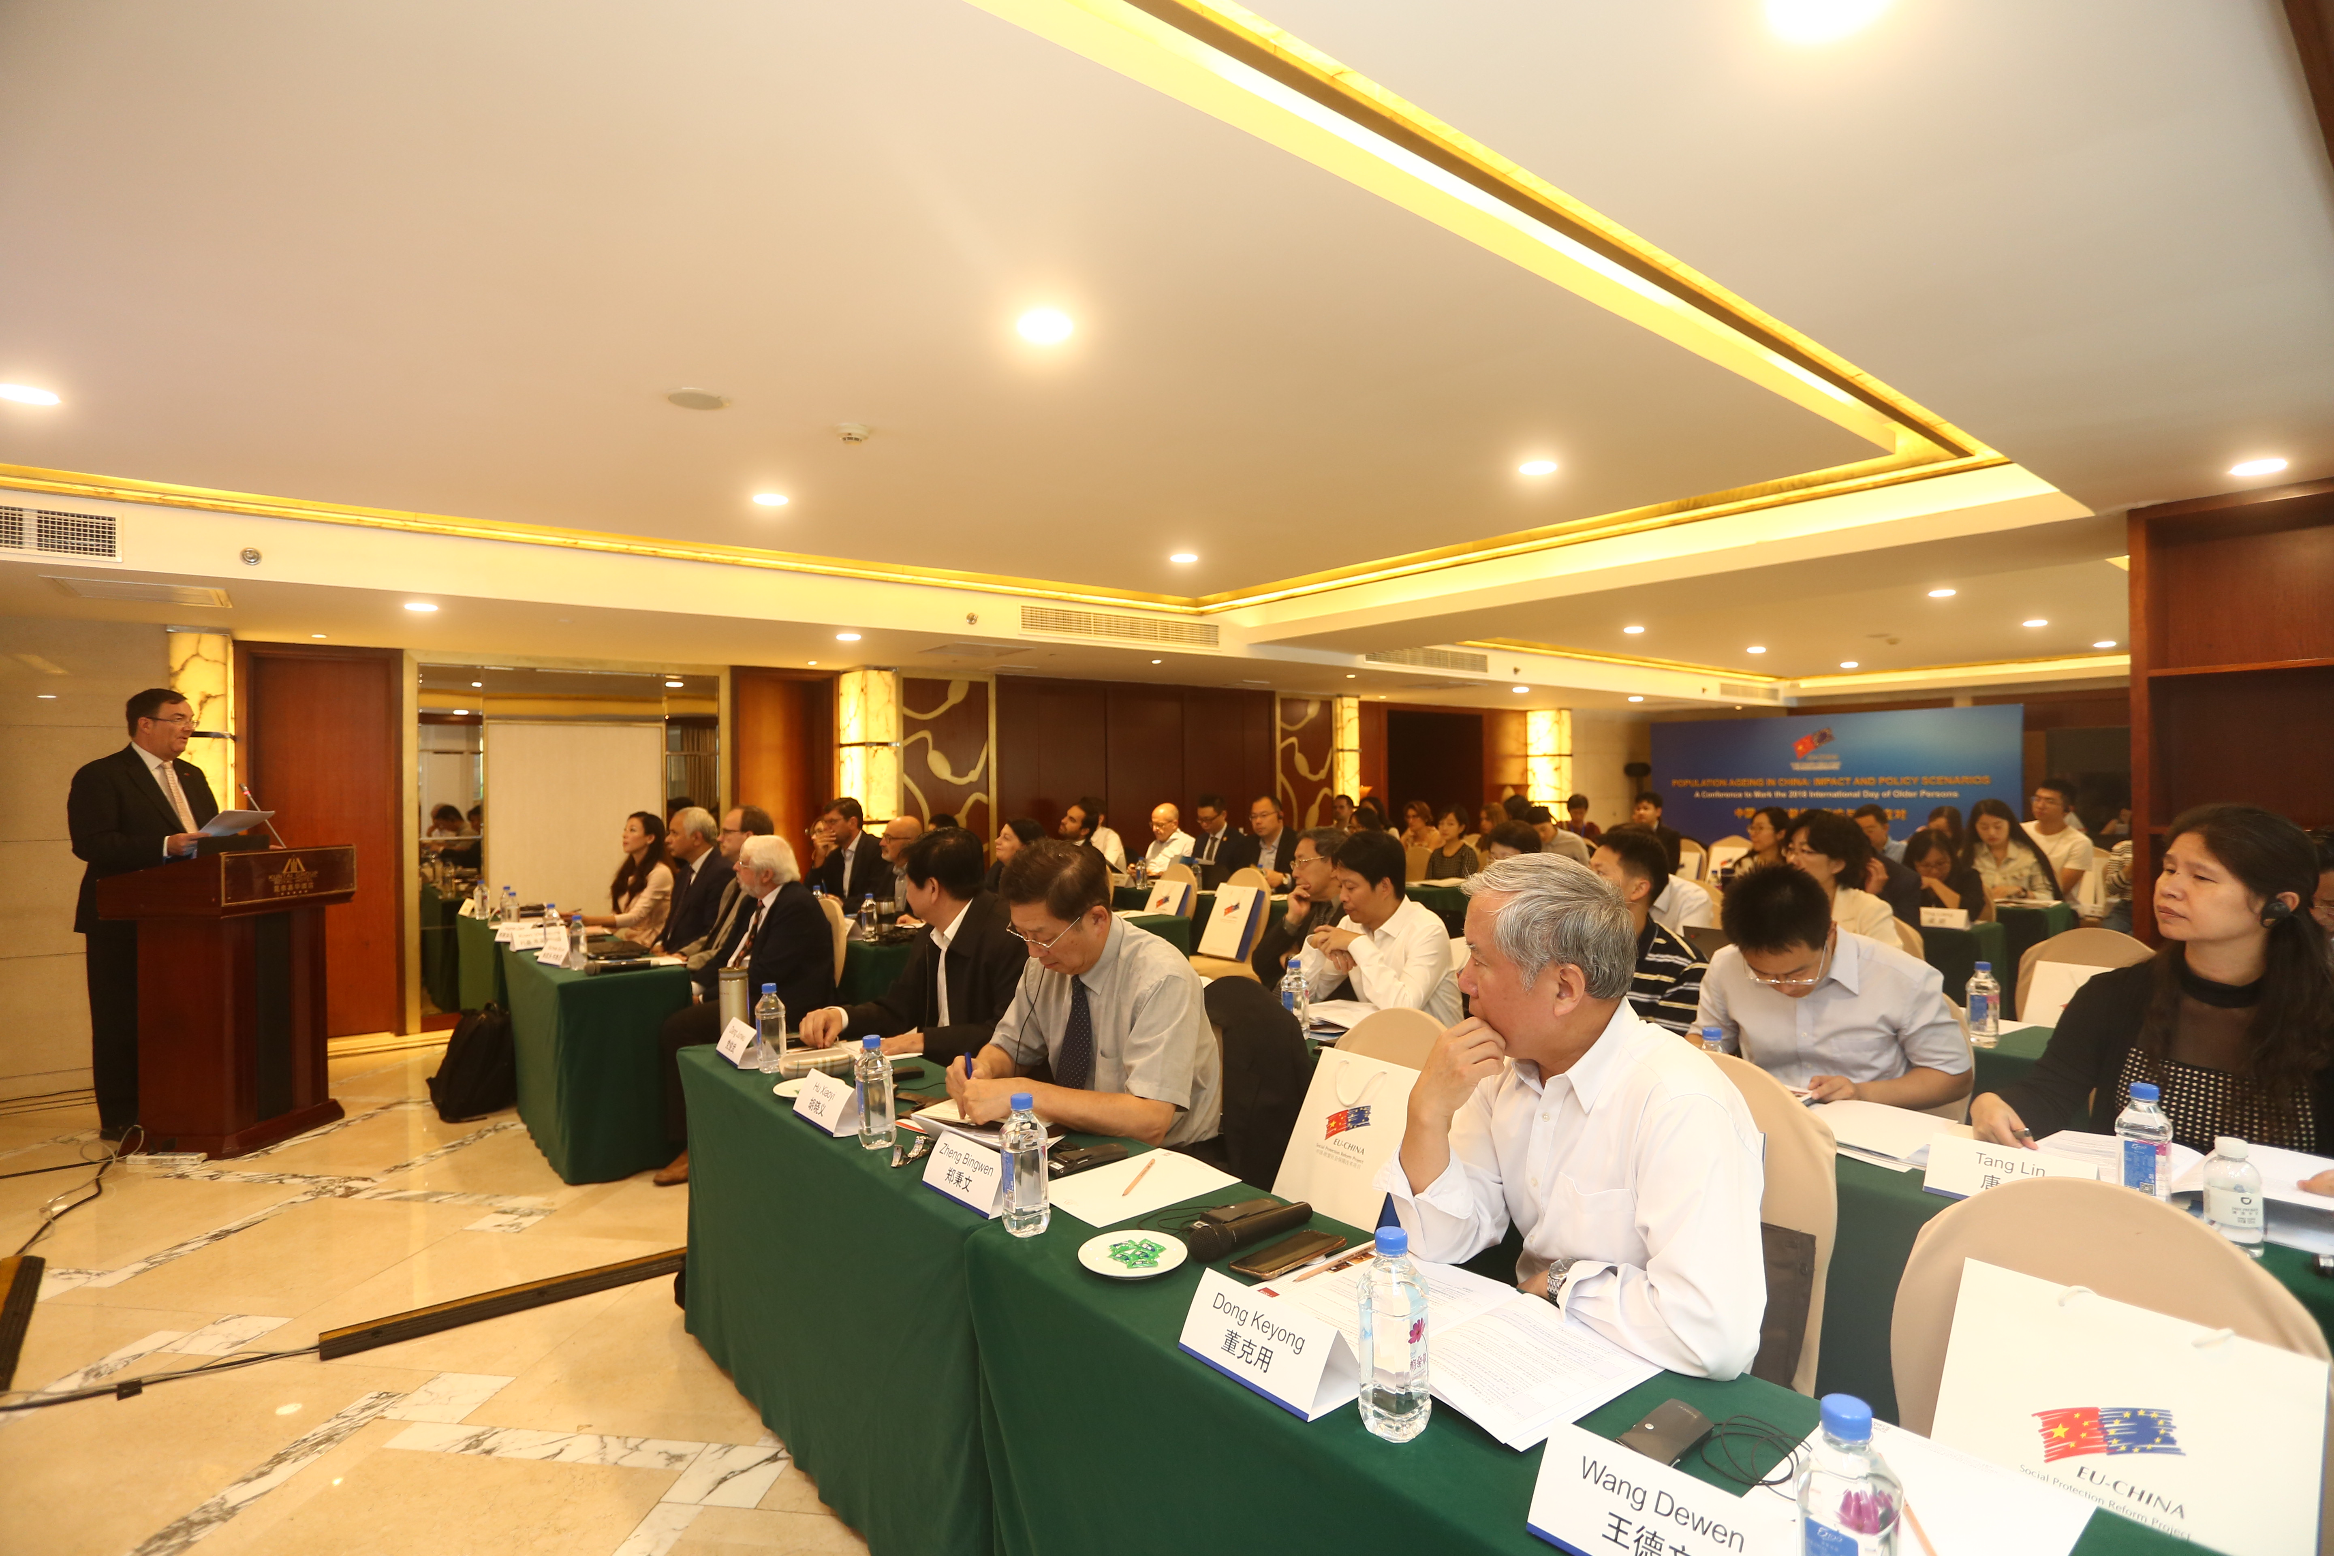
Mr. Chris Wood, Minister and Deputy Head of Delegation of the European Union to China, Mr. Dang Junwu, Deputy Director of the China Center for Scientific Research on Ageing, and Prof. Michele Bruni, Team Leader of the EU-China SPRP opened the conference. Over 60 participants attended the event, representing Chinese government agencies - National Development Reform Commission, Ministry of Finance, Ministry of Civil affairs, China Social Insurance Association, China Population and Development Research Center -, as well a civil society, international organizations, EU member state embassies and academia.
Among the speakers, renowned experts such as Prof. Zheng Bingwen (CASS), Mr. Wang Dewen (World Bank), Prof. Asghar Zaidi (Seoul National University, London School of Economics) and many others discussed a series of topics and research results obtained by the EU-China SPRP, including: evaluations of the ageing process and its economic impact; the sustainability of the Chinese pension system and the role of the enterprise annuity funds in creating a multi-pillar system; how to improve elderly care services and education and vocational training implications created by the fast expansion of the long-term care system.

The Conference also produced a set of policy suggestions that attracted the attention of institutions and media present at the event.
