WHO IS WHO – COMPONENT ONE
MAIN CHINESE PARTNER: The National Development Reform Commission NDRC
C1 PROJECT LEADERS FOR NDRC:
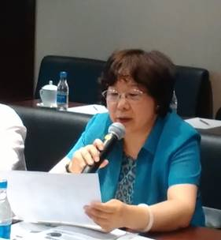
Ms. Ji Ning, Counselor, Department of Employment and Income Distribution (2015-2016)
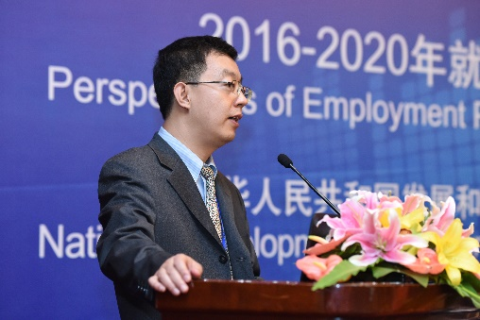
Mr Pu Yufei, Director General, Employment and Income Distribution Department (2016-2017)
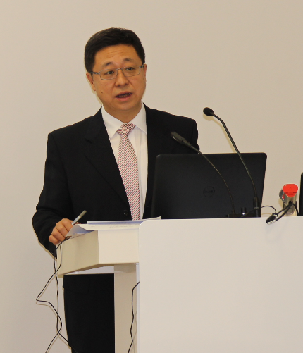
Mr Li Kang, Director General, Employment and Income Distribution Department (2017-)
PROJECT C1 COORDINATORS FOR NDRC:
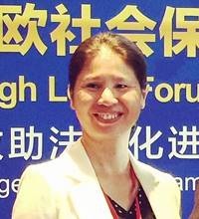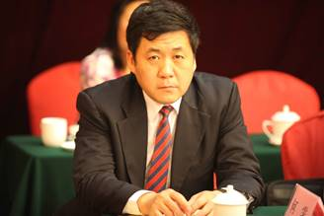
Ms. Tang Ling Employment & Income distribution Department and Mr. Chang Hao , NDRC International cooperation Centre

C1 COMPONENT COORDINATOR: EXPERTISE FRANCE (formerly ADECRI)
Mr. Laurent de Lespinay, Component coordinator
THE PROJEC TEAM IN BEIJING
Resident expert Mr. Jean-Victor Gruat;
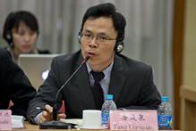
Main Chinese expert Operations; Main Chinese expert Research
Mr Zhang Guoqing Mr Fang Lianquan

Component assistants:
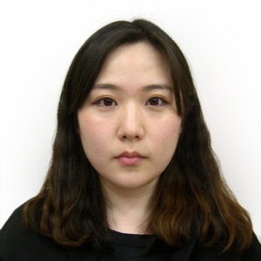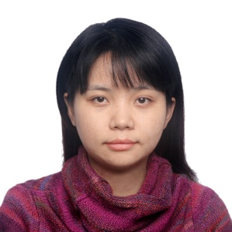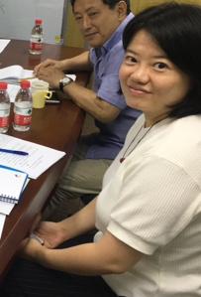
Wang Qingqing (2015) Xu Chenjia (2016) Li Lingxi (2017) Shi Chuan (2018)

