Recent reforms of the Czech pension system
捷克养老金制度近期改革
Introduction引言
The Czech pension system is characterized by high dependence on 1st pillar pension which represents around 95 % of old age people income. Supplementary schemes have not been well developed yet and play only a very limited role. Therefore, the pension reform, from the Czech perspective, is mostly parametric reform measures of the 1st pillar with only a few attempts of paradigmatic changes.
捷克养老金制度的特点是高度依赖第一支柱养老金，第一支柱养老金占老年人口收入的95% 左右。补充养老金计划尚未发展成熟，发挥的作用也非常有限。因此，就捷克的情况而言，养老金改革主要聚焦第一支柱的指数化改革，模式变革只进行少数尝试。

The pension reform is a continuous process that was started at the beginning of 1990’s hand in hand with the transformation from centrally planned to market based economy. Almost all governments have had the pension reform measures on their agendas since then. Firstly as a part of general social reform adapting social system to new economic circumstances culminated by adopting the New Pension Act in 1995.
养老金改革是一个持续进行的过程。养老金改革进程始于1990年初，同时期捷克经济模式正从中央计划经济向市场经济转型。从那时起，几乎各级政府都将养老金改革措施纳入工作日程。1995年捷克颁布了新养老金法案。为使社会发展适应新的经济环境，捷克进行了全面的社会改革，养老金改革是其中的一个部分。

Further reform measures have been driven mainly the population ageing phenomenon, characterized by the increase of the proportion of people in higher age groups (the old and the oldest old), which is a world-wide phenomenon impacting mainly pension, health and long term care schemes especially highly developed social schemes in European countries.
在人口老龄化问题的推动下，捷克出台了进一步改革的措施。捷克老龄化现象的特点是，高年龄群体（老年人和高龄老年人）占总人口的比例不断攀升，这是全世界范围的普遍情况。养老金改革主要影响了养老金、医疗健康和长期照料机制，特别是欧洲国家高度发达的社会机制。
It means that 2008 and 2011 pension reforms describe in this text, do not stand alone, but they a part of ongoing process and it should be looked at them from this point of view.
这意味着，2008年和2011年的养老金改革是在这种社会背景下进行的，而非孤立存在的。我们应将养老金改革视为持续的过程。

2008 Reform
2008年的改革

The need for parametric reforms of the Czech pension system, which was introduced in 1995, started to grow within the public debate in the late 1990s. Between 1999 and 2002 two separate committees of the Parliament, one in the Senate and the other in the Chamber of Deputies, discussed the further course of pension reform. The projections of the pension system at this time indicated a highly unsustainable long-term trajectory of pension expenditure, with the overall balance of the pension system dropping to negative 4 % GDP by 2050.
20世纪90年代末期，需要对捷克养老金制度进行指数化改革的声音开始在公开讨论中蔓延。指数化改革于1995年正式开始。1999年至2002年期间，议会的两个独立委员会，参议院和众议院，对养老金改革的进程进行了进一步讨论。目前对养老金制度的预测表明，养老金支出的发展很大程度上不可持续，养老金制度的整体收支平衡点到2050年会降至GDP的-4%。

The situation culminated in 2004 when the Team of Experts was established by mutual agreement and membership of political parties represented in the Chamber of Deputies, supported by the Executive Team. The Executive Team was an independent body consisting of representatives of public administration (mainly the Ministry of Labour and Social Affairs, Ministry of Finance and the Czech National Bank) that was tasked by the Team of Experts with performing a thorough analysis of the current state of the pension system, its development trends and assessing the reform proposals of the political parties. The Executive Team finished its work in June 2005 by publishing its Final Report.
2004年，改革发展达到高潮。通过共同协议捷克成立了专家团队，成员包括众议院中各政党的代表，管理团队对其予以支持。管理团队是由公共行政部门（主要是劳工和社会事务部、财政部和捷克国家银行）的代表组成的独立机构。管理团队由专家团队分派任务，对养老金的运行状态、发展趋势进行深入分析，并对各政党提出的改革提案进行评估。管理团队在2005年6月完成工作，并发布了总结报告。

Based on the Final Report and further discussion in the Team of Experts the political parties were supposed to agree on a Proposal on Agreement on the Basic Principles of further Pension Reform. Unfortunately, the document has never been approved and sign by the leaders of the political parties. Nevertheless, the new government in 2008 followed the findings of the Executive Team proposed a significant parametric reform, which was subsequently adopted by the Parliament. The main goal of the reform was to enhance long-term sustainability of the pension scheme.
基于总结报告和专家团队的深入讨论，各政党应就深化养老金改革的基本原则达成一致意见，并形成协议。遗憾的是，这份文件从未获得批准，也未获得各政党的领导者的签署。然而，2008年新上台的政府根据管理团队的调查结果提出了一项重大的养老金指数化改革，之后这项提议在议会获得通过。改革的主要目标是提高养老金计划的长期可持续性。

The pension reform made numerous changes to the pension scheme. Firstly a previously started process of gradual increase in the retirement age was prolonged3. The statutory retirement age was set to increase to 65 years of age for men and to 62 – 64 years of age for women based on the number of children they have raised. The retirement age was to be increased, at the same pace as already legislated, by two months per year for men and by four months per year for women until the final values will have been reached in 2030. Details on the retirement age increase schedule prior and after the reform can be found in Annex 1.
养老金改革给养老金制度带来了巨大的变化。首先，退休年龄逐步提高这一进程早已启动，时间将进一步延长。法定退休年龄将提高，根据抚养子女的数量，男性法定退休年龄将延长到65岁，女性是62-64岁。退休年龄的增加跟法律确定的提高
速度一致，男性每年延长两个月，女性每年延长四月，直到达到2030年的最终值。有关提高退休年龄的详情请参阅附件1。

In addition to the changes to the statutory retirement age the old-age pension qualifying condition of minimum required period of insurance was tightened. The minimum insurance period was increased from 25 years prior to the reform to 35 years. In order to ensure a smooth transition and to minimize the potential negative impact on workers moving to retirement, this increase was also implemented gradually, starting in 2010 and reaching the final 35 years of insurance in 2018.
除了法定退休年龄变化以外，获得养老金所需的最低投保期限进一步加严。最低投保期限从改革前的25年增加到了35年。为了确保顺利过渡，并尽量减少对即将退休的劳动者产生潜在不利影响，最低投保期限的延长将从2010年开始逐步实施，并在2018年达到最终确定的35年的投保要求。

Further changes were adopted in the field of credited non-contributory periods. Periods of studies acquired after 2009 stopped being treated as non-contributory periods of insurance. While these periods no longer increase the overall insured period they have kept their status of excluded periods and therefore they do not lower the calculation base of the pension.
可获得补助的非缴费期方面也进行了变革。2009年之后，受教育的时期不再被计入非缴费投保期。尽管如此，受教育时间作为排除时期，不会降低养老金的计算基数。

Additionally, the extent to which the non-contributory periods are taken into account for minimum required insurance period qualifying condition was reduced from 100 % to 80 % similarly as for already legislated pension amount calculation. That means that for 5 years of being in a state that constitutes a non-contributory period only 4 years are credited. This change does not apply to periods of child care and compulsory military service.
此外，在规定的最低保险期限条件下，非缴费期的权重从100%降至80%，类似于已列入法律的养老金金额。这意味着， 5年非缴费期中只有4年可被补助。这种变革不适用于照料子女和服义务兵役的时期。

Further changes were made with regard to flexibility of old-age pension take up and work activity after retirement. Newly, the periods of concurrence of economic activity and pension payment grant a slight yearly increase in the paid out pension equal to 0,4 % of the calculation base and a possibility to combine half the old-age pension with economic activity was allowed. In the latter case the pension is increased by 1,5 % of the calculation base for every 180 days of such concurrence.
捷克还变革了提取养老金的灵活性和退休后的工作等事项。改革后，如果经济活动和养老金给付时期有所重合，支付的年度养老金有轻微增加，增幅相当于计算基数的0.4%，并且还有可能将一半的养老金和经济活动联系起来。在后面一种情况，每存在180天的重合期，养老金的计算基数将增加1.5%。

Moreover, new rules of early pension were adopted. The period in which an early pension can be drawn was extended from 3 to 5 years with the condition that pension cannot be granted earlier than 3 years before reaching statutory retirement age at an age lower than 60. Therefore the change will have come into power gradually, since the retirement age for men will not have reached more than 63 years until 2017 and for women the necessary age would be reached even later. The penalties for early pension were also overhauled. For every 90 day period within the first 720 days of early pension the pension is reduced by 0,9 % of the calculation base and for each 90 days period which occur earlier than 720 days prior to retirement the reduction equals to 1,5 % of the calculation base.
此外，提前领取养老金采用了新的规则。可以提早领取养老金的期限由3年延长至5年，条件是早于法定退休年龄三年以上进行给付，且投保人的年龄应低于60岁。变革措施逐渐发挥作用，原因是是男性退休年龄直到2017年才能达到63岁，女性退休年龄达到预期年龄的时间更晚。提前领取退休金的削减措施也有较大变化。提前领取退休金的头720天，每90天养老金金额将以计算基数为基础减少0.9%。在退休前，每90天早于退休年龄前720天，养老金金额将以计算基数为基础将减少1.5%。

Last but not least, a new system of disability classification was introduced, changing the older system of partial and full disability which had been granted if the ability to perform economic activity declined by at least 33 % and 66 % respectively to a system that recognizes only one disability with 3 degrees with 35 %, 50 % and 70 % reductions in ability to perform economic activity. The first and second degree disability replaced the former partial disability, while reducing the benefits the first degree disability from 0,75 % to 0,5 % of the calculation base for each full year of insurance. For the second degree disability the pension level stayed unchanged (equal to previous partial disability pension level). The former full disability pensions were transformed to third degree disability pensions and the benefits remained the same at 1,5 % of calculation base per year of insurance. In addition to that, disability pensions of people reaching 65 years of age (or statutory retirement age if it is higher than 65 years) are transformed to old age pension (the level of pension is maintained) and all disability pension older than 65 years were transformed to the old age as well.
最后一项变革也同样重要，即采用新的残疾分类系统，改变了过去将残疾分为部分伤残和完全伤残的方式。如果正常参与经济活动的能力下降了33 %和66 %以上，那么系统将把伤残程度分别地列为三个等级，在参与经济活动的能力分别下降35 %、50 %和70 %。第一级和第二级伤残取代了此前的部分伤残，对一级伤残福利从全年保险基数的0.75 %减少为0.5 %。对于二级伤残而言，抚恤金水平不变化（等于之前的部分伤残抚恤金水平）。此前的完全伤残的抚恤金转化为三级伤残抚恤金，收益维持在每年保险基数的1.5%。除此之外，达到65岁的领取残疾抚恤金的群体（或者如果年龄高于65岁，达到法定退休年龄的群体）转化为养老金（养老金水平维持不变），年龄超过65岁群体的所有的残疾抚恤金也都转化为养老金。

2011 Reform
2011年的改革

The 2011 pension reform was mainly brought about by the Constitutional Court ruling of 2010. Based on a legal action of a former high income citizen whose income was replaced by a pension that constituted less than 20 % of his previous income, the Constitutional Court had invalidated the pension calculation formula. The ruling was to come into power in September 2011 and a new calculation formula had to be adopted prior to this date.
2011年的养老金改革主要是由2010年的宪法法院裁决触发的。有一项关于退休前收入很高的公民的法律诉讼，高收入公民的收入被养老金替代后，养老金不足退休前收入的20%。基于这起诉讼，宪法法院已使养老金计算公式失效。这项裁决将于2011年9月生效，在这个日期之前必须制定新的计算公式。

In addition the financial crisis of 2008 and the following economic downturn had aggravated the sustainability prospects of the Czech pension scheme. As austerity measures became paramount, additional changes to the pension scheme were proposed and adopted as a part of the reform package of 2011.
2008年的金融危机，以及接踵而来的经济低迷使捷克养老金计划的可持续发展前景进一步恶化。紧缩措施变得极为重要。作为2011年一揽子改革方案的组成部分，进一步改革养老金计划的方案被提出并予以通过。

The first change introduced was reworking the pension calculation formula. The former system of two reduction thresholds was replaced by a system with one threshold and ceiling. Previously earnings up to the first threshold had been taken into account fully (this rule is maintained), 30 % of earnings between the first and second had been included and 10 % of earning above the second threshold. Newly, 26 % of the earnings between the first threshold and ceiling is taken into account. The new pension formula ensures a more adequate replacement rate for mid- and high-earners.
2011年的改革进行的第一项变化是修改养老金计算公式。之前的养老金制度中有两项养老金降低标准。在新的制度中，这两项标准变为了一项标准、一项上限。新制度充分考虑了此前达到第一个标准值的收入（保持这一规则），30%的收入介于第一个和第二个标准值之间，10%的收入超过第二个标准值。新制度还考虑了第一个标准值和上限值之间的26%的收入。新的养老金公式确保中高收入群体有更为充足的养老金替代率。

In addition the Czech government no longer has any leeway in setting the pension system parameters, as the reduction thresholds are specified directly in the Law and are anchored to the national average wage. The first reduction threshold is set as 44 % of the average wage and the second one as 400 % of the average wage which corresponds to the cap on pension insurance contributions. The same stands for other pension system parameters which were newly set as fixed by the Law, namely the Basic Amount of a pension and the pension indexation formula.
此外, 捷克政府在设定养老金制度指数方面不再有任何变动，法律直接规定了养老金降低的标准值，且以全国平均工资为固定标准。第一个降低的门槛值设定为平均工资的44%，第二个降低门槛值是平均工资的400%，相当于养老金保险缴款的上限。其他指数也采用同样的标准，这是法律确定的新标准值，即养老金基数和养老金指数化公式。

Further changes, aimed at promoting financial sustainability of pensions, included another long-term increase of the statutory retirement age. The process of retirement age increasing for women was set to be sped up to 6 months per year (from the former 4 months). The statutory retirement age for men was decreed to increase past 65 years of age and it was set to increase by 2 months per year with no upper limit. The retirement age for women was to gradually reach the retirement age of men and then increase at the same pace. Details on the retirement age increase schedule prior and after the reform can be found in Annex 1.
捷克还进行了其他方面的变革，包括另一项长期提高法定退休年龄的举措，旨在促进养老金的财务可持续发展。提高女性退休年龄的节奏是每年提高6个月（之前是4个月）。法令规定法定男性退休年龄要超过65岁，并且无上限进行提高，每年提高两个月。女性退休年龄将逐渐达到男性的退休年龄后，男女性的退休年龄以同样的速度增长。有关退休年龄提高的详情，请参阅附件1。

Another significant change adopted in 2011 was the extending of the reference period for pension calculation. Previously the pension was calculated based on the average earnings in the period of the last 30 years prior retirement (but not before 1986). Since 2011 the reference period was extended to include the full income history (1986 remains unchanged).
2011年通过的另一项重大改革是延长养老金计算的参考期。以前养老金是根据退休前30年前的平均收入为基数计算的（1986年之前除外）。自2011年以来，参考期范围扩大到所有有收入的时期（1986年不变）。

Also, a minor tweak was made to the penalties for early retirement. Newly, the early pension is reduced by 1,2 % of the calculation base for every 90 day period of early retirement in the period between 360 and 720 days before reaching the statutory retirement age. The remaining penalties have not changed since the 2008 reform. That means that for the first 360 days of early pension the benefit is lowered by 0,9 % of the calculation base for every 90 day period of early retirement, the next 360 days (between 361st do 720th day of early retirement) the benefit is lowered by 1,2 % of the calculation base for every 90 day period of early retirement and for early retirement preceding the 721st day the penalty amounts to 1,5 % of the calculation base for each 90 day period of early retirement.
此外, 还对提前退休的降低作了轻微调整。新的情况是, 在达到法定退休年龄前的360至720天期间, 每提早90天退休，提前退休的养老金计算基数会减少1.2%。自2008改革以来，其他规则并没有改变。这意味着，达到法定退休年龄前的第一个360天，每提早90天退休，提前退休的养老金计算基数会减少0.9%；第二个360天（即第361天到第720天），提前退休的养老金每90天减少1.2%。超过721天的情况下，提前退休的养老金每90天减少1.5%。

Endorsement process
立法进程

Both parametric reforms underwent a standard legislative process. As a first step the reform packages were prepared by the responsible ministries, mainly the Ministry of Labour and Social Affairs. The proposal contained both the necessary legislative changes in the form of proposed amendments to the Pension Act (law No. 155/1995 Coll., on Pension Insurance) and the accompanying documents that contain the analysis and reasons for the proposed changes.
两次指数化改革都经历了标准的立法过程。第一步是，负责的相关政府部门编写改革的一揽子计划，主要是劳动和社会事务部。计划包括以《养恤金法》（关于养老金保险的第155/1995号法律）的修正案形式进行的必要法律法规变化，以及附带文件，包括提议变革的分析和理由。

The proposals were preliminarily discussed by Governmental working group consisting of economic ministers. After these discussions and resulting modifications, the amendment bills were submitted by the ministry to the Government as a whole, which approved the proposal and passed it onto the Chamber of Deputies of the Parliament. During the discussions in the Government, the reform proposal were also discussed on a tripartite basis with representatives of trade unions and employer organizations, as well as on the grounds of the Legislative Council of the Government which is tasked with assessing legislative proposal with regard to their conformity with the existing legal order.
由经济部长组成的政府工作组初步讨论了这些建议。经过讨论和修改后，经济部向政府各部门提交了修正案草案，政府通过了该提案并将其转交议会众议院。在政府的讨论中，改革建议也是在三方的基础上进行，与工会和雇主组织的代表讨论，以政府立法机构为基础，负责评估立法建议是否符合现行的法律秩序。

Afterwards, the proposed bills underwent the legislative process in the Chamber of Deputies, which consists of three readings and including sectional talks in specialized committees that consist of parties political experts on various fields, such as social policy or budgetary policy.
随后，拟议的法案在众议院进入立法程序，其中包括三轮审阅，与会的的包括各政党各领域的政治专家，如社会政策或预算政策，在各专门委员会中进行各部分会谈。

After the Chamber of Deputies approved the proposals, they were passed on to the Senate of the Parliament, which discussed them in a similar, yet slightly more condensed fashion. After the approval of the proposals they were submitted to the President of the Czech Republic for the final signature that precedes the formal endorsement of the proposals.
众议院批准了这些提案之后，提案递交到议会参议院，他们以类似的方式进行讨论，但讨论略微更加紧凑。在提案获得批准之后，提案被提交给捷克共和国总统，以获得正式核准以及最终签署。

The 2008 reform package was approved by the Government in February 2008 and came into full power effective on January 1st 2009. The 2011 reform proposal was passed through the Government in February 2011 and came into power on September 30th 2011.
政府于2008年2月批准了2008年的改革方案，方案于2009年1月1日正式生效。2011年改革提案于2011年2月获得政府通过，于2011年9月30日生效。

Expected effects预期效果

2008 Reform
2008年的改革
As was mentioned before, the main goal of the 2008 parametric change was to promote long-term fiscal sustainability of the pension system. Previously the pension scheme had been projected to remain balanced for about 10 years, until 2015. Afterwards the balance was projected to steadily drop into the red, reaching negative 4 % GDP in 2050.
如前所述，2008年指数化改革的主要目标是促进养老金制度的长期财政可持续性。此前养老金计划预计可在10年内保持收支平衡，直到2015年。改革后的养老金制度预计将把收支平衡稳步下降到赤字水平，在2050年达到GDP的-4%。

Figure 1 Projected balance of the pension scheme pre- and post-reform (2008)
图1：改革前和改革后的养老金制度预计收支平衡情况（2008年）
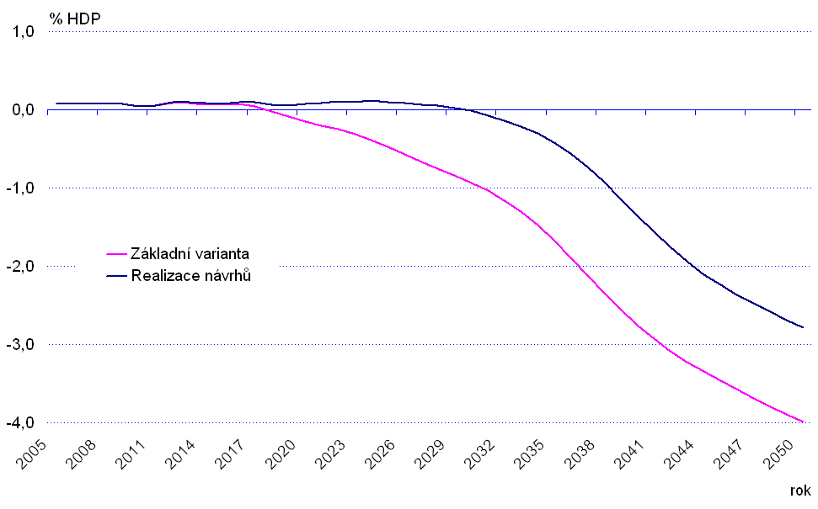
% GDP %GDP
Base case 基础情况
Reform 改革后的情况
Year 年份

The reform package was set to curtail the expenditure on public pensions throughout the period when the statutory retirement age would be increased. The change was driven by keeping the expenditures on the same level as in 2010. Thus, the pension system after the change was projected to remain in balance until 2030 -2035 and dipping into negative afterwards. The overall effects of the 2008 change are captured in figures 1 and 2.
改革的一揽子计划的目的是，在法定退休年龄增加的整个期间，削减公共养老金支出。驱动这一变革的主要原因是养老金支出一直维持在2010年的水平。因此，变革后的养老金制度预计将保持收支平衡，直到2030-2035年，随后再进入赤字负值。2008年改革的总体影响在图1和2中有所体现。

Figure 2 Projected expenditure of the pension scheme pre- and post-reform (2008)
图2：改革前和改革后的养老金制度预计支出情况（2008年）
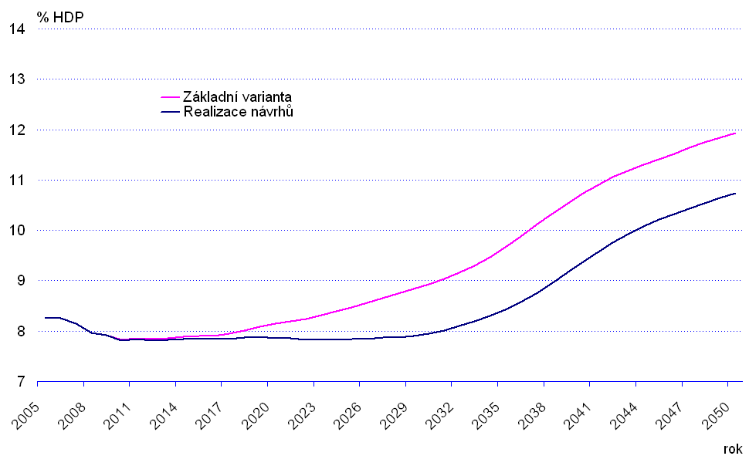
% GDP %GDP
Base case 基础情况
Reform 改革后的情况
Year 年份

The total impact of the reforms can be split between the effect on expenditure on old age pensions and disability pensions. In the area of old age pensions the expenditure change was mainly driven by the prolonging of the period of retirement age increase and by the higher cap on statutory retirement age, which was set to 65 years instead of the previous 63 years of age. This change has shifted the moment at which the pension expenditure would rise from approximately 2015 to 2030 when the process of retirement age increase was to be finished while slightly increasing the expenditure in the first years after adoption. The total impact was estimated to be at 0.5 % GDP in 2050 as is shown in figure 3.
改革的总体影响可分为对养老金支出和残疾养恤金支出的影响。在养老金方面，支出变化的主要原因是退休年龄的提高。法定退休年龄上限提高，目前为65岁而非之前的63岁。
改革改变了养老金支出从大约2015年到2030年逐渐上升的时间点，在这一期间，退休年龄的增加已经基本完成。退休年龄最终确定后，头几年的养老金支出会受到轻微的影响，支出将略有上升。据估计，整体影响到2050年将占GDP的0.5%，如图3所示。

Figure 3 Old-age pension expenditure projection (2008)
图3：养老金支出情况预测（2008年）
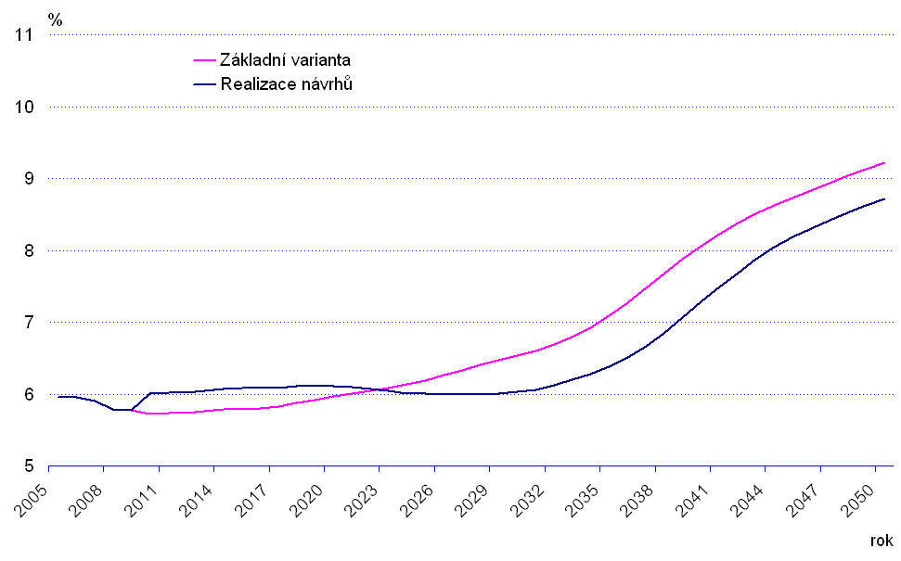
% GDP %GDP
Base case 基础情况
Reform 改革后的情况
Year 年份

The transition from partial and full disability to the new three degree disability classification also improved the outlook of the expenditure side of the pension system. The reclassification of the existing disability pensions was expected to rapidly lower the expenditure by 0.4 % GDP (mainly due to disability pensions transformation to old age at the age of 65) and subsequently to slow down the pace of expenditure growth with a final effect of lowering expenditure in 2050 by additional 0,3 % GDP.
从部分和完全伤残过渡到新制度中的三级伤残对养老金制度的支出前景也有所改善。现有残疾抚恤金的重新分类预计将迅速降低养老金制度，降低幅度为GDP的0.4%（主要是由于残疾抚恤金在65岁时转化为养老金）。随后，养老金支出降低的幅度将放缓，最终在2050年将使养老金支出额外再降低GDP的0.3%。

Figure 4 Disability pension expenditure projection (2008)
图4：残疾抚恤金支出情况预测（2008年）
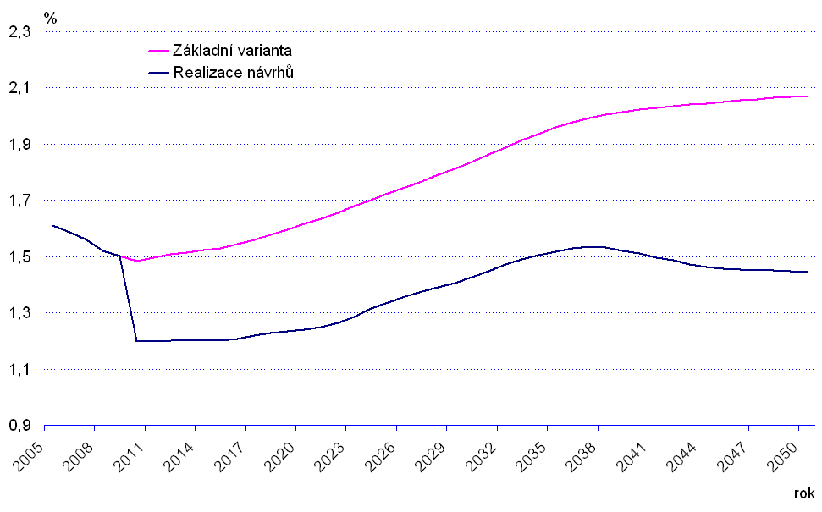
% GDP %GDP
Base case 基础情况
Reform 改革后的情况
Year 年份

While it is difficult to gauge the full impact of the change in the area of old age pensions, given that the reform effects were projected to become significant only after 2020 and also due to the economic downturn and further changes adopted in 2011, the situation regarding disability pensions is a lot clearer. The sum of disability pensions paid out dropped from CZK 57.5 billion in 2008 to CZK 43 billion in 2016. This represents a decrease in expenditure from 1.4 % GDP to the recent 0.9 % GDP.
尽管对养老金制度的全面影响很难衡量，考虑到改革效果预计将在2020年开始发力，也因为经济衰退和2011年进行的进一步变革，残疾抚恤金的情况更加清楚。支付的残疾抚恤金数额从2008年的575亿捷克克朗下降到2016年的430亿捷克克朗。这相当于残疾抚恤金支出的份额从GDP1.4%的下降到0.9%。

As the projected expenditure on old age pensions change was to be mostly brought about by changes to the statutory retirement age and no major changes were done in the calculation formula, the reform was not expected to have any strong effect on the benefit levels. On the other hand the average replacement rate of I. and II. degree disability pensions compared to the former partial disability pensions was projected to dip by 4 percentage points from 24 to 20 percent of the average wage. The impact on disability pensions can be supported with statistical data, as the ratio of average non-full disability pension to the average wage has gone down from 25.3 % in 2008 to 21.8 % in 2016.
养老金开支预计的变化主要是由法定退休年龄发生变化，计算公式并未作出较大调整。因此，整个改革预计不会对福利水平有任何重大影响。另外，一级和二级伤残抚恤金的平均替换率，相较之前的部分伤残抚恤金，预计将下降4个百分点，从平均工资的24%下降到20%。
对残疾抚恤金的影响可从统计数据中得到印证，非完全伤残群体的抚恤金对比平均工资的比例从2008年的25.3%下降到了2016年的21.8%。

Figure 5 Benefit ratio projection (2008)
图5：收益比预测（2008年）
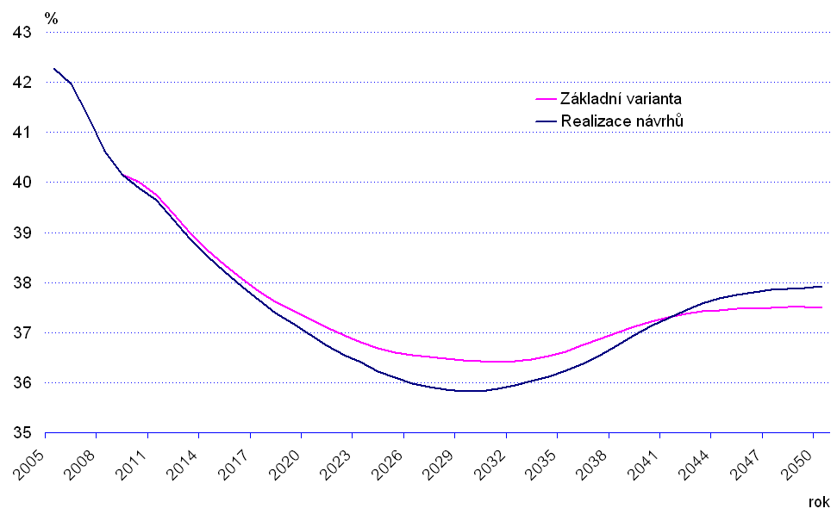
2011 Reform
2011年的改革

In the aftermath of the financial crisis of 2008 and the following economic downturn the pension scheme current and expected future balance deteriorated rapidly. While the difference between contributions on pension insurance and expenditure on benefits in 2008 was positive CZK 6 billion, in 2009 the same balance accrued negative CZK 30 billion. This represents an almost 1 % GDP swing on a year-to-year basis. By 2011 the difference between contributions and benefits reached negative CZK 40 billion.
在2008年金融危机以及随后的经济低迷之后，养老金计划当前的收支平衡和预计未来的收支平衡都迅速恶化。养老金保险缴款与2008年福利支出之间的差额是60亿捷克克朗，2009年达到同样的平衡点，累计差额为负300亿捷克克朗。这一变化说明每年有将近1%的GDP波动。到2011年，缴费和福利之间的差额达到了负400亿捷克克朗。

Moreover, while the post-reform projections from 2008 expected the pension system to remain in slightly positive balance until 2030, under the effects of a worsened economic outlook and starting position the system was expected to remain in a deficit for the whole projection period by actualized calculations made in 2010.
此外，尽管2008年起改革后的情况，预计养老金制度将保持积极的收支平衡状态，直至 2030年。在经济前景恶化和起始基准的影响下，根据2010年作出的更新计算，整个预测期期间，养老金系统预计将处于赤字状态。

Over this economic background came the ruling of the Czech Constitutional Court that decreed that granting pensions of 20 % or less of the previous incomes to high-earners was in contradiction to the right on adequate old-age security as guaranteed by the Czech Constitution. Effective from September 2011, the Constitutional Court abolished the legal provisions of the Pension Act which contained the pension calculation formula. This forced the Government to react and enact a new calculation formula and also presented the opportunity to propose further changes promoting long- term financial sustainability of the pension scheme.
在这一经济背景下，捷克宪法法院的裁决规定，向高收入群体发放的养老金水平是他们以前收入的20%或更少。这与捷克宪法所保证的充足的老年保障权利相抵触。从2011年9月起，宪法法院废除了养老金法中关于养老金计算公式的法律规定，这迫使政府作出反应，制定新的计算公式，并提出了进一步改革的机会，以实现养老金计划的长期财政可持续发展。

The change to the calculation formula was designed to be financially neutral. Therefore, the new formula primarily brought about a different distribution of newly granted pension (pensions being paid out at the moment of the change were not recalculated). The formula change was designed to not impact the low-earners, it slightly reduced the replacement rate of mid-earners while significantly improving the level of pensions of high-earners.
对计算公式的更改主要目的是保持财务中立。新的方案主要是对新发放的养老金进行不同的分配（改革发生时所支付的养老金没有进行重新计算）。改变公式是为了不影响低收入群体。计算公式变化后，中等收入群体的替换率旅游降低，但高收入群体的养老金水平显著提高。

Figure 6 Replacement rate by income decile pre- and post-reform (2011)
图6：改革前及改革后不同收入水平群体的替换率（2011年）
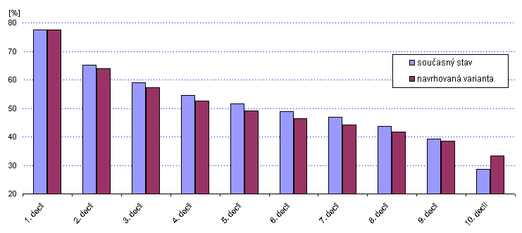
Statistically speaking, the new formula has decreased the pensions of 80 % of the new pensioners when compared to the previous legal state and increased the pensions of the top 10 % earners. With respect to previous earnings, the pension level was kept constant for people, who had previously been earning up to 0.45 times of the average wage. The second breakeven point was set at 1.5 times the average wage with people above this income gaining a higher pension then previously.
从数据上看，与此前的立法情况相比，新的养老金计算公式使得退休人员的养老金减少了80%，但增加了前10%的收入人群。关于此前的收入，养老金水平对人们而言保持不变，之前他们的收入的平均工资的0.45倍。第二个收支平衡点设在平均工资的1.5倍，相较以前，收入高于此水平的群体所领取的养老金数额也更高。

Figure 7 Replacement rate by income pre- and post-reform (2011)
图7：改革前及改革后收入对应的替换率（2011年）

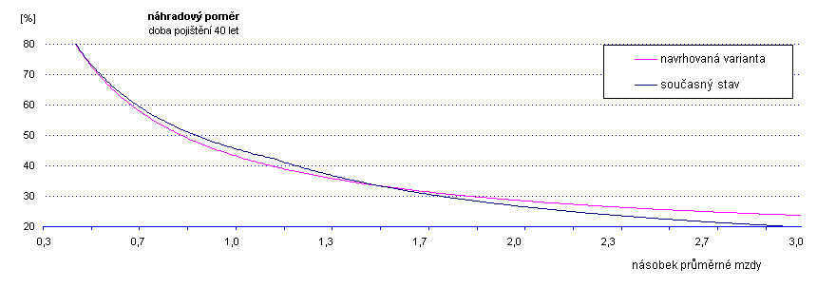

The other legislated changes help ensure a much stronger fiscal position of the pension system. Driven mainly by the increases in prospective statutory retirement age, the pension system was started on a balanced trajectory which would keep the pension system at a relatively stable deficit under 1 % GDP. Only in the period between 2035 and 2070 the deficit would be temporarily bigger, which is to be caused by a demographic wave where the numerically strong generations of the 1970s would be moving into retirement and the prime workforce would be consisting of the less numerous generations of 1990s and early 2000s.
其他立法改革变化有助于确保养老金制度的财政状况更加稳定。在未来法定退休年龄增加的推动下, 养老金制度将从较为平衡的轨迹开始运行，这将使养老金制度的赤字相对稳定，即-1%的GDP。只有在2035至2070期间，赤字才会暂时变大，这是由人口波动造成的。在这段时期，20世纪70年代的大批群体即将退休，劳动力将主要由90后和00后组成。

The other reform changes, i.e. the extension of the reference period and changes in early retirement, conditions should have an earlier, albeit lesser impact. These changes can be seen in figure 8, with their impact starting around 2015 with the full effect being estimated at approximately 0.5% GDP.
其他改革变化，例如延长参考期和提前退休方面，影响到来的较快，但影响力度更小。这些变化可在图8中看到，从2015年左右就能看到这些变化带来的影响，整体带来的影响预计将达到约GDP的0.5%。

Figure 8 Projected balance of the pension scheme pre- and post-reform (2011)
图8：改革前和改革后养老金计划收支平衡的预测情况（2011年）
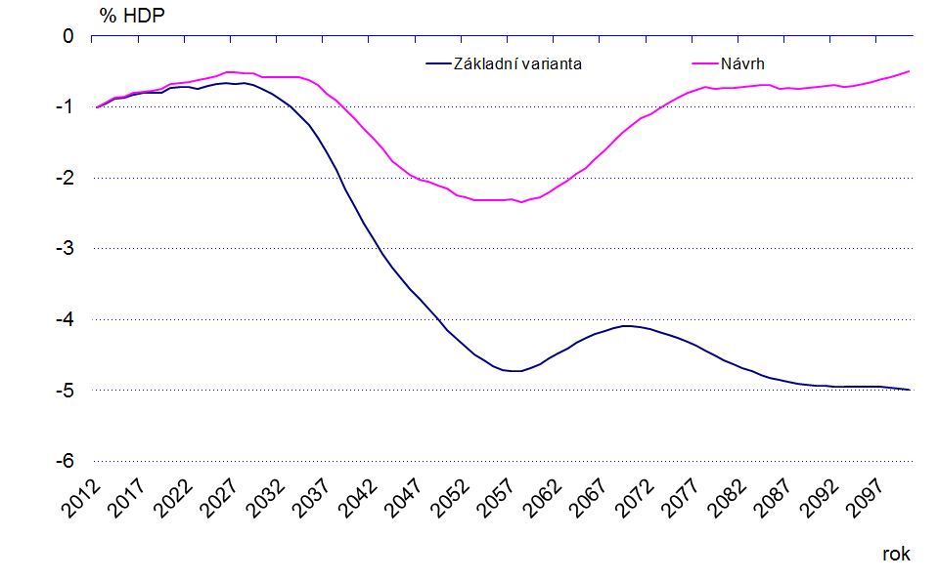
As the austerity of the reform change was mainly achieved through changes in retirement conditions, namely statutory retirement age, the tradeoff for the overwhelming decrease in pension spending in terms of benefit generosity is very limited. The average replacement rate was projected to drop ever so slightly, by less than half percentage point between 2015 and 2060.
养老金紧缩方面的改革是通过改变退休条件（即法定退休年龄）人为实现的。因此，在养老金支出大幅缩减的情况下，很难保证福利的高水平。在2015-2060年之间， 平均更替率预计将下降有极为轻微的下降，不到0.5个百分点。
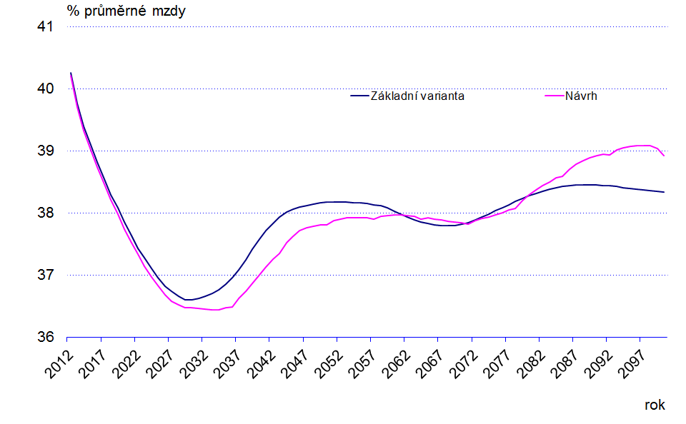
Figure 9 Benefit ratio projection (2011)
图9：收益率预测（2011年）
After this period, the effect of longer working careers should kick in and negate the effects of the lower pension caused by extending the reference period which lowers the average calculation base.
这段时期之后，对长期工作期限的影响将开始出现，并且参考期延长引发的养老金下降的负面效应，也会带来平均计算基数的下降。

Cumulative effect of reforms
改革的综合效应

The full impact of the two major reforms passed in the last 10 years can be hard to estimate. Given the fact that most of the changes, mainly the changes to the retirement age increase schedule, are not expected to come into full power until 2025 – 2030. The effects must therefore be extracted from changes in the projected development of the key variables of the pensions system.
过去十年通过的两项重大改革的全面影响难以估计。大多数的变化都要到2025-2030年预计才能全部发挥作用，主要是退休年龄增加及时间安排。因此，养老金制度关键指数的发展变化必须提前发挥作用。
The Ministry of Labour and Social Affairs has acquired a new modelling tool in a dynamic microsimulation model in 2011 and undertook the actualization of the pension system projections using the new model. The recent results (2015) confirm that a significant improvement in terms of long-term fiscal sustainability have been achieved with the 2008 and 2011 reforms. While the absolute figures may not be perfectly representative, it is clear that the Czech pension system has been set on a well-balanced trajectory.
劳工和社会事务部于2011年在动态微观模拟中获取了新的建模工具，利用这个新的模型模拟预测了养老金制度的发展。最近的结果（2015年）证实，在2008年和2011年的改革中，养老金制度在长期财政可持续性方面取得了重大进展。尽管绝对数可能不完全具有代表性，但这一结果清楚地表明，捷克的养老金制度走上平衡的发展轨道。

The late influence of the economic crisis should wear off in the late 2010s, bringing the expected fiscal position of the pension scheme into positive figures after 2020. Afterwards the pension scheme should remain in balance for the rest of the projection period with some ups and downs caused mainly by the demographic waves that will be coming into retirement in the coming years.
经济危机的后期影响在本世纪10年代末期将逐渐消退，这将使养老金计划的预期财政状况在2020年之后变成正数。此后，养老金方案在剩下的预测期内将保持收支平衡，因人口波动会有一些起伏，这将在未来几年人口逐步退休而显现。

Figure 10 Projected pension system balance (2015)
图10：预计养老金制度收支平衡情况（2015年）

The positive trend can be partly confirmed by the latest statistical figures. In 2016 the pension system deficit, or more correctly the difference between the sum of contributions on pension insurance and the total of pension benefits paid out, was equal to CZK 16 billion, representing only a 0,3 % GDP deficit.
最新的统计数字证实了这一积极趋势。2016年养老金制度的赤字，或者更准确地来说，养老保险的缴费额与给付的养老金福利总额之间的差额相当于160亿捷克克朗，赤字仅为GDP的0.3%。

The reforms did not affect the revenue side of the pension system, leaving the contribution rate and base intact, the effects are concentrated on the expenditure side. A downward trend in the expenditures on pensions is projected, reducing the public spending on pensions from the current 9,5 % GDP to 8 % GDP by 2100.
改革不影响养老金制度的收入，缴款率和基数基本维持不变，影响主要集中在支出方面。预计养老金支出将出现下降趋势，养老金的公共支出将从目前占GDP比重的9.5%减少到2100年的8%。

Figure 11 Projected pension system expenditure (2015)
图11：预测养老金制度的开支情况（2015年）

Both the 2008 and 2011 reforms were not aimed at addressing the issue of pension benefits. Therefore, changes to the overall generosity of pensions are only secondary. The current projections do not expect any abrupt changes to the level of granted pensions. A gradual decline in the benefit ratio, i.e. the ratio of the average old-age pension to the average wage, is forecasted as a result of the extension of the reference period, the abolishment of some of the non-contributory periods as well as a result of the changed distribution of wages in the post-transformation era.
2008年和2011年的改革都并未着力解决养老金福利的问题。因此，对养老金给付的慷慨水平是否做出改变是次要问题。根据目前预测，给付的养老金水平不会发生明显变化。由于参考其延长、部分非缴款期取消以及后改革时代工资分配发生变化，福利比率预计将逐渐下降，即平均养老金与平均工资的比率。

Figure 12 Projected benefit ratio (2015)
图12：预测收益比率（2015年）

As the reforms did little in the area of pension adequacy, they were bound to have some negative impact on the social situation of pensioners. The total impact is difficult to assess as the older modelling equipment did not allow for an analysis of impact on an individual level. It is nevertheless obvious that the austere nature of the reforms had contributed to the negative expected development of the at-risk-of-poverty indicator, which is expected to rise significantly between 2015 and 2060.
改革在养老金充分性方面发挥的作用不大，这必然会对养老金领取者的社会状况产生一些负面影响。由于旧的模式无法对个人的生活水平受到的影响进行分析，因此总体影响难以评估。然而很显然，改革的严峻性使得贫困风险相关指数呈现消极的预期发展态势，这一指数预计在2015年和2060年之间将显著上升。

Figure 13 Pensioners at-risk-of-poverty
图13：有贫困风险的养老金领取者

Further policy changes – reform reversals
进一步的政策改革—改革反复情况

The 2008 and 2011 reforms were passed in a quite unique conjunction of circumstances. Firstly, both reforms were proposed during the reign of governments consisting of right leaning political parties. Secondly, the financial and economic crisis prepared the grounds for strict austerity policies that would be much more difficult to pass in normal economic conditions. In addition, the Constitutional Court ruling forced the Government to act and make changes to the Pension Act in quick succession after the 2008 reform, which allowed for more substantial changes in a short span of time.
2008年和2011年的改革是在特殊情况下通过的。首先，这两项改革都是在由右翼政党组成的政府执政期间提出的。其次，金融和经济危机使得严格的养老金紧缩政策成为合理诉求，在正常的经济条件下, 这中举措将更加困难。此外，宪法法院的裁决使得政府在2008年改革之后迅速采取行动，对养老金法案进行修改，这使得在短时间内养老金制度进行更大的变革。

While the reforms, and especially the 2011 reform, had a strongly positive impact on fiscal sustainability and tried to influence the level of benefits minimally, the changes were not overall positively accepted. As the reforms were passed without seeking a political consensus beforehand, the left wing opposition criticized the reform for not being socially acceptable. Moreover, the social partners, mainly the trade unions, also expressed their dissatisfaction, culminating with a series of public protests and a cautionary one-day strike of workers in public services.
然而，经历多次改革后，特别是2011年的改革，养老金制度的财政可持续性获得了积极的发展。改革也试图最低限度地对福利水平造成影响。尽管如此，变革方案并未被全盘积极接受。由于改革是在没有事先寻求政治共识的情况下通过的，左翼反对派批评这项改革没有得到社会的认可。此外，社会合作伙伴，主要是工会，也表达了他们的不满。最后还引发了一系列的公众抗议活动以及公共服务部门劳动者为期一天的罢工。

The main brunt of political and public opposition was taken by the newly introduced fully funded pension pillar which was seen as anti-social and undermining the financial stability of the state run first pension pillar. Nevertheless the social aspects of the 2011 reform also came under scrutiny, especially the statutory retirement age increases with no cap on retirement age.
新采纳的资金累积型养老金支柱受到了政治界和公众反对，这种制度被认为是反社会的，且破坏了国家运营的第一养老金支柱的财政稳定性。然而，2011年的改革在社会方面也获得了支持，特别是定退休年龄无上限提高这一项。

The negative public reception and negative publicity had had a visible effect in terms of number of people opting for an early retirement (figure 14). Despite the fact that granted pensions were only marginally influenced there was a massive influx of early pensions in the second half of 2011. Between July and December 2011, the number of early pensioners grew by almost 57 thousand, compared to the 12 thousand in 2010. In 2008 and 2009 this number was around 15 – 20 thousand, which was already inflated above normal due to the effects of the economic downturn, where companies were solving laying off workers with a short time remaining till retirement.
负面公众传播和负面宣传对选择提前退休的人数有显著影响（图14）。尽管发放的养老金只受到了轻微的影响，但2011年下半年出现了大量的早期养老金。在2011年7月和12月之间，提前退休群体的人数增长了近5.7万，而2010年仅1.2万。2008年和2009年期间，这一数字大约是1.5-2万。由于经济低迷，企业正想办法解决即将退休人员被解雇的问题，提前退休的人数已经超出正常水平。

Figure 14 Number of early old-age pensions
图14：提前退休养老金的数额

After the general elections in 2013 a new Government was installed in January 2014. The new Government established an advisory Pension Committee that was tasked with analyzing the pension system and proposing further reform steps. As the political climate has changed and the public policy became more social oriented, a significant part of the proposals of the Committee was aimed at revoking certain part of the previous reforms.
2013年大选后，新政府于2014年1月成立。新政府设立了养老金咨询委员会，负责分析养老金制度，并提出进一步改革措施。随着政治环境变化、公共政策变得更加社会化，委员会的提议中很重要的一部分就是希望撤销以前改革的某些部分。

Based on the work of the Committee a change in the process of retirement age increase was proposed by the Government and submitted to the Chamber of Deputies of the Parliament of the Czech Republic in September 2016. The proposal sets once again a cap on statutory retirement age at 65 years of age, which should be reached in 2030. In addition a procedure of review of retirement age is envisaged by the proposal, but with limited legal power only. The proposal was further supplemented with a change in the pension indexation formula. After the bill is passed, the pensions in payment should be indexed by the price index growth and half the real wage growth every year, compared to the current price index and 1/3 of the real wage growth. The declared goal of the change is to improve the income situation of pensioners and prevent their risk-of-poverty. The proposal is, as of today, being passed through the legislative process and has not been fully endorsed yet. It is expected that the changes will come into power by August 2017.
根据委员会的工作，政府提议改变退休年龄增加的进程，并将此项提议于2016年9月提交捷克共和国议会众议院审议。这项建议再次规定了法定退休年龄为65岁，这一上限应于2030年达到。此外, 该提案还设想了一项退休年龄审查程序，但法律权力有限。这项建议进一步补充了养老金指数公式的变化。在条例草案获得通过后，养老金给付应按物价指数的增长和每年实际工资增长的一半进行指数化调整，目前是的调整标准是价格指数和实际工资增长的1/3。宣布的改革目标是改善养老金领取者的收入状况, 并防止贫困风险。目前, 这项建议已通过立法程序, 尚未完全获得通过。预计这些变革措施将在2017年8月开始生效。

Meanwhile, another measure to address the low pension indexation was approved in 2016. The Government regained the ability to increase the indexation percentage above the minimum set by statistical indices which was taken from it as a part of the 2011 reform. The main difference between the old and the new authorization is that an upper limit is set at 2.7 %. Therefore if the indexation calculated based on the statistically measured inflation and real wage growth is lower that the aforementioned 2.7 % the Government can decree a higher increase, up to the limit of 2.7 %.
与此同时，2016年还批准了另一项解决低养老金指数化的措施。政府恢复了将指数化百分比提高到最低限度的能力, 将其作为2011年改革的一部分，从统计指数中扣除。旧的和新的授权之间的主要区别是，上限设置为2.7%。因此, 如果按数据估算的通货膨胀率和实际工资增长情况来看，指数化水平低于上述的2.7%，政府可以下令提高增幅, 直至达到上限2.7%。

On the overall, it can be said that the reform of 2011 was, at least in the main features, completely revoked in the following years, bringing the state of the pension system broadly to the post 2008 situation. This development has certainly helped the income situation of the current pensioners, but opened the necessity of further reform once again.
总的来说， 2011年的改革，至少是主要特点，在随后的几年中被完全取消了。很大程度上，养老金制度回到了2008年的情况。这种发展确实有助于目前养老金领取者改善收入，但这又再次引发了进一步改革的必要性。

Conclusions结语
The pension reform is highly politically sensitive issue, mainly due to negative perception of reform measures as they are primarily restrictive. The Czech experience shows the combination of continuous political and expert debate and time to time concrete reform proposal as a result of the debate. Pension reform debate plays an important educative role among public and increases its social (or at least pension system) literacy.
养老金改革是一个高度政治敏感的问题，主要原因是改革措施很大程度上具有限制性，对改革措施的消极认识比较普遍。捷克的经验显示，应将持续的政治讨论与专家讨论结合，并及时提出具体的改革建议。养老金改革辩论对公众而言起着重要的教育作用，也强化了社会认知（至少是对养老金制度的了解）。

Despite the debate a broad political consensus on specific reform measures has not been reached in last decade. However, something that can be called as implicit acceptance of unpopular but necessary steps forward exists, mainly on the retirement age increase.
过去十年进行的辩论尚未就具体改革措施达成广泛的政治共识。尽管有些措施不受欢迎，被大众勉强接受，但这些措施也是改革向前发展所必须的步骤，主要是在退休年龄提高方面。

The 2008 as well as 2011 reforms show the retirement age and its increase as the primary tools to improve long term financial sustainability in the ageing society. The retirement age increase has double positive effect on financial stability by decreasing number of pension recipients (and lower expenditures) and on the other hand increasing number of contributors (and increase revenues). As the positive effect on expenditures side is direct. The effect on revenue side needs additional measures on labour market, mainly via adapting workplaces for older workers to maintain them at work.
2008年以及2011年的改革表明，退休年龄及其提高是改善老龄化社会长期财政可持续性的主要手段。退休年龄的提高对经济稳定的积极影响体现在两个方面，一方面减少了养老金领取者的人数（支出减少），另一个方面增加了缴费者的数量（收入增加）。对支出的积极影响是非常直接的。在收入方面的影响还需要劳动力市场额外措施的配合，主要是通过使劳动力市场更让老年劳动者适应并持续工作。

The latest development revoking a significant part of previous reform measures (esp. very forward- looking retirement age increase adopted in 2011 with strong impact on long term financial stability) indicates that 2011 reform were too ambitious and broke the unwritten rule of gradual reform steps. It confirms that successful pension reform should be continuous process of gradual step (not a “big bang”) based on expert debate and at least implicit political consensus (do not be part of political struggle) which is understandable but invisible for society.
最近的发展取消了以前改革措施的很大一部分（特别是2011年改革中通过的退休年龄提高，这一举措对长期财务可持续性有很大贡献）。这表明2011年的改革过于雄心勃勃，打破了渐进式改革步骤的不成文规则。这次改革证实，成功的养老金改革应该是循序渐进的过程 （而非“大爆炸”式的改革），而且应该基于专家讨论，达成默契的政治共识（而非政治斗争的一部分），对社会公众来说可以理解，但不被明显感知。

2011年之后
男性 女性
无子女 1名子女 2名子女 3名子女 4名子女 5名子女
1935 60岁零 0个月 57岁零 0个月 56岁零 0个月 55岁零 0个月 54岁零 0个月 54岁零 0个月 53岁零 0个月
1936 60岁零 2个月 57岁零 0个月 56岁零 0个月 55岁零 0个月 54岁零 0个月 54岁零 0个月 53岁零 0个月
1937 60岁零 4个月 57岁零 0个月 56岁零 0个月 55岁零 0个月 54岁零 0个月 54岁零 0个月 53岁零 0个月
1938 60岁零 6个月 57岁零 0个月 56岁零 0个月 55岁零 0个月 54岁零 0个月 54岁零 0个月 53岁零 0个月
1939 60岁零 8个月 57岁零 4个月 56岁零 0个月 55岁零 0个月 54岁零 0个月 54岁零 0个月 53岁零 0个月
1940 60岁零 10个月 57岁零 8个月 56岁零 4个月 55岁零 0个月 54岁零 0个月 54岁零 0个月 53岁零 0个月
1941 61岁零 0个月 58岁零 0个月 56岁零 8个月 55岁零 4个月 54岁零 0个月 54岁零 0个月 53岁零 0个月
1942 61岁零 2个月 58岁零 4个月 57岁零 0个月 55岁零 8个月 54岁零 4个月 54岁零 4个月 53岁零 0个月
1943 61岁零 4个月 58岁零 8个月 57岁零 4个月 56岁零 0个月 54岁零 8个月 54岁零 8个月 53岁零 4个月
1944 61岁零 6个月 59岁零 0个月 57岁零 8个月 56岁零 4个月 55岁零 0个月 55岁零 0个月 53岁零 8个月
1945 61岁零 8个月 59岁零 4个月 58岁零 0个月 56岁零 8个月 55岁零 4个月 55岁零 4个月 54岁零 0个月
1946 61岁零 10个月 59岁零 8个月 58岁零 4个月 57岁零 0个月 55岁零 8个月 55岁零 8个月 54岁零 4个月
1947 62岁零 0个月 60岁零 0个月 58岁零 8个月 57岁零 4个月 56岁零 0个月 56岁零 0个月 54岁零 8个月
1948 62岁零 2个月 60岁零 4个月 59岁零 0个月 57岁零 8个月 56岁零 4个月 56岁零 4个月 55岁零 0个月
1949 62岁零 4个月 60岁零 8个月 59岁零 4个月 58岁零 0个月 56岁零 8个月 56岁零 8个月 55岁零 4个月
1950 62岁零 6个月 61岁零 0个月 59岁零 8个月 58岁零 4个月 57岁零 0个月 57岁零 0个月 55岁零 8个月
1951 62岁零 8个月 61岁零 4个月 60岁零 0个月 58岁零 8个月 57岁零 4个月 57岁零 4个月 56岁零 0个月
1952 62岁零 10个月 61岁零 8个月 60岁零 4个月 59岁零 0个月 57岁零 8个月 57岁零 8个月 56岁零 4个月
1953 63岁零 0个月 62岁零 0个月 60岁零 8个月 59岁零 4个月 58岁零 0个月 58岁零 0个月 56岁零 8个月
1954 63岁零 2个月 62岁零 4个月 61岁零 0个月 59岁零 8个月 58岁零 4个月 58岁零 4个月 57岁零 0个月
1955 63岁零 4个月 62岁零 8个月 61岁零 4个月 60岁零 0个月 58岁零 8个月 58岁零 8个月 57岁零 4个月
1956 63岁零 6个月 63岁零 2个月 61岁零 8个月 60岁零 4个月 59岁零 0个月 59岁零 0个月 57岁零 8个月
1957 63岁零 8个月 63岁零 8个月 62岁零 2个月 60岁零 8个月 59岁零 4个月 59岁零 4个月 58岁零 0个月
1958 63岁零 10个月 63岁零 10个月 62岁零 8个月 61岁零 2个月 59岁零 8个月 59岁零 8个月 58岁零 4个月
1959 64岁零 0个月 64岁零 0个月 63岁零 2个月 61岁零 8个月 60岁零 2个月 60岁零 2个月 58岁零 8个月
1960 64岁零 2个月 64岁零 2个月 63岁零 8个月 62岁零 2个月 60岁零 8个月 60岁零 8个月 59岁零 2个月
1961 64岁零 4个月 64岁零 4个月 64岁零 2个月 62岁零 8个月 61岁零 2个月 61岁零 2个月 59岁零 8个月
1962 64岁零 6个月 64岁零 6个月 63岁零 6个月 63岁零 2个月 61岁零 8个月 61岁零 8个月 60岁零 2个月
1963 64岁零 8个月 64岁零 8个月 64岁零 8个月 63岁零 8个月 62岁零 2个月 62岁零 2个月 60岁零 8个月
1964 64岁零 10个月 64岁零 10个月 64岁零 10个月 64岁零 2个月 62岁零 8个月 62岁零 8个月 61岁零 2个月
1965 65岁零 0个月 65岁零 0个月 65岁零 0个月 64岁零 8个月 63岁零 2个月 63岁零 2个月 61岁零 8个月
1966 65岁零 2个月 65岁零 2个月 65岁零 2个月 65岁零 2个月 63岁零 8个月 63岁零 8个月 62岁零 2个月
1967 65岁零 4个月 65岁零 4个月 65岁零 4个月 65岁零 4个月 64岁零 2个月 64岁零 2个月 62岁零 8个月
1968 65岁零 6个月 65岁零 6个月 65岁零 6个月 65岁零 6个月 64岁零 8个月 64岁零 8个月 63岁零 2个月
1969 65岁零 8个月 65岁零 8个月 65岁零 8个月 65岁零 8个月 65岁零 2个月 65岁零 2个月 63岁零 8个月
1970 65岁零 10个月 65岁零 10个月 65岁零 10个月 65岁零 10个月 65岁零 8个月 65岁零 8个月 64岁零 2个月
1971 66岁零 0个月 66岁零 0个月 66岁零 0个月 66岁零 0个月 66岁零 0个月 66岁零 0个月 64岁零 8个月
1972 66岁零 2个月 66岁零 2个月 66岁零 2个月 66岁零 2个月 66岁零 2个月 66岁零 2个月 65岁零 2个月
1973 66岁零 4个月 66岁零 4个月 66岁零 4个月 66岁零 4个月 66岁零 4个月 66岁零 4个月 65岁零 8个月
1974 66岁零 6个月 66岁零 6个月 66岁零 6个月 66岁零 6个月 66岁零 6个月 66岁零 6个月 66岁零 2个月
1975 66岁零 8个月 66岁零 8个月 66岁零 8个月 66岁零 8个月 66岁零 8个月 66岁零 8个月 66岁零 8个月
1976 66岁零 10个月 66岁零 10个月 66岁零 10个月 66岁零 10个月 66岁零 10个月 66岁零 10个月 66岁零 10个月
1977 67岁零 0个月 67岁零 0个月 67岁零 0个月 67岁零 0个月 67岁零 0个月 67岁零 0个月 67岁零 0个月

Retirement age of people born after 1977 was to increase by 2 months per year of birth with no upper limit
出生在1977年之后的群体的退休年龄每后一年出生将增加2个月，没有上限。

http://www.mpsv.cz/files/clanky/3445/Final_report.pdf
See Actuarial Report on Pension Insurance for pension calculation rule details (www. ) 要了解养老金计算规则的具体细节，请参见《养老金保险精算报告》(www.)
The 1995 reform started the process of gradual increase of retirement age. 1995年的改革开始了逐步提高退休年龄的进程。
Periods, when pension rights are accumulated while the pension contributions are not paid, e.g. child care or unemployment. 养老金权益累计但不必进行缴费的时期，例如：照料子女或事业期。
The at-risk-of-poverty indicator is measured as the percentage of people in households with equalized income lower that 60 % of the median of the equalized income. 贫困风险这一指标的衡量标准是，家庭中拥有社会收入收入的人占比低于社会中位收入的60%。
The absolute levels shown in the chart should be taken as only indicative due to problems with methodology and restrictions of model calculations, but the trend is deemed valid. 在图表中显示的绝对值只应作为指示性指标，因为模型计算的方法和限制存在问题，但这种趋势被认为是有根据的。
Another part of the 2011 reform which is not discussed as it is outside of the scope of this paper. 2011年改革的另一部分没有讨论，因为它不是本文的论述范围。

