**Parametric Pension Reform in European Member States**

**Country Report**

**The Czech Republic**



**Component 1**

**June 2017, v.1**

# Recent reforms of the Czech pension **system**

# Jan Škorpíc, Marek Suchomel,

# Ministry of Labour and Social Affairs

# Introduction

The Czech pension system is characterized by high dependence on 1st pillar pension which represents around 95 % of old age people income. Supplementary schemes have not been well developed yet and play only a very limited role. Therefore, the pension reform, from the Czech perspective, is mostly parametric reform measures of the 1st pillar with only a few attempts of paradigmatic changes.

The pension reform is a continuous process that was started at the beginning of 1990’s hand in hand with the transformation from centrally planned to market based economy. Almost all governments have had the pension reform measures on their agendas since then. Firstly as a part of general social reform adapting social system to new economic circumstances culminated by adopting the New Pension Act in 1995.

Further reform measures have been driven mainly the population ageing phenomenon, characterized by the increase of the proportion of people in higher age groups (the old and the oldest old), which is a world-wide phenomenon impacting mainly pension, health and long term care schemes especially highly developed social schemes in European countries.

It means that 2008 and 2011 pension reforms describe in this text, do not stand alone, but they a part of ongoing process and it should be looked at them from this point of view.

## 2008 Reform

The need for parametric reforms of the Czech pension system, which was introduced in 1995, started to grow within the public debate in the late 1990s. Between 1999 and 2002 two separate committees of the Parliament, one in the Senate and the other in the Chamber of Deputies, discussed the further course of pension reform. The projections of the pension system at this time indicated a highly unsustainable long-term trajectory of pension expenditure, with the overall balance of the pension system dropping to negative 4 % GDP by 2050.

The situation culminated in 2004 when the Team of Experts was established by mutual agreement and membership of political parties represented in the Chamber of Deputies, supported by the Executive Team. The Executive Team was an independent body consisting of representatives of public administration (mainly the Ministry of Labour and Social Affairs, Ministry of Finance and the Czech National Bank) that was tasked by the Team of Experts with performing a thorough analysis of the current state of the pension system, its development trends and assessing the reform proposals of the political parties. The Executive Team finished its work in June 2005 by publishing its Final Report[1].

Based on the Final Report and further discussion in the Team of Experts the political parties were supposed to agree on a Proposal on Agreement on the Basic Principles of further Pension Reform. Unfortunately, the document has never been approved and sign by the leaders of the political parties. Nevertheless, the new government in 2008 followed the findings of the Executive Team proposed a significant parametric reform, which was subsequently adopted by the Parliament. The main goal of the reform was to enhance long-term sustainability of the pension scheme.

The pension reform made numerous changes to the pension scheme[2]. Firstly a previously started process of **gradual increase in the retirement age** was prolonged[3]. The statutory retirement age was set to increase to **65 years of age for men** and to **62 – 64 years of age for women** based on the number of children they have raised. The retirement age was to be increased, at the same pace as already legislated, by two months per year for men and by four months per year for women until the final values will have been reached in 2030. Details on the retirement age increase schedule prior and after the reform can be found in Annex 1.

In addition to the changes to the statutory retirement age **the old-age pension qualifying condition of minimum required period of insurance** was tightened. The minimum insurance period was increased **from 25 years prior to the reform to 35 years**. In order to ensure a smooth transition and to minimize the potential negative impact on workers moving to retirement, this increase was also implemented gradually, starting in 2010 and reaching the final 35 years of insurance in 2018.

Further changes were adopted in the field of credited non-contributory periods[4]. **Periods of studies** acquired after 2009 stopped being treated as non-contributory periods of insurance. While these periods no longer increase the overall insured period they have kept their status of excluded periods and therefore they do not lower the calculation base of the pension.

Additionally, the extent to which the **non-contributory periods are taken into account for minimum required insurance period qualifying condition was reduced from 100 % to 80 %** similarly as for already legislated pension amount calculation**.** That means that for 5 years of being in a state that constitutes a non-contributory period only 4 years are credited. This change does not apply to periods of child care and compulsory military service.

Further changes were made with regard to flexibility of old-age pension take up and work activity after retirement. Newly, the **periods of concurrence of economic activity and pension payment grant a slight yearly increase in the paid out pension** equal to 0,4 % of the calculation base and a possibility to **combine half the old-age pension with economic activity** was allowed. In the latter case the pension is increased by 1,5 % of the calculation base for every 180 days of such concurrence.

Moreover, new rules of early pension were adopted. The **period in which an early pension can be drawn was extended from 3 to 5 years** with the condition that pension cannot be granted earlier than 3 years before reaching statutory retirement age at an age lower than 60. Therefore the change will have come into power gradually, since the retirement age for men will not have reached more than 63 years until 2017 and for women the necessary age would be reached even later. The penalties for early pension were also overhauled. For every 90 day period within the first 720 days of early pension the pension is reduced by 0,9 % of the calculation base and for each 90 days period which occur earlier than 720 days prior to retirement the reduction equals to 1,5 % of the calculation base.

Last but not least, a new system of disability classification was introduced, changing the older system of partial and full disability which had been granted if the ability to perform economic activity declined by at least 33 % and 66 % respectively to a system that recognizes **only one disability with 3 degrees** with 35 %, 50 % and 70 % reductions in ability to perform economic activity. The first and second degree disability replaced the former partial disability, while reducing the benefits the first degree disability from 0,75 % to 0,5 % of the calculation base for each full year of insurance. For the second degree disability the pension level stayed unchanged (equal to previous partial disability pension level). The former full disability pensions were transformed to third degree disability pensions and the benefits remained the same at 1,5 % of calculation base per year of insurance. In addition to that, disability pensions of people reaching 65 years of age (or statutory retirement age if it is higher than 65 years) are transformed to old age pension (the level of pension is maintained) and all disability pension older than 65 years were transformed to the old age as well.

## 2011 Reform

The 2011 pension reform was mainly brought about by the Constitutional Court ruling of 2010. Based on a legal action of a former high income citizen whose income was replaced by a pension that constituted less than 20 % of his previous income, the Constitutional Court had invalidated the pension calculation formula. The ruling was to come into power in September 2011 and a new calculation formula had to be adopted prior to this date.

In addition the financial crisis of 2008 and the following economic downturn had aggravated the sustainability prospects of the Czech pension scheme. As austerity measures became paramount, additional changes to the pension scheme were proposed and adopted as a part of the reform package of 2011.

The first change introduced was reworking the pension calculation formula. The former system of **two reduction thresholds was replaced by a system with one threshold and ceiling**. Previously earnings up to the first threshold had been taken into account fully (this rule is maintained), 30 % of earnings between the first and second had been included and 10 % of earning above the second threshold. Newly, 26 % of the earnings between the first threshold and ceiling is taken into account. The new pension formula ensures a more adequate replacement rate for mid- and high-earners.

In addition the Czech **government no longer has any leeway in setting the pension system parameters, as the reduction thresholds are specified directly in the Law and are anchored to the national average wage**. The first reduction threshold is set as 44 % of the average wage and the second one as 400 % of the average wage which corresponds to the cap on pension insurance contributions. The same stands for other pension system parameters which were newly set as fixed by the Law, namely the Basic Amount of a pension and the pension indexation formula.

Further changes, aimed at promoting financial sustainability of pensions, included **another long-term increase of the statutory retirement age**. The process of retirement age increasing for women was set to be sped up to 6 months per year (from the former 4 months). The statutory retirement age for men was decreed to **increase past 65 years of age and it was set to increase by 2 months per year with no upper limit**. The retirement age for women was to gradually reach the retirement age of men and then increase at the same pace. Details on the retirement age increase schedule prior and after the reform can be found in Annex 1.

Another significant change adopted in 2011 was the **extending of the reference period** for pension calculation. Previously the pension was calculated based on the average earnings in the period of the last 30 years prior retirement (but not before 1986). Since 2011 the reference period was extended to include the full income history (1986 remains unchanged).

Also, a minor tweak was made to the **penalties for early retirement**. Newly, the early pension is reduced by 1,2 % of the calculation base for every 90 day period of early retirement in the period between 360 and 720 days before reaching the statutory retirement age. The remaining penalties have not changed since the 2008 reform. That means that for the first 360 days of early pension the benefit is lowered by 0,9 % of the calculation base for every 90 day period of early retirement, the next 360 days (between 361st do 720th day of early retirement) the benefit is lowered by 1,2 % of the calculation base for every 90 day period of early retirement and for early retirement preceding the 721st day the penalty amounts to 1,5 % of the calculation base for each 90 day period of early retirement.

# Endorsement process

Both parametric reforms underwent a standard legislative process. As a first step the reform packages were prepared by the responsible ministries, mainly the Ministry of Labour and Social Affairs. The proposal contained both the necessary legislative changes in the form of proposed amendments to the Pension Act (law No. 155/1995 Coll., on Pension Insurance) and the accompanying documents that contain the analysis and reasons for the proposed changes.

The proposals were preliminarily discussed by Governmental working group consisting of economic ministers. After these discussions and resulting modifications, the amendment bills were submitted by the ministry to the Government as a whole, which approved the proposal and passed it onto the Chamber of Deputies of the Parliament. During the discussions in the Government, the reform proposal were also discussed on a tripartite basis with representatives of trade unions and employer organizations, as well as on the grounds of the Legislative Council of the Government which is tasked with assessing legislative proposal with regard to their conformity with the existing legal order.

Afterwards, the proposed bills underwent the legislative process in the Chamber of Deputies, which consists of three readings and including sectional talks in specialized committees that consist of parties political experts on various fields, such as social policy or budgetary policy.

After the Chamber of Deputies approved the proposals, they were passed on to the Senate of the Parliament, which discussed them in a similar, yet slightly more condensed fashion. After the approval of the proposals they were submitted to the President of the Czech Republic for the final signature that precedes the formal endorsement of the proposals.

The 2008 reform package was approved by the Government in February 2008 and came into full power effective on January 1st 2009. The 2011 reform proposal was passed through the Government in February 2011 and came into power on September 30th 2011.

# Expected effects

## 2008 Reform

As was mentioned before, the main goal of the 2008 parametric change was to promote long-term fiscal sustainability of the pension system. Previously the pension scheme had been projected to remain balanced for about 10 years, until 2015. Afterwards the balance was projected to steadily drop into the red, reaching negative 4 % GDP in 2050.

Figure 1 Projected balance of the pension scheme pre- and post-reform (2008)

% GDP

Reform

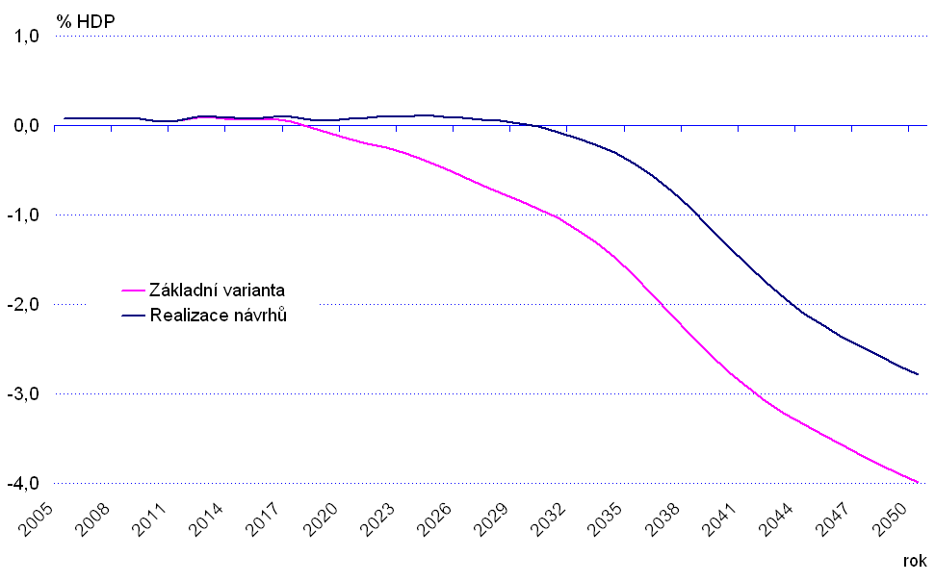

Base case

Reform

Year

Reform

The reform package was set to curtail the expenditure on public pensions throughout the period when the statutory retirement age would be increased. The change was driven by keeping the expenditures on the same level as in 2010. Thus, the pension system after the change was projected to remain in balance until 2030 -2035 and dipping into negative afterwards. The overall effects of the 2008 change are captured in figures 1 and 2.

Figure 2 Projected expenditure of the pension scheme pre- and post-reform (2008)

% GDP

Reform

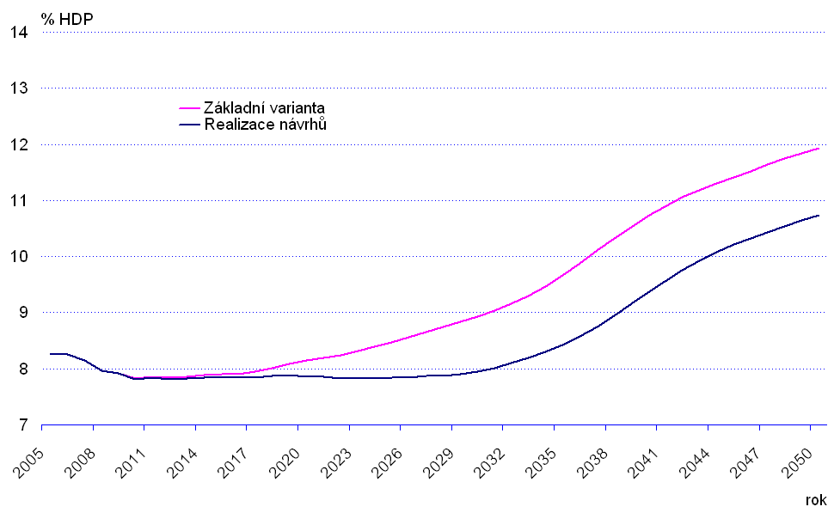

Base case

Reform

Year

Reform

The total impact of the reforms can be split between the effect on expenditure on old age pensions and disability pensions. In the area of old age pensions the expenditure change was mainly driven by the prolonging of the period of retirement age increase and by the higher cap on statutory retirement age, which was set to 65 years instead of the previous 63 years of age. This change has shifted the moment at which the pension expenditure would rise from approximately 2015 to 2030 when the process of retirement age increase was to be finished while slightly increasing the expenditure in the first years after adoption. The total impact was estimated to be at 0.5 % GDP in 2050 as is shown in figure 3.

Figure 3 Old-age pension expenditure projection (2008)

% GDP

Reform

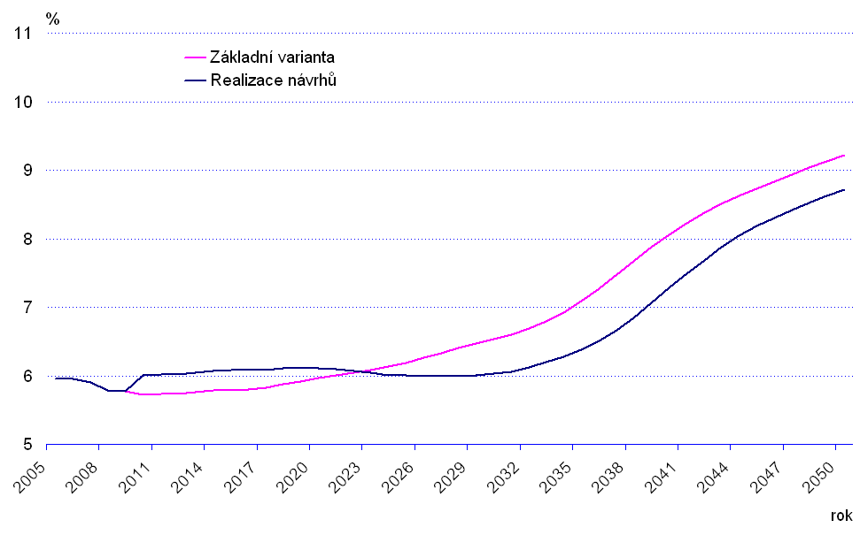

Base case

Reform

Year

Reform

Base case

Reform

The transition from partial and full disability to the new three degree disability classification also improved the outlook of the expenditure side of the pension system. The reclassification of the existing disability pensions was expected to rapidly lower the expenditure by 0.4 % GDP (mainly due to disability pensions transformation to old age at the age of 65) and subsequently to slow down the pace of expenditure growth with a final effect of lowering expenditure in 2050 by additional 0,3 % GDP.

Figure 4 Disability pension expenditure projection (2008)

% GDP

Reform

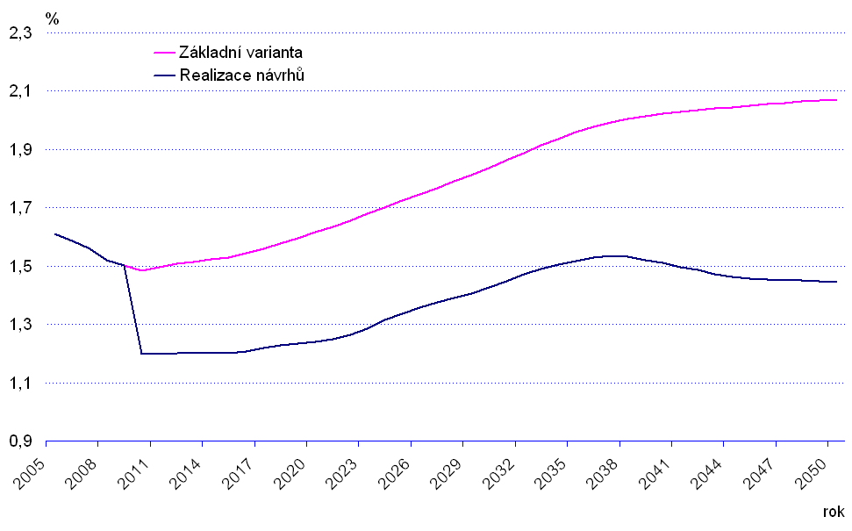

Base case

Reform

Year

Reform

While it is difficult to gauge the full impact of the change in the area of old age pensions, given that the reform effects were projected to become significant only after 2020 and also due to the economic downturn and further changes adopted in 2011, the situation regarding disability pensions is a lot clearer. The sum of disability pensions paid out dropped from CZK 57.5 billion in 2008 to CZK 43 billion in 2016. This represents a decrease in expenditure from 1.4 % GDP to the recent 0.9 % GDP.

As the projected expenditure on old age pensions change was to be mostly brought about by changes to the statutory retirement age and no major changes were done in the calculation formula, the reform was not expected to have any strong effect on the benefit levels. On the other hand the average replacement rate of I. and II. degree disability pensions compared to the former partial disability pensions was projected to dip by 4 percentage points from 24 to 20 percent of the average wage. The impact on disability pensions can be supported with statistical data, as the ratio of average non-full disability pension to the average wage has gone down from 25.3 % in 2008 to 21.8 % in 2016.

Figure 5 Benefit ratio projection (2008)

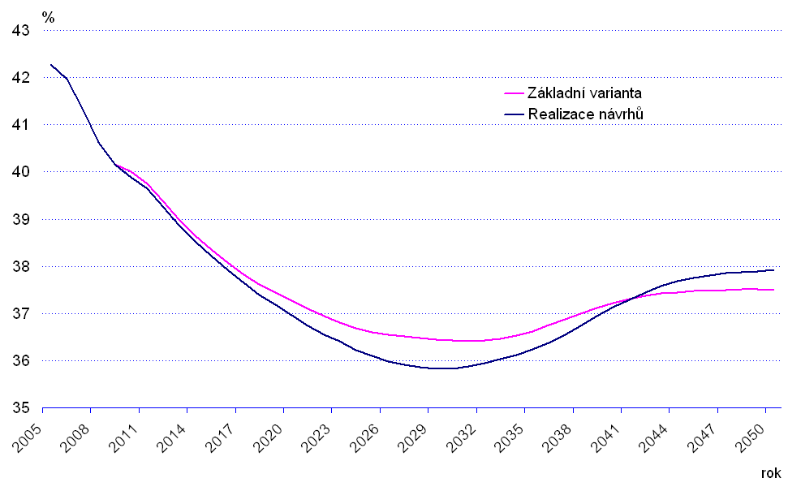

Year

Reform

Base case

Reform

## 2011 Reform

In the aftermath of the financial crisis of 2008 and the following economic downturn the pension scheme current and expected future balance deteriorated rapidly. While the difference between contributions on pension insurance and expenditure on benefits in 2008 was positive CZK 6 billion, in 2009 the same balance accrued negative CZK 30 billion. This represents an almost 1 % GDP swing on a year-to-year basis. By 2011 the difference between contributions and benefits reached negative CZK 40 billion.

Moreover, while the post-reform projections from 2008 expected the pension system to remain in slightly positive balance until 2030, under the effects of a worsened economic outlook and starting position the system was expected to remain in a deficit for the whole projection period by actualized calculations made in 2010.

Over this economic background came the ruling of the Czech Constitutional Court that decreed that granting pensions of 20 % or less of the previous incomes to high-earners was in contradiction to the right on adequate old-age security as guaranteed by the Czech Constitution. Effective from September 2011, the Constitutional Court abolished the legal provisions of the Pension Act which contained the pension calculation formula. This forced the Government to react and enact a new calculation formula and also presented the opportunity to propose further changes promoting long-term financial sustainability of the pension scheme.

The change to the calculation formula was designed to be financially neutral. Therefore, the new formula primarily brought about a different distribution of newly granted pension (pensions being paid out at the moment of the change were not recalculated). The formula change was designed to not impact the low-earners, it slightly reduced the replacement rate of mid-earners while significantly improving the level of pensions of high-earners.

Figure 6 Replacement rate by income decile pre- and post-reform (2011)

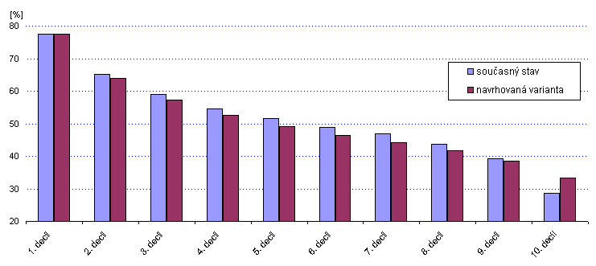

Base case

Reform

Statistically speaking, the new formula has decreased the pensions of 80 % of the new pensioners when compared to the previous legal state and increased the pensions of the top 10 % earners. With respect to previous earnings, the pension level was kept constant for people, who had previously been earning up to 0.45 times of the average wage. The second breakeven point was set at 1.5 times the average wage with people above this income gaining a higher pension then previously.

Figure 7 Replacement rate by income pre- and post-reform (2011)

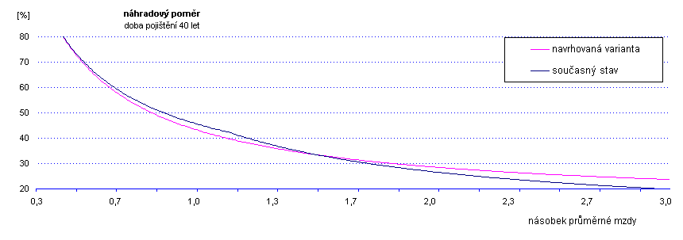

Multiple of average wage

Replacement rate with 40 years of insurance

Reform

Base case

The other legislated changes help ensure a much stronger fiscal position of the pension system. Driven mainly by the increases in prospective statutory retirement age, the pension system was started on a balanced trajectory which would keep the pension system at a relatively stable deficit under 1 % GDP. Only in the period between 2035 and 2070 the deficit would be temporarily bigger, which is to be caused by a demographic wave where the numerically strong generations of the 1970s would be moving into retirement and the prime workforce would be consisting of the less numerous generations of 1990s and early 2000s.

The other reform changes, i.e. the extension of the reference period and changes in early retirement, conditions should have an earlier, albeit lesser impact. These changes can be seen in figure 8, with their impact starting around 2015 with the full effect being estimated at approximately 0.5 % GDP.

Figure 8 Projected balance of the pension scheme pre- and post-reform (2011)

% GDP

Reform

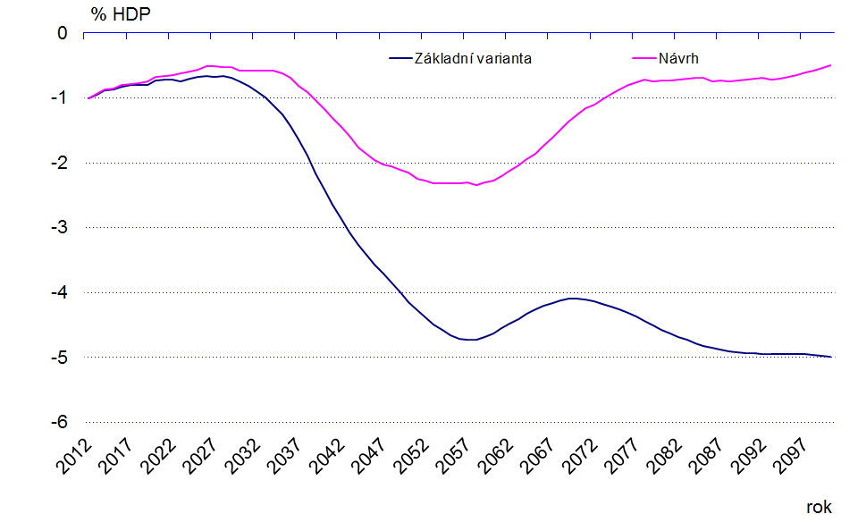

Year

Reform

Reform

Base case

As the austerity of the reform change was mainly achieved through changes in retirement conditions, namely statutory retirement age, the tradeoff for the overwhelming decrease in pension spending in terms of benefit generosity is very limited. The average replacement rate was projected to drop ever so slightly, by less than half percentage point between 2015 and 2060.

Figure 9 Benefit ratio projection (2011)

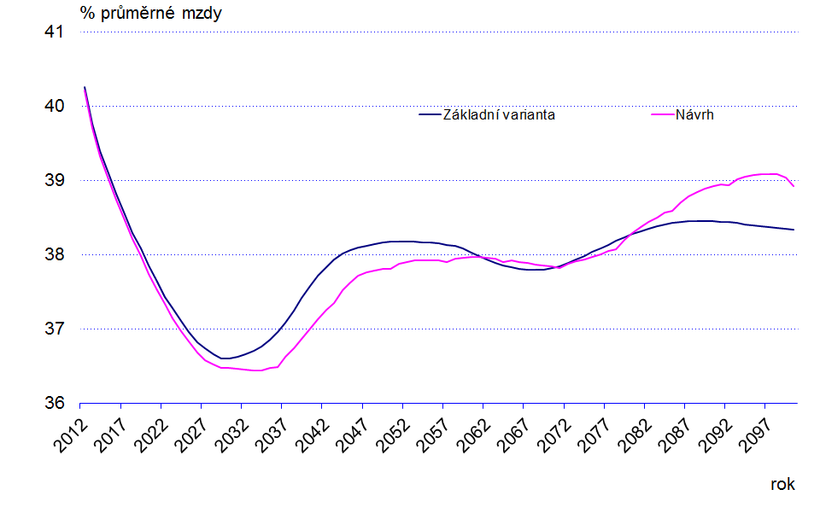

Reform

Reform

Base case

Reform

Year

Reform

After this period, the effect of longer working careers should kick in and negate the effects of the lower pension caused by extending the reference period which lowers the average calculation base.

# Cumulative effect of reforms

The full impact of the two major reforms passed in the last 10 years can be hard to estimate. Given the fact that most of the changes, mainly the changes to the retirement age increase schedule, are not expected to come into full power until 2025 – 2030. The effects must therefore be extracted from changes in the projected development of the key variables of the pensions system.

The Ministry of Labour and Social Affairs has acquired a new modelling tool in a dynamic microsimulation model in 2011 and undertook the actualization of the pension system projections using the new model. The recent results (2015) confirm that a significant improvement in terms of long-term fiscal sustainability have been achieved with the 2008 and 2011 reforms. While the absolute figures may not be perfectly representative, it is clear that the Czech pension system has been set on a well-balanced trajectory.

The late influence of the economic crisis should wear off in the late 2010s, bringing the expected fiscal position of the pension scheme into positive figures after 2020. Afterwards the pension scheme should remain in balance for the rest of the projection period with some ups and downs caused mainly by the demographic waves that will be coming into retirement in the coming years.

Figure 10 Projected pension system balance (2015)



The positive trend can be partly confirmed by the latest statistical figures. In 2016 the pension system deficit, or more correctly the difference between the sum of contributions on pension insurance and the total of pension benefits paid out, was equal to CZK 16 billion, representing only a 0,3 % GDP deficit.

The reforms did not affect the revenue side of the pension system, leaving the contribution rate and base intact, the effects are concentrated on the expenditure side. A downward trend in the expenditures on pensions is projected, reducing the public spending on pensions from the current 9,5 % GDP to 8 % GDP by 2100.

Figure 11 Projected pension system expenditure (2015)



Both the 2008 and 2011 reforms were not aimed at addressing the issue of pension benefits. Therefore, changes to the overall generosity of pensions are only secondary. The current projections do not expect any abrupt changes to the level of granted pensions. A gradual decline in the benefit ratio, i.e. the ratio of the average old-age pension to the average wage, is forecasted as a result of the extension of the reference period, the abolishment of some of the non-contributory periods as well as a result of the changed distribution of wages in the post-transformation era.

Figure 12 Projected benefit ratio (2015)



As the reforms did little in the area of pension adequacy, they were bound to have some negative impact on the social situation of pensioners. The total impact is difficult to assess as the older modelling equipment did not allow for an analysis of impact on an individual level. It is nevertheless obvious that the austere nature of the reforms had contributed to the negative expected development of the at-risk-of-poverty indicator[5], which is expected to rise significantly between 2015 and 2060.

Figure 13 Pensioners at-risk-of-povertry[6]



# Further policy changes – reform reversals

The 2008 and 2011 reforms were passed in a quite unique conjunction of circumstances. Firstly, both reforms were proposed during the reign of governments consisting of right leaning political parties. Secondly, the financial and economic crisis prepared the grounds for strict austerity policies that would be much more difficult to pass in normal economic conditions. In addition, the Constitutional Court ruling forced the Government to act and make changes to the Pension Act in quick succession after the 2008 reform, which allowed for more substantial changes in a short span of time.

While the reforms, and especially the 2011 reform, had a strongly positive impact on fiscal sustainability and tried to influence the level of benefits minimally, the changes were not overall positively accepted. As the reforms were passed without seeking a political consensus beforehand, the left wing opposition criticized the reform for not being socially acceptable. Moreover, the social partners, mainly the trade unions, also expressed their dissatisfaction, culminating with a series of public protests and a cautionary one-day strike of workers in public services.

The main brunt of political and public opposition was taken by the newly introduced fully funded pension pillar[7] which was seen as anti-social and undermining the financial stability of the state run first pension pillar. Nevertheless the social aspects of the 2011 reform also came under scrutiny, especially the statutory retirement age increases with no cap on retirement age.

The negative public reception and negative publicity had had a visible effect in terms of number of people opting for an early retirement (figure 14). Despite the fact that granted pensions were only marginally influenced there was a massive influx of early pensions in the second half of 2011. Between July and December 2011, the number of early pensioners grew by almost 57 thousand, compared to the 12 thousand in 2010. In 2008 and 2009 this number was around 15 – 20 thousand, which was already inflated above normal due to the effects of the economic downturn, where companies were solving laying off workers with a short time remaining till retirement.

Figure 14 Number of early old-age pensions



After the general elections in 2013 a new Government was installed in January 2014. The new Government established an advisory Pension Committee that was tasked with analyzing the pension system and proposing further reform steps. As the political climate has changed and the public policy became more social oriented, a significant part of the proposals of the Committee was aimed at revoking certain part of the previous reforms.

Based on the work of the Committee a change in the process of retirement age increase was proposed by the Government and submitted to the Chamber of Deputies of the Parliament of the Czech Republic in September 2016. The proposal sets once again a cap on statutory retirement age at 65 years of age, which should be reached in 2030. In addition a procedure of review of retirement age is envisaged by the proposal, but with limited legal power only. The proposal was further supplemented with a change in the pension indexation formula. After the bill is passed, the pensions in payment should be indexed by the price index growth and half the real wage growth every year, compared to the current price index and 1/3 of the real wage growth. The declared goal of the change is to improve the income situation of pensioners and prevent their risk-of-poverty. The proposal is, as of today, being passed through the legislative process and has not been fully endorsed yet. It is expected that the changes will come into power by August 2017.

Meanwhile, another measure to address the low pension indexation was approved in 2016. The Government regained the ability to increase the indexation percentage above the minimum set by statistical indices which was taken from it as a part of the 2011 reform. The main difference between the old and the new authorization is that an upper limit is set at 2.7 %. Therefore if the indexation calculated based on the statistically measured inflation and real wage growth is lower that the aforementioned 2.7 % the Government can decree a higher increase, up to the limit of 2.7 %.

On the overall, it can be said that the reform of 2011 was, at least in the main features, completely revoked in the following years, bringing the state of the pension system broadly to the post 2008 situation. This development has certainly helped the income situation of the current pensioners, but opened the necessity of further reform once again.

## Conclusions

The pension reform is highly politically sensitive issue, mainly due to negative perception of reform measures as they are primarily restrictive. The Czech experience shows the combination of continuous political and expert debate and time to time concrete reform proposal as a result of the debate. Pension reform debate plays an important educative role among public and increases its social (or at least pension system) literacy.

Despite the debate a broad political consensus on specific reform measures has not been reached in last decade. However, something that can be called as implicit acceptance of unpopular but necessary steps forward exists, mainly on the retirement age increase.

The 2008 as well as 2011 reforms show the retirement age and its increase as the primary tools to improve long term financial sustainability in the ageing society. The retirement age increase has double positive effect on financial stability by decreasing number of pension recipients (and lower expenditures) and on the other hand increasing number of contributors (and increase revenues). As the positive effect on expenditures side is direct. The effect on revenue side needs additional measures on labour market, mainly via adapting workplaces for older workers to maintain them at work.

The latest development revoking a significant part of previous reform measures (esp. very forward-looking retirement age increase adopted in 2011 with strong impact on long term financial stability) indicates that 2011 reform were too ambitious and broke the unwritten rule of gradual reform steps. It confirms that successful pension reform should be continuous process of gradual step (not a “big bang”) based on expert debate and at least implicit political consensus (do not be part of political struggle) which is understandable but invisible for society.

# Annex 1 Retirement age changes







1. http://www.mpsv.cz/files/clanky/3445/Final_report.pdf
2. See Actuarial Report on Pension Insurance for pension calculation rule details (http://www.mpsv.cz/files/clanky/14299/PMZ_2012_en_final.pdf)
3. The 1995 reform started the process of gradual increase of retirement age.
4. Periods, when pension rights are accumulated while the pension contributions are not paid, e.g. child care or unemployment.
5. The at-risk-of-poverty indicator is measured as the percentage of people in households with equalized income lower that 60 % of the median of the equalized income.
6. The absolute levels shown in the chart should be taken as only indicative due to problems with methodology and restrictions of model calculations, but the trend is deemed valid.
7. Another part of the 2011 reform which is not discussed as it is outside of the scope of this paper.