Parametric Pension Reform in European Member States

Country Report
Germany

Component 1

June 2017, v.1

CONTENTS
I. Introduction 3
II. The German Public Pension System 4
1. General Remarks 4
2. Rules to Qualify for Pensions 4
3. Calculation of Benefits 6
4. Indexation of Benefits in Pay 9
5. Early Retirement 9
6. Taxation Rules 10
7. Accumulation of pension benefits and income derived from continued occupational activity 11
III. Reforms in Pension Insurance 11
1. General Remarks 11
2. Reform in 2001 13
3. Reform in 2005 17
4. Reform in 2006 18
5. Reform in 2007 19
6. Reform in 2014 20
7. Reforms in 2016/17 21
IV. Conclusion 22

The contents of this publication is the sole responsibility of the EU_China SPRP and can in no way be taken to reflect the views of the European Union

Parametric Pension Reforms in Germany

By
Prof. Dr. Heinz-Dietrich Steinmeyer

I. Introduction

Germany has a long established pension system consisting of three tiers (or layers):- the public insurance pension, supplementary pensions – usually provided by the employer – and personal savings. In the late nineteen eighties and early nineties reforms were introduced which led to a move towards employee-financed supplementary pensions using an instrument known as ‘conversion of earnings’ (earmarked savings for pension).
The current public pension system is based on a pension reform of 1957 which introduced a Pay As You Go system and was aimed to provide an income which represents a decent replacement for earnings during the working career. It was in the beginning roughly aimed at about 60 % replacement rate.
This system has been faced with especially demographic problems – starting in the 90s. In 2001 a major reform has been introduced which is the major foundation of the system as it currently works. Therefore the paper will also have to cover that – older – reform. Also reforms in 2005/2006 should be covered shortly which introduced a special demographic factor in the benefit formula and changed taxation rules for benefits and contributions.

II. The German Public Pension System

1. General Remarks

The German system of old age income protection is a three-tier-system or three-layer-system consisting of a public pension insurance, occupational (supplementary) pensions and private savings/life insurance etc.
The public system is financed by contributions – currently 18.7 % of income to be shared between employer and employee by 50 % each - plus state subsidies which amount to 75 Billion € per year. The total expenditures amount to 300 billion € per year (2017).
Covered by the system are all workers gainfully employed as well as certain self-employed. Not covered by this system are public officials who fall under a special retirement system.
The system provides benefits in old age but also covers invalidity and death. In case of invalidity the system provides benefits in case of partial invalidity and in case of full invalidity. For the case of death there are widow´s and widower´s benefits.
The system also provides rehabilitation measures in order to reintegrate persons into the labor market or to prevent persons from leaving the labor market for health reasons. This means in-kind-benefits by the pension insurance including specialized hospitals, vocational training etc.).

2. Rules to Qualify for Pensions

To qualify for old age benefits a person has to meet the retirement age and has to fulfill certain other conditions like qualifying periods.

a. Retirement Age
The retirement age currently (2017) is 65 years and 6 months. In 2007 there was a reform increasing retirement to 67 by 2030. There is a gradual increase per year until that year to be seen from the following list:
Year of birth 1947 - increase by 1 month resulting in 65 years and 1 month
Year of birth 1948 - increase by 2 months resulting in 65 years and 2 months
Year of birth 1949 - increase by 3 months resulting in 65 years and 3 months
Year of birth 1950 - increase by 4 months resulting in 65 years and 4 months
Year of birth 1951 - increase by 5 months resulting in 65 years and 5 months
Year of birth 1952 - increase by 6 months resulting in 65 years and 6 months
Year of birth 1953 - increase by 7 months resulting in 65 years and 7 months
Year of birth 1954 - increase by 8 months resulting in 65 years and 8 months
Year of birth 1955 - increase by 9 months resulting in 65 years and 9 months
Year of birth 1956 - increase by 10 months resulting in 65 years and 10 months
Year of birth 1957 - increase by 11 months resulting in 65 years and 11 months
Year of birth 1958 - increase by 12 months resulting in 66 years and 0 month
Year of birth 1959 - increase by 14 months resulting in 66 years and 2 months
Year of birth 1960 - increase by 16 months resulting in 66 years and 4 months
Year of birth 1961 - increase by 18 months resulting in 66 years and 6 months
Year of birth 1962 - increase by 20 months resulting in 66 years and 8 months
Year of birth 1963 - increase by 22 months resulting in 66 years and 10 months
There are a number of special provision for certain cases and certain groups of people. More details about retirement age provisions and their conditions and effects will be covered later since they are interrelated with the qualifying conditions and the benefit formula.

b. Qualifying Periods
To qualify for a pension benefit a person has to have at least five years of contributions. There may be different qualifying periods in case of early retirement.

3. Calculation of Benefits

a. Contribution-based
The amount of benefits is based on the contribution paid. The contribution base is the gross amount of the wages. This amount may be reduced by the – limited – amount a person pays into certain kinds of supplementary pension funds and in case of “conversion of earnings”. This means that the employee decides to put a certain amount of his salary into the pension plan of his employer and then “saves” social insurance contributions. In case of self-employed the basis is their profit before taxes. There may be certain special deductions. Subject to contributions are only the first 6.350 € of monthly gross income (upper earnings threshold – Beitragsbemessungsgrenze) which is about twice the average monthly gross wage. For East Germany (former German Democratic Republic) the amount is lower – 5.700 €; by 2024 there will be a uniform amount for entire Germany. In case of persons receiving unemployment benefits the basis 80 % of former wages and the contribution is paid by the Federal Employment Agency (Bundesagentur für Arbeit).

b. The Benefit Formula in Detail
The calculation of pension benefits is strictly earnings-related. The benefit formula is aimed to provide a pension in relation to income from work during the working career. Since it is a contributory system it also takes into account the periods (years/months) of contribution. Non-contributory periods are calculated on the basis of fictitious earnings.

(1) Earnings Points
All this means that the formula consists of several elements; the first element of the formula are the so-called “earnings points” which reflect the relative earnings position of the employee. So if a person during a year of his/her working life has earned 100 % of average income of that year the person will be credited one earnings point (Entgeltpunkt) and persons receiving 50 % of average earnings will be credited 0.5 earnings points. This ensures that the earnings of a person will be put into relation of average income and by that present the relative earnings position.

(2) Years of Service
The next element of the benefit formula are the years of service / contributory years. These comprise of years of active contributions to the system but also service years without contributions paid – like military service, three years for bringing up a child for one of the parents, years of unemployment for which the public unemployment insurance has not paid contributions.
The law assumes 45 years of employment or other periods as a standard base for calculation and calls this the normal earnings history (Eckrentner). But as a matter of fact the average number of years is considerably lower. So the current retirees have on average 40 years (males West Germany), 44,6 years (males East Germany), 28 years (females West Germany) and 40 years (females East Germany). The difference between East and West comes from the fact that in the former GDR (German Democratic Republic) by definition unemployment was not existing and all people were required to work. But these figures also show that the idea of this fictitious normal earnings history is indeed a fictitious one and leads to lower pensions for women in the West. This trend may even accelerate in the future since younger people have usually a far more interrupted working career.

(3) Current Pension Value
Another element then is the current pension (point) value (aktueller Rentenwert). This element is indexed to annual changes in the level of wages net of pension contributions and thus represents the current income situation in the country. This also means that the retiree and the applicant for pensions participate in the rising prosperity generated by the economy. This means that not only the current pension value is adjusted annually but also the ongoing pension benefits are indexed by the percentage the current value of a year has been adjusted in reaction to the year before.
The current pension value as of July 1, 2017 is 31,03 € West Germany und 29,69 € East Germany. These differences between East and West have been fixed due to the different productivity rates and different income levels. By 2024 they have to be equalized.

(4) Sustainability Factor
A very specific element of this current pension value is the sustainability factor. This means in principle that the change of the number of standardized contributors is measured in relation to the number of standardized pensioners; the sustainability factor links the adjustment of the pension point value to the changes in the statutory pension scheme’s dependency ratio, the ratio of pensioners to contributors. This is an answer to the challenges of demographics in Germany.
This system generally works automatically and without any government intervention. The calculation of the current pension value and the sustainability factor are based on figures to be determined on the basis of publicly available data. The only task for the Federal Government each year is to make public the results of the calculation.

(4) Pension Type Factor
These three elements are the standard components of calculation of an old age pension. They also apply to other kinds of pensions like invalidity pensions, widow´s, widower´s and orphan´s pensions. In case of those the amount should be smaller and therefore there is another factor depending on the pension type. In case of old age pension this factor is 1 and in case of a widow´s pension for example it is generally 0.55.

(5) Example
So this means that a person having earned the average income for 40 years will have obtained 40 earnings points which for a current old-age pension will be multiplied by 31,03 € in West Germany and has to be multiplied by one due to the pension type factor. This in the end would mean that this person receives a pension of 1.214,20 € per month in 2017.

(6) Non-Contributory Years
In case of non-contributory years there are provisions fixing the earnings points in special cases. So the earning points for one year of child care is one. The same applies to mandatory military service. In other cases the earnings points for non-contributory periods are based on the average of earnings points for contributory years. Non-contributory years (beitragsfreie Zeiten) are those meeting certain additional requirements like illness, pregnancy and motherhood, unemployment, certain years of study or other kinds of education.

(7) Actuarial Factor
For actuarial reasons there is an additional factor taking into account that in case of early retirement the period of payments of benefits will be longer and in case of later retirement the period will be shorter. Therefore this factors reduces the amount of pensions in case of retiring earlier than the usual retirement age which is currently 65 years and six months the amount will be reduced by the factor 0.003 per month which means 0.036 per year and a pension amount reduced by 3.6 % per year. There is no factor to increase the pension in case of late retirement. On the average by 2015 persons retired at age 64. This figure has raised considerably in the years up to 2015 but may decrease due to some additional recent changes in the system.

4. Indexation of Benefits in Pay

In case of retirees receiving benefits their benefits will be adjusted annually in accordance with the percentage the current pension value has been changed in relation to the year before.

5. Early Retirement

Early retirement has been very popular in Germany in the past and has led then to an overall average actual retirement age of around 60 years of age. In the past there also have been different retirement ages for men and women which meant that women could retire already at age 60 which was seen as unconstitutional and has been removed. The last age cohort have been women born in 1951 – so retirement in 2011.
Currently it is more restricted to retire earlier and the person has to meet a number of additional conditions and maybe faced with the actuarial reduction.
Generally it is possible to retire earlier than with age 65 and 6 months. In that case people have to accept the actuarial reduction of 3.6 % per year and have to be 62 at least. In addition they have to meet the requirement of a qualifying period of 35 years. For those people being disabled the retirement age remains at currently 63 and 10 months without actuarial reductions and 60 and 10 months with actuarial reduction; in that case in addition to the requirement of disability there is a special qualifying period of 35 years. For the qualifying period of 35 years all periods are taken into account which count for pensions either as contributory period or as non-contributory period. Last but not least there is an even more generous rule for persons who have a very long pension insurance history. They may retire at age 65 without actuarial reductions but would have to meet a requirement of 45 years qualifying period which should not include non-contributory years.
Just recently these rules have been amended fundamentally by introducing what is called “Rente mit 63” which means retirement at age 63. As a result of protests against the new retirement age of 67 a law was enacted that allows more generally people to retire without actuarial reductions at age 63 – currently age 63 and 4 months. This exception from the general rules requires also 45 years waiting period and is limited to persons born between 1953 and 1963.
Even earlier retirement has been possible in the past and was subsidized by the state according to a number of laws that made possible even earlier retirement than shown above. This have been especially an Act on Early Retirement (Vorruhestandsgesetz) making possible a retirement even at 58 years of age and another Act on Old-Age Part-Time (Altersteilzeitgesetz) which originally was planned to make possible working part-time and receiving a part-time pension benefit over a period of five years starting age 55. This was nearly always used in another – possible – version meaning that people used the subsidies provided by continuing to work for 2 1/2 years and then retiring under this plan. Both approaches were mainly used to fight unemployment by taking older workers out of the labor force. Both acts are still existing but the state subsidies are no longer available.
There are still certain forms of early retirement by collective agreements between trade unions and employers / employers associations. But this provide early retirement without using the public pension system.

6. Taxation Rules

In Germany generally all income – including pensions – is subject to income tax.

a. Taxation of Benefits
Originally pensions from public pension insurance were subject to income tax only in part. The philosophy was that only the profit (yield) share of the pension should be subject. This was held unconstitutional because in case of public pensions it is difficult to define a profit share and this also would mean unequal treatment compared with other pensions – especially those for public executives.
So in principle now public pension insurance pensions are subject to income tax and expenses for those pensions (contributions) are tax deductible. In detail there is still a transition rule which does not make pensions from public pension insurance totally subject to income tax; instead for a person retiring in 2017 74 % of the pension will be subject for tax and the other 26 % are tax exempt. Retiring in 2040 100 % of pension benefits is subject to income tax.

b. Tax-Deductibility of contributions
Contributions of the employee for pension insurance are tax deductible from his/her income tax. In addition other kinds of precautionary expenses (private pension insurance, health insurance, liability insurance) are also tax-deductible. There is an upper limit of 19.624 € for a person in 2017.

7. Accumulation of pension benefits and income derived from continued occupational activity

In principle it is possible to receive a pension and continue to work as well. This person may choose to pay contribution from his/her earnings in order to further increase the pension; for the employer to continue to pay contributions is generally speaking compulsory.
There are limits in case of retiring earlier than the normal retirement age. If a person retires at normal retirement age there are no limits for additional earnings. In case of a full pension received before normal retirement age additional earnings are limited to 6.300 € per year. If a person earns more than that 40 % of earnings will be deducted from the pension amount.

III. Reforms in Pension Insurance

1. General Remarks

The German public pension insurance system is that of an industrialized country with a history of more than 130 years. The system is matured and covers a population far more homogenous than that of the People´s Republic of China. The average income of all areas of Germany is rather similar which is also a reason for finally removing the different figures for East and West Germany.
The major problems of the German public pension insurance system are of a financial type. Germany is a country with one of the lowest birth rates in the world which means for a system based on the principle of pay-as-you-go that a working generation has to finance those in retirement and those not yet working. If the reproduction rate is low and the number of retirees is high – the “Baby-Boom”- generation born after World War II is now retiring – the financing of public pension insurance becomes difficult. Also the period of education is rather long in Germany so that people enter the work force late and people try to retire early.
There are different ways to face this problem.
One is to increase contributions to the system. This does not really help since in Germany already now the state takes a big share from people´s income. Taking about 30 % as the average tax-rate for average income and 9.35 % (out of 18.7 %) contribution for the pension system, 7.3 % (out of 14.6 %) for public health insurance, 1.275 % (out of 2.55 %) for long-term care insurance and 1,5 % (out of 3 %) for unemployment insurance about half of gross wages are taken away for taxes and social security contributions. In addition it has to be expected that health insurance contributions will increase due to the ageing population; the same applies to long-term care insurance. So there is not much space for increasing contributions.
Other way might be to finance it by taxes to a larger extent. But also here the same problem arises. Already now the tax subsidies to pension insurance take a large share of the Federal budget and taxes have to be paid by the same persons paying the contributions.
So increase of taxes or contributions could only be of very limited help.
The other approach would be to change benefit rules. This could mean either later retirement or cutting benefits. To raise retirement age beyond age 65 has been difficult during high unemployment and is also difficult “to sell” due to expectations of people. Cutting benefits would mean less pensions and thus a decreasing replacement rate.
A final approach is to supplement the pay-as-you-go system by a supplementary funded system.
So the reforms to be reported deal with this. In 2003 a committee established by the Federal Government - chaired by Prof. Bert Rürup – published a study on “Nachhaltigkeit in der Finanzierung der Sozialen Sicherungssysteme” (Sustainability in the Financing of Social Security Systems) which addressed all issues and already then presented solutions which roughly have been followed by the reforms to come.
The following charts will show the age pyramid for Germany as of 2015. (“Männer in Tausend” means “men in thousand” and “Frauen in Tausend” means “women in thousand”)
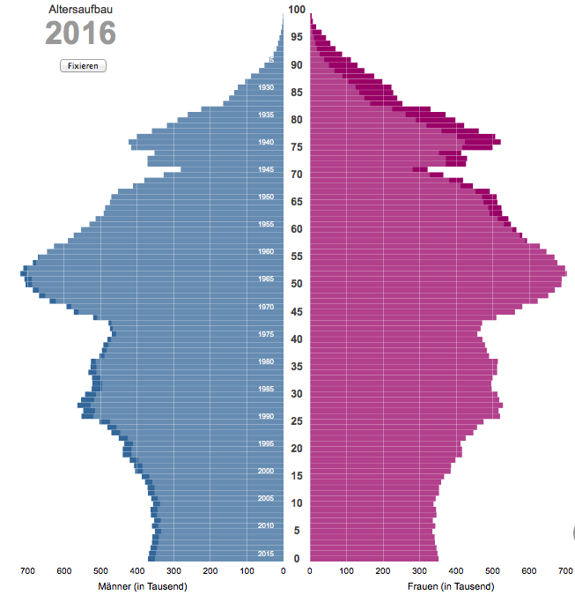
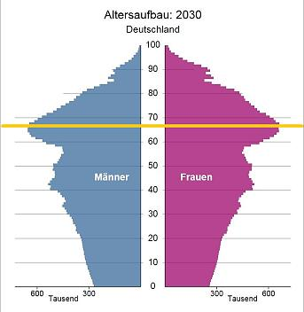

2. Reform in 2001

In 2001 there was a major pension reform in Germany which introduced subsidized private pensions and subsidized conversions of earnings. The relevant acts (Altersvermögensgesetz and Altersvermögensergänzungsgesetz) were passed on June 26, 2001 resp. March 21, 2001 and became effective January 1, 2002. The reasons for the reform were as follows:- it was feared that the contribution rate for public pension insurance would rise to 26 per cent by 2030 – due to demographic change. Such a high contribution rate together with expected increases in public health insurance contributions were viewed as being too high. The viability of the pay-as-you-go system is vulnerable to demographic change (a low birth rate in the baby-boom generation), from early retirement and late entry into the job market. Reforms over the recent years have made early retirement less attractive and have introduced small cuts or “adjustments” in the benefit system; but without the reforms of 2001, the contribution rate for pension insurance would have been 26 % of gross salary compared with a current rate of 18.7 %.
The reform therefore was aimed at keeping the contribution rate in public pension insurance at around 20 % until 2020 and 22 % until 2030 but with some reduction in the overall replacement rate. The outcome of a debate on pay-as-you-go financing compared with funding led to the introduction of some elements of capital funding in the overall system of old age protection.
By 2030 the replacement rate was at that time projected to be at 58.5 %. In 2040 the projected level was assumed at 51.5 %. The solution was to introduce a capital funded personal pension – named Riester-Pension after the Federal Minister for Labour and Social Order at that time Walter Riester. It is a system of subsidized personal pensions organised on a voluntary basis. The subsidy is via tax deductibility, cash subsidies and a reduced social insurance contribution base. When the scheme was initially developed lawmakers were not sure if this new measure would be widely accepted and thus planned to make it mandatory if the acceptance rate was low. This meant also tax-sponsoring of occupational pensions meeting the requirements of conversion of earnings which means that if an employee decides to convert earnings into pension entitlements in a pension plan provider by his/her employer, the employer then has to convert this into a pension right which means that s/he will set up an account on behalf of the employee in the employer pension scheme. This is voluntary for the employee and the employee can in principle “convert” as much of current pay into pension entitlements as s/he wants but practically speaking will limit it to what can be afforded and what is tax deductible as expenses for pensions and other provision.
The Reform in 2001 recognised these developments and introduced a requirement that employers are obliged to provide plans for conversion of earnings. Employees may also purchase other personal pensions which meet certain requirements set up by law. A combination of different approaches was used in the reform of 2001: in the first place any employee could require that his employer establishes a pension plan to be used for conversion of earnings of up to 254 € per month. In addition a system of state subsidies was established which applies if a person subscribes to a pension plan or a pension contract meeting certain requirements. This pension plan can be used either for conversion of earnings – linked to an insurance-based employer´s pension plan – or for any other plan which can be exclusively used only for retirement and works as a lifetime annuity, i.e. covering longevity risks as well. These plans are offered by insurance companies, banks and investment funds; what kind of investment they make depends on the rules for the different providers. “Riester Pensions” in a narrowly defined sense refer to these latter plans. The conversion of earnings in the meaning described above might be referred to as a Riester-sponsored pension or - in a broader sense a Riester Pension.
In all cases it is required by law that an amount equivalent to the contributions paid has to be guaranteed at the time of payment of the Riester pension. This means that investment risks are borne by the provider of the Riester product and results in a conservative investment approach. Therefore there is also no discussion on the effects of the credit crisis on Riester pensions.
To make Riester pensions attractive for employees a special tax subsidy was introduced. This means that amounts up to 2.100 € per annum are tax deductible. An alternative subsidy is not based on tax exemptions but on a cash subsidy administered by a special authority. This is specifically aimed at low income people who may be unemployed or whose income is insufficient to pay tax. In order to receive this subsidy an individual must establish and contribute to a Riester Pension plan. In order to be eligible for the cash subsidy at least the basic amount (4 % of last year´s income) has to be paid into the contract. For a person with two children at an income level of 30.000 € p.a. this subsidy may be of 754 €.
In the first years the take-up of Riester pensions was low. Possible reasons for this were the lack of awareness of the need for additional pension coverage, the unattractiveness of these plans for the insurance industry since charges could not be ‘front-loaded’ (groups at the beginning of the plan) but must be spread over a period of ten years. In addition in the first years subsidies were low as the system was phased in over a number of years. Last but not least the rules for this system were very complicated and difficult to understand and to work with – not so much for employees but for financial firms such as banks and the insurance industry. In this period it was feared that the Riester Pension would turn into a Riester flop. Against this background there were some reforms of the Riester system in more recent years. In 2005 the rules for certification were simplified and the system of commission for financial firms selling Riester contracts was made more attractive. In 2006 a general requirement of unisex mortality tables in Riester pensions was introduced. Finally from January 1, 2008 Riester pension entitlements can be used for financing a house or apartment intended for own use instead of receiving a Riester pension as an annuity. The development of Riester is shown by the following table which shows the number of contracts.
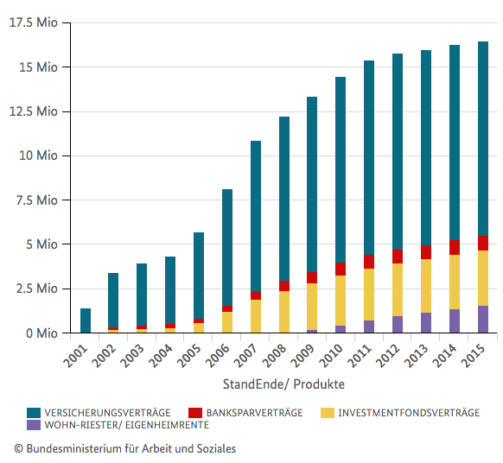
Findings have shown that personal pensions, i.e. Riester plans and conversion of earnings, are popular among medium and high income people. But they are not popular among low income people. It could be argued that low income individuals cannot afford additional pension contribution. Although it should be noted that those on low incomes receive a cash subsidy so that in order to contribute to a Riester pension very little of their own funds must be contributed; the cash subsidy is applicable if a person contributes at least 1 % of its own last year´s income. One possibility is that low income groups are not aware of the subsidies attached to Riester pensions. Another possibility might be that the Riester pension will be regarded as income under a means test in the case of a means-tested benefit in old age.
Therefore a basic criticism of the reforms is that the aim of avoiding poverty in old age is only met for people with medium and higher income who must contribute a greater amount than before the reforms. So those who contribute to Riester pensions will compensate for the reduction in Social insurance based pensions but in the end they pay more to achieve the same replacement rate as might be expected from the public insurance system alone prior to the reforms. So this reform has met its expectations only in part.

3. Reform in 2005

The reform in 2005 was a kind of follow-up on the reform of 2001. It was found that the measures in 2001 had not been sufficient enough to ensure a sustainable system. Therefore this reform – also called Rentenversicherungs-Nachhaltigkeitsgesetz (Act on Sustainability of Public Pension Insurance) introduced the above-mentioned sustainability factor which has shared the demographic risk between retirees and workers. The factor also takes into account the financial efforts of individuals to save in a Riester plan, i.e. to get additional private and funded pensions and reduces the income base. The “Riester Factor” has been criticized since private additional efforts reduce the pension paid by the public pension system.
This reform also abolished certain types of early retirement – for example retiring at age 60 after periods of unemployment.
The reform was aimed to achieve a more long-run stability and intergenerational equity in the pension system. This ought to have a self-stabilizing effect. It as a matter of fact indeed stabilized the system but also reduced pension benefits and by that reduced the replacement rate which in the end leads to less money on old age – and by that more burden on other social systems like social assistance because a lower pension might lead to poverty among the elderly. As computed, this factor in the first years due to low wage increases would have led to not only smaller increase but even cuts in benefits in pay. As a consequence it was fixed by law that the benefit amount should not be cut but it would be compensated by Zero-indexation for a couple of years; that again led to political problems since pensions were practically not adjusted despite considerable wage increases.
But in general this reform was not controversial as such since it was clear that such a stabilizing measure was necessary. The “only” problem has been that by this measure the replacement rate decreased further.

4. Reform in 2006

As already mentioned above the tax treatment of pensions from public pension insurance vs. pensions for executives was found unconstitutional by the Federal Constitutional Court (Bundesverfassungsgericht) in 2002.
In order to follow the constitutional requirements in the Alterseinkünftegesetz (Act on Old-Age Income) the taxation system was adjusted and now in principle not only pensions of public executives are taxable income but also pensions from public pension insurance. In order to make this workable from a fiscal point of view but also from the point of view of the beneficiaries there is a long transition period.
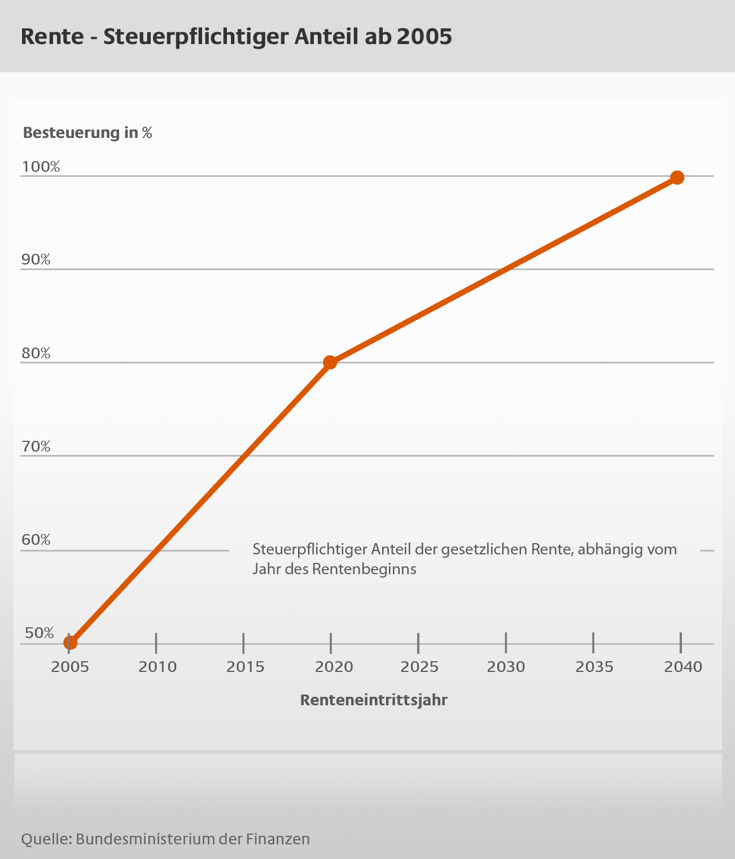
Rente – Steuerpflichtiger Anteil ab 2005 – means Pension from public pension insurance – part subject to taxation
Renteneintrittsjahr means year of start of pension
It can be seen from the table that over a long time public pension insurance benefits will be taxable income only in part – and in the same way deductible expenses will increase over the years.
This reform was a consequence of a legal issue but as an effect it also harmonized the German taxation rules substantially with the taxation rules of most other countries which in general make expenses for pensions tax deductible and tax pensions after retirement as income. The different rules have brought a number of problems in Europe when persons moved from one country to another one.

5. Reform in 2007

A highly controversial reform has been done in which changed the retirement age for the first time since 1916 when it was brought down from age 70 to age 65. As mentioned above one of the solutions for the pension problems is to increase retirement age which shortens the average period of payment of benefits and by that may lead to savings in pension expenditures. Therefore the intention of the Altersgrenzenanpassungsgesetz (Act on Adjustment of Retirement Age) raised the normal retirement age from 65 to 67. This is not done in one step but as shown above in a number of steps until 2030. This also applies to other old age systems like those for public executives and occupational – private – pensions.
This move has been highly controversial – not among the experts who had discussed and proposed it already for a long time - but in the general public. Experts always have been convinced that retirement age has to be increased and already urge to increase retirement age even more – to 69 or 70 in the foreseeable future. Originally the retirement age of 65 was aimed to give a pension to people who are typically unable to work because of age. Public health has been improved substantially over the decades and so people age 65 are much fitter than they have been decades ago. Early retirement then became a chance to enjoy a healthy retirement. The move towards working longer therefore was very unpopular and may even have become one of the reasons why the Social Democrats in elections in 2009 came down to around 25 % of voters from over 35 % before. It is still to be seen that most people retire before the normal retirement age of 65 and 6 months as of 2017 but the average age they retire has raised considerably. But earlier retirement has become “more expensive” because the actuarial reduction now takes the now normal retirement age as the basis.

6. Reform in 2014

In 2014 – right after the beginning of the current term of the German Bundestag (Federal Parliament) and government two different measures have been introduced which are in a way improvement in a sense that they improved the position of beneficiaries and possible retirees. It did not ease the financial burden on the system but rather introduced additional expenses.
This reform dealt with the so-called Mütterrente (mothers’pension) which means that the same number of credits for children are provided for births before 1992 as are provided for births after that date. So by now for those births two earnings points are credited until 2017 and after that three earnings points. This has put an additional financial burden on the system but was justified for reasons of equal treatment.
Far more controversial and problematic has been the introduction of early retirement at age 63 without actuarial reductions. This is limited to certain age cohorts and requires additional conditions to be met. In the first place it was estimated by the Federal Government that the claiming of this benefit would be limited but instead this form seems to be very attractive. The criticism comes from the fact that the message to be sent to the general public should be to accept later retirement rather than to make a kind of early retirement more attractive. It is a draw-back from the idea behind the actuarial reduction in case of earlier retirement. The additional costs or less savings for the system (no actuarial reduction) may be 10 billion € in 2018 and close to 20 billion per year in 2020. It is also criticized that only the older generation may profit from it and the younger generation has to bear the additional costs. Last but not least it is also contradictory to moves at the EU level to get people acquainted with a longer working life. The EU Commission proposes to link retirement age to increasing life expectancy. In a period of decreasing unemployment, industry also points to a loss of experienced and qualified personnel. In conclusion here this seems to be a move by the Social Democrats in government to deal with the opposition against unpopular raising retirement to age 67.

7. Reforms in 2016/17

In 2016/17 there have been several reforms in public pensions to be mentioned. Following the certain move towards back to earlier retirement the „Gesetz zur Flexibilisierung des Übergangs vom Erwerbsleben in den Ruhestand und zur Stärkung von Prävention und Rehabilitation im Erwerbsleben“ (Flexirentengesetz)“ (Act on a more flexible transition to retirement and on prevention and rehabilitation) was adopted. This new law will make it easier to work part-time in the period prior to full retirement and to receive a kind of part-time old-age pension. This law also makes it easier to work beyond retirement and thus gives additional incentives to work longer and retire later.
A very recent reform will finally unify the rules for pensions between East Germany and West Germany. Generally the same system applies but still there are some different figures calculations are based on. This will be harmonized gradually over the years until 2024.

IV. Conclusion

The German situation gives a mixed picture. In a way Germany has used all possible parameters for a sound and sustainable financing of public pension insurance.
The choice of increased pension contribution has not been considered. This is mainly because the financial burden – taxes and contributions – on the wages and other income is already rather high and cannot be increased anymore. This also would affect international competitiveness of Germany. There has once been a discussion on linking contributions to productivity; but this has been sorted out; this was especially for two reasons - one being the danger for competitiveness in high technology and the other being the weakening of the contributory nature of the system and the earnings-relation of benefits.
The choice of cutting benefits has been used in a number of detailed provisions. This was done mainly by using the system of earnings points and changing the value of non-contributory periods.
Indirectly this was also done by using the pension value formula. Here it has to be pointed to the sustainability factor which takes into account the relation of number of retirees to the number of persons paying into the system. The demographic risks by this move is shared between the working generation and the retired. All this is done with a kind of legislative automatism and therefore beyond the influence of government, by contrast with changes on which the legislator – parliament – has to act.
Another parameter used is the retirement age. This – like in other countries including China – has been the politically most difficult move since retirement age has something to do with planning one´s life and people view retirement as a – final – chance to just enjoy life. In addition there are also jobs with high consumption of personal energy that cannot be performed anymore by older workers so they wish to retire earlier. The retirement age move has been to raise it to age 67 but allow earlier retirement – but with actuarial reduction reducing the amount of benefits. The problem of this move is shown by the recent instruction of a retirement at age 63 without actuarial reduction for a number of years. This has to be seen as a political move and should not put into question the overall need to increase retirement age even more in the future.
Instead of enabling early retirement the move should be to make working longer more attractive. This is not only an issue of the rules of the public pension system but also of other incentives to stay in the labor market like part-time retirement or incentives for employers to employ older workers or continue to keep them in the jobs. Therefore consequently the latest move in Germany is that of arranging more flexibility.
Nevertheless all this has led to a considerably lower replacement rate for the future. Originally public pension insurance was aimed to provide a replacement rate after a full career of about 60 - 70 % of net income. Now it is estimated at less than 50 % and will even be lower in the future (Rentenniveau means net replacement rate)
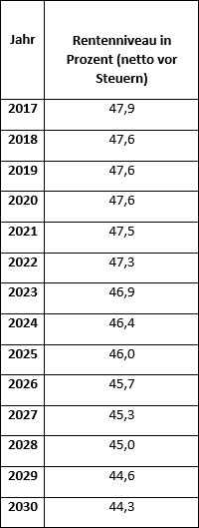
This is because of all the moves explained in this paper but also increased life expectancy.
This also means that public pension insurance can no longer be the only source of income in old age. Therefore Germany just recently has considerably improved the system of supplementary – occupational – pensions and tries to improve coverage also among employees of small and medium-sized companies. This will be done by introducing defined contribution plans based on collective agreements. In addition people are advised to save for retirement themselves.

Figures for 2017 – changed annually according to development of wages
Rentenversicherung in Zahlen 2016, pp. 40
The other half paid by employer
Bundesministerium für Gesundheit und Soziale Sicherung, Nachhaltigkeit in der Finanzierung der Sozialen Sicherungssysteme, Bericht der Kommission, Berlin 2003
© Statistisches Bundesamt
See Steinmeyer, Private und betriebliche Altersvorsorge zwischen Sicherheit und Selbstverantwortung, Gutachten 65. Deutscher Juristentag, 2004, Munich 2005; See on this Veil, Germany´s Pension Reform in 2001:More or Less Gender Equality?, in: Hughes/Stewart (Ed.), Reforming Pensions in Europe, 2004, pp. 207
Coppola/Gasche, Die Riester-Förderung – das unbekannte Wesen, MEA Research Paper 244/2011
See Bundesministerium für Gesundheit und Soziale Sicherung, Nachhaltigkeit in der Finanzierung sozialer Sicherungssysteme – Bericht der Kommission, Berlin 2003
Steffen, Wirkungsanalyse der Riester-Treppe, Berlin 2013
See Börsch-Supan/ Reil-Held/Wilke, How to make a Defined Benefit System Sustainable: The “Sustainability Factor” in the German Benefit Indexation Formula, Mannheim Institute for the Economics of Aging, Reserch Paper 37-2003
Decision of March 6, 2002 - 2 BvL 17/99
See also Wagner: Die neue Renten- und Pensionsbesteuerung, Regensburg, Berlin 2004.
Berkel/Börsch-Supan, Renteneintrittsentscheidungen in Deutschland: Langfristige Auswirkungen verschiedener Reformoptionen, MEA Research Paper 31/2003
See Deutsche Bundesbank, Monatsbericht August 2016 pp. 69
Institut der Deutschen Wirtschaft, Rentenpolitik: Die Jungen sind die Dummen, Cologne April 2017
European Commission, White Paper, An Agenda for Adequate, Safe and Sustainable Pensions, COM(2012) 55 final
Rentenversicherungsbericht 2015
See Steinmeyer, in Erfurter Kommentar zum Arbeitsrecht, Commentary on Betriebsrentengesetz – Supplementary Pensions Act, 18th edition – in Print

