A Summary of
NDRC Study Visit to France, Sweden and Finland
Organized by
Component 1, EU-China Social Protection Reform Project
September 2017

- Background of the Study Visit
With the objective to strengthen institutional capacity for social protection policy development and reforms in China, Component 1 (C1) of EU-China Social Protection Reform Project (SPRP) is commissioned to organize study visit, foreseen in the plan of the project as one of the key and normal activities, for its Chinese beneficiary, the National Development and Reform Commission (NDRC), particularly, its Department of Employment and Income Distribution (DEID).
From 13th - 21st September of 2017, a study visit was conducted in Europe, during which the Chinese Delegation from the DEID (the Delegation) had attended meetings and paid visits in three EU countries, namely, France (in Paris), Sweden (in Stockholm) and Finland (in Helsinki).
The Delegation was led by Mr. Li Kang, new Director General of the DEID since 2017, with the following members:
Mr. Niu Ming, official of Social Security Division, DEID, assuming the role of secretary for the Delegation;
Ms. Zhang Xia, official of General Division, DEID; and
Mr. Li Xiaoliang, official of the Employment Division, DEID.
The organizational and logistical support was provided by Expertise France, particularly Mr. Laurent de LespInay, coordinator of C1, with background work done by Mr. Jean-Victor Gruat, resident expert of CD1, assisted by Ms Li Lingxi, assistant of C1 and Mr. Dai Bowen from International Cooperation Center (ICC), who helped translating the slides presented in the meetings.
For special reasons, Mr. Giovanni (Guowang) Lin, assumed the role of assistant to this study visit, mainly working as companion of the Delegation and interpreter of the conferences and meetings.
During the conferences and meetings, researchers and representatives of EU counterparts invited by C1 gave speeches or made presentations to the NDRC delegation, constituting major activities of this study visit. The following paragraphs are mainly dedicated to the summary of these presentations.

2. Study Visit in Paris
Three activities were foreseen and organized in Paris, namely an International Workshop on Social Protection (Pension) the Policy Dialogue, and Co-operation Meeting between NDRC and EU counterparts.
2.1 International Workshop: Towards Fair Affordable and Adequate Pensions – Parametric Reform and Redistribution through Public Pension Schemes
Workshop is the final stage of researching activities planned in the SPRP framework. This workshop in Paris is the conclusion of C1 research topic related to redistribution effect of pension system.
Participants of the workshop include officials from EU agencies, member-states and OECD, and experts from EU and China. They made their presentations respectively in the sessions of the workshop:
2.1.1 In Opening Ceremony, Mrs Nathalie Nikitenko, Delegate for the European and International Affairs, Ministry of Solidarities and Health, Ministry of Labour (France) and Mr. Li Kang, Director General, DEID, NDRC made key-note speeches for the workshop.
Mr. Andraz Rangus, Chair of EU Social Protection Committee Working Group on the Pension adequacy report, made his presentation on Pension adequacy in European Union countries.
2.1.2 In the 1st session Parametric Reforms in Public Pension System, Mr. Mr. Koen Vleminckx, Director General Strategy, Research and International, Federal Public Service Social Security, Belgium, took the chair.
Ms. Zhou Hong, Researcher, Member of Academic Board of Chinese Academy of Social Sciences (CASS), made her presentation on Chinese pension reform, and the relevance of the European experience.
Following are experts from EU member-states that gave reviews on pension systems in their respective countries, including Mr. Jan Skorpik and Mr. Marek Suchomel, from Ministry of Labour and Social Affairs of Czech Republic; Ms Anne Lavigne, General secretary, Pensions Orientation Council from France; Mr. Carlo Mazzaferro, from University of Bologna, Italy; Mr. Andrzej Szybkie, from the Social Insurance Institution ZUS, Poland; and Mr. Karl Birkholz, from the Swedish Pensions Agency, Sweden.
In the afternoon, it’s the 2nd session, which is on The Influence of Parametric Reform on Redistribution through Public Pension Schemes, chaired by Ms. Zhou Hong, CASS.
For this session, Mr. Li Shi, Dean of China Institute for Income Distribution, Beijing Normal University, made his presentation on Current and prospective redistribution through the Chinese pension scheme for urban employees;
Mr. Pieter Vanhuysse, Danish Center for Welfare Studies 30 minutes made his presentation on Political Economy of Pensions and Redistribution effects in Europe; and
Ms. Céline Thévenot, Social Policy Division, Directorate for Employment, Labour and Social Affairs, OECD, made her presentation on Trend, causes and remedies to income inequality in OECD.
Following the 2nd session was the general discussion, and then Mr. Li Kang, Director General, DEID, NDRC and Mr. Bertrand Barbé, Director General Delegate, Expertise France made closing comments on the international workshop, marking the success of the conference.
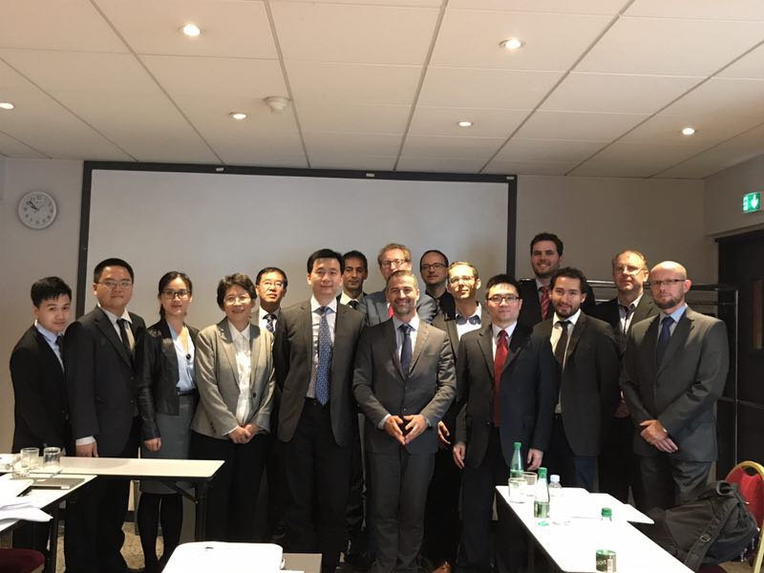
  - Policy Dialogue
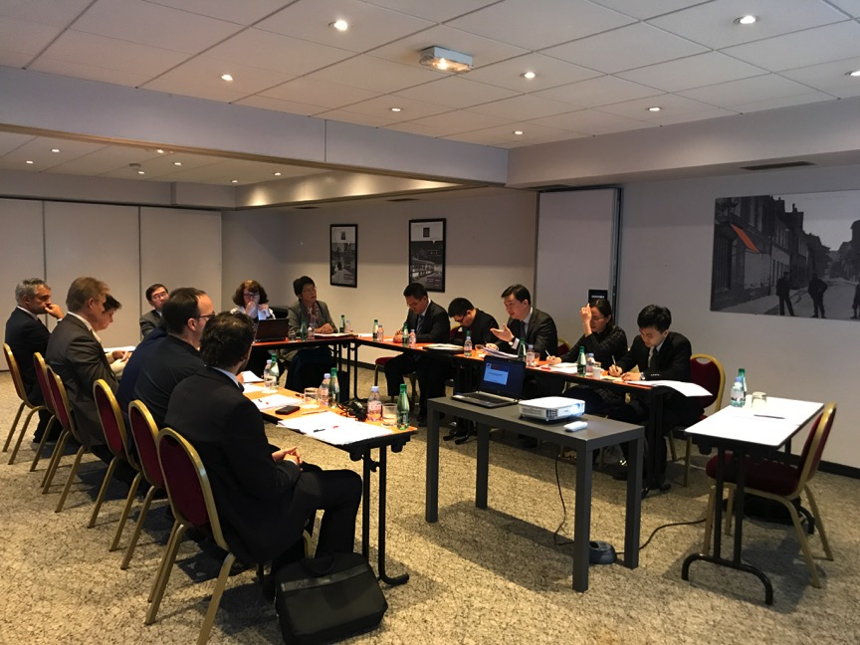
Policy Dialogue is an activity foreseen by EU-China SPRP as an event for the Chinese beneficiary to make face-to-face talk with EU counterparts.
During the study visit, a Policy Dialogue was held in the morning of 15th September, with the participation of NDRC delegation, including NDRC officials led by Director General Li Kang, professor Zhou Hong from CASS and professor Li Shi from BNU, and EU counterparts, including
Ms. Barbara Kaufmann, Employment, Social Affairs and Inclusion DG, European Commission;
Mr. Stefano Scarpetta, Director for Employment, Labour and Social Affairs, OECD;
Mr. Antero Kiviniemi, Social Protection Expert, Finland Representation to the EU;
Mr. Koen Vleminckx, Federal Public Service Social Security, Belgium
Mr. Michel Villac, Vice-President of French High Council of Family, Children and Aged Persons (HCFEA).
Mr. Michel Villac and Mr. Li Kang were the co-chairs of the dialogue.
The dialogue was divided into two sessions:
1^{st:} Employment and Social Integration; and
2^{nd:} Social security and income redistribution.
During the two sessions, EU and Chinese participants had made their speeches and exchanged their opinions on concerned issue, in particular the income distribution effect, as well as social integration function, of social security system.
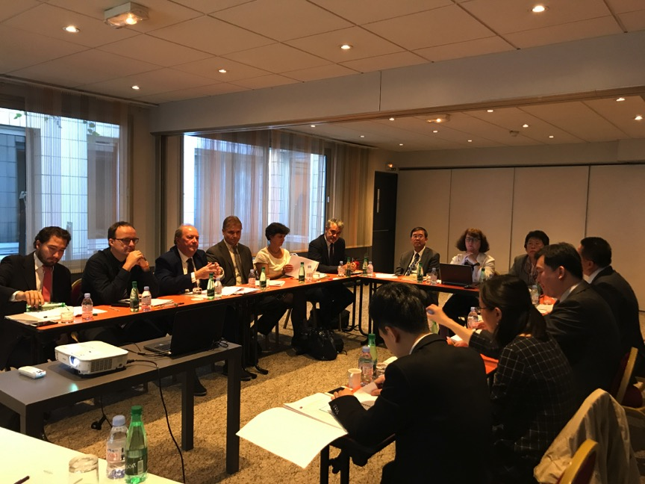
  - Co-operation Meeting
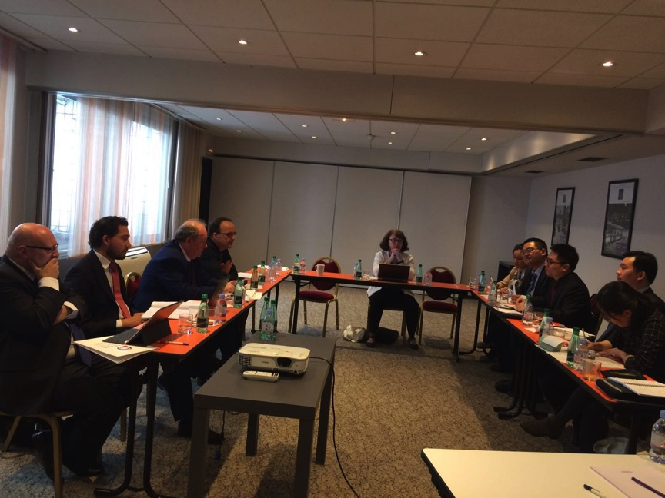
NDRC Delegation intended to establish or reinforce co-operation with EU counterparts. For this, Component 1 organized a co-operation meeting for the Delegation in the afternoon of 15th September. The speaker of the meeting was Mr. Michel Villac, whose speech was supplemented by other participants, including representative from French mutual insurance agency.
The Chinese Delegation had expressed their intention to deepen relationship with EU counterparts in social security issues, and EU counterparts had also responded to this intention and expected to realize further cooperation in an appropriate way.
The Co-operation Meeting marked the successful end of NDRC Delegation’s official visit in Paris, after which the Delegation proceeded to Sweden (Stockholm) for meeting relevant agencies.
- Study Visit in Stockholm
  - Swedish Pension Agency
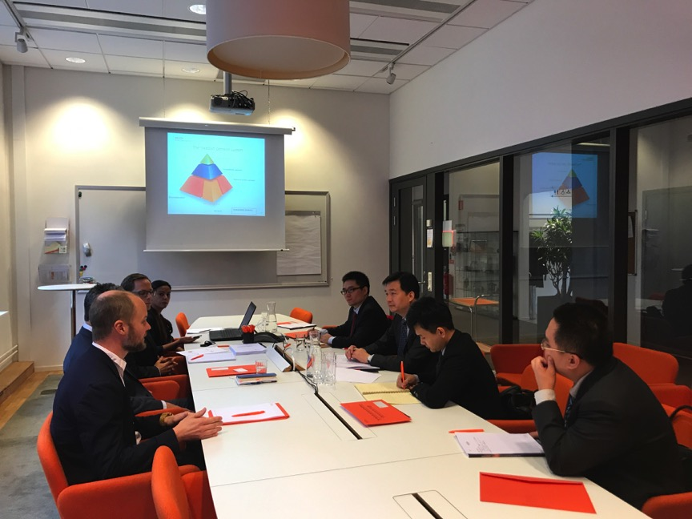
As planned, the meeting with Swedish Pension Agency was held at 9 :00 on 18th September 2017.
Mr. Mats Öberg, Head of Fund and Finance, made welcome speech to the Delegation and brought salute from the President of Swedish Pension Agency. Following his speech, Director Li Kang, delivered his opening speech, introducing the purpose of this mission, after which a presentation from Swedish side was made.
The presentation was jointly made by Ms. Estrella Zarate, team manager and actuary of Swedish Pension Agency, and Mr. Karl Birkholz, analyst of the Agency, who had also participated in the International Workshop in Paris. The presentation was on the pension system of Sweden, with more detailed information. During the presentation, Mr. Erik Granseth, analyst of the Agency, had made additional explanation to several points and the Chinese attendants also raised their questions, such as what is the comment of the speakers on the Swedish pension system and what are the challenges facing this system.
Finally, for the conclusion Director Li Kang extended his appreciation to the hospitality of Swedish Pension Agency and expressed the intention of NDRC to continue cooperation and study with the Agency.
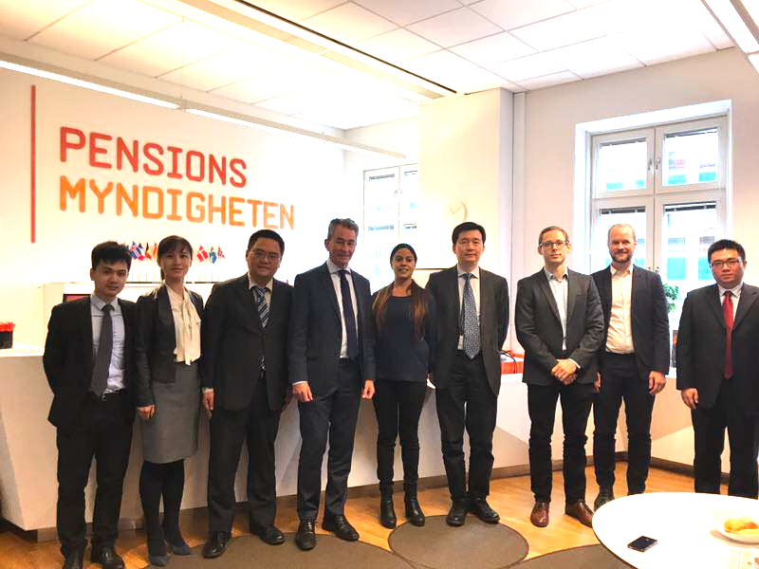

  - Swedish Ministry of Social Affairs and Health
The meeting between NDRC delegation and Swedish Ministry of Social Affairs and Health was started at 13 :00 on 19th September 2017.
Ms. Cecilia Ryberg and Ms. Helena Kristiansson-Torp, officials from Ministry of Social Affairs had welcomed the Chinese Delegation and given the participants joint presentation on the reform made by the current Swedish government, and what’s the function of the Ministry during the reform. Problems that Sweden is concerned with were also introduced.
The Chinese Delegation had also raised their questions on interested issues. After the presentation, the two Swedish officials had also presented materials regarding Swedish reform to the delegation.
- Study Visit in Helsinki
  - UNU-WIDER
The United Nations University World Institute for Development Economics Research, UNU-WIDER, located in Helsinki, provides economic analysis and policy advice with the aim of promoting sustainable and equitable development for all, particularly developing countries.
The meeting between NDRC delegation and UNU-WIDER was started at 9:00 on 20th September 2017.
Professor. Finn Tarp, director of UNU-WIDER, hosted the meeting and gave the first presentation to NDRC, which was the introduction to UNU-WIDER and the researches the organization had done by then.
Director Li Kang gave his speech, introducing the mission of NDRC and the main concerns of the Delegation.
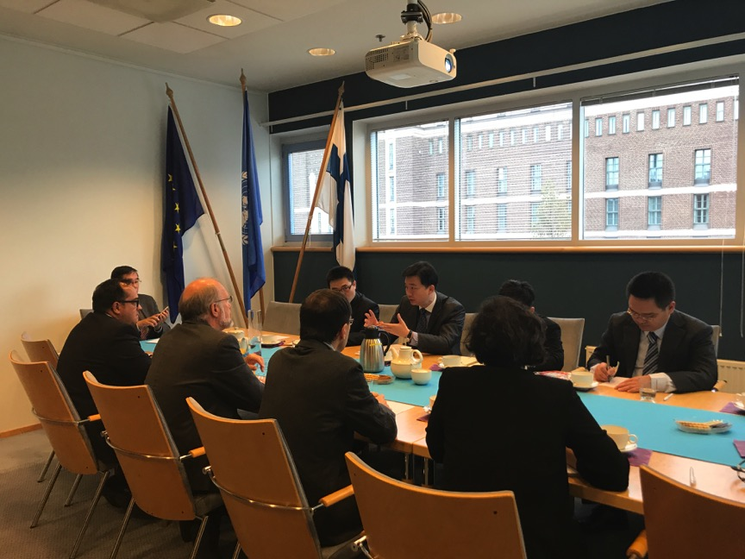
Following the speeches made by the two directors, three presentations were made, respectively by researchers at UNU-WIDER, as follows:
Dr. Carlos Gradín, research fellow from Spain, Dr. Miguel Niño-Zarazúa, research fellow from Mexico, and Dr. Rachel M. Gisselquist, reasearch fellow from US. Each of the reasearch fellows had made presentation on their respective researches, including that on the inequality of pension protection among different ethnical groups.
The meeting with UNU-Wider was concluded with a friendly lunch, during which discussions on interested issues were still going on.

  - Finnish Unemployment Insurance Fund
The Finnish Unemployment Insurance Fund, TVR, is a public body that manages unemployment insurance system for Finnish citizens, is responsible for proposing yearly contribution rate of unemployment insurance to the Finnish parliament, and has indirect relation with Finnish Ministry of Social Affairs, etc.
After communication, TVR and NDRC Delegation agreed to hold their meeting at 9 :00, 21st September 2017.
Mr. Janne Metsämäki, Managing Director of the TVR since January 2015, hosted the meeting, with the participation of Mr. Tapio Oksanen, economist and Deputy Managing Director of TVR since 2012, and assistant of Mr. Janne Metetsämäki.
Two presentations were given to the NDRC delegation. The first one, by Mr. Janne Metsämäki, was mainly on the general features of TVR, its mission and relationship with other public organs in Finland.
The second presentation was made by Mr. Tapio Oksanen, mainly on economical analysis on Finish situation, especially the situation after the 2008-2009 crisis. A key issue in the presentation is the recover of employment after the crisis, following the recover of Finnish economy, for which Mr. Oksanen made economical comparison between Finland and China, which might be better fitting into the interest of Chinese delegation.
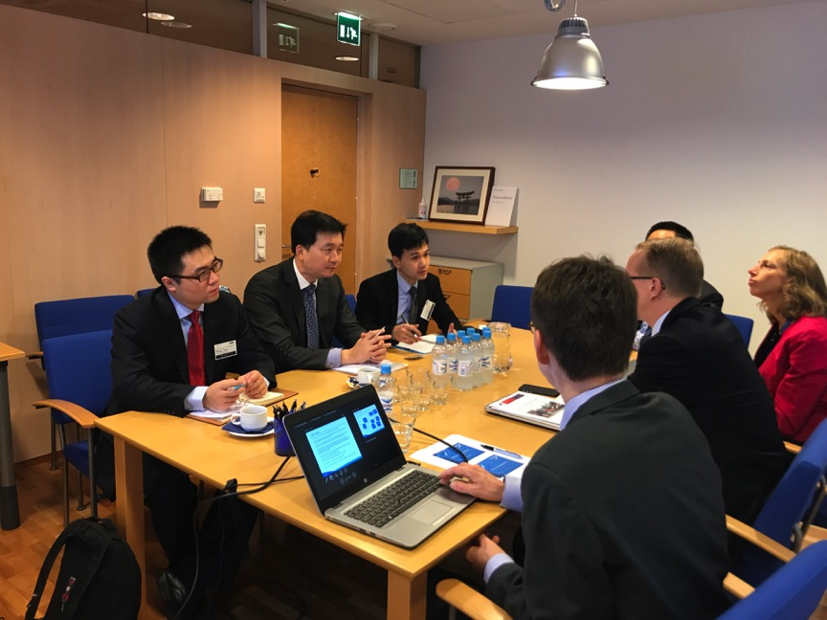

  - Finnish KELA
KELA is the Social Insurance Institution of Finland, managing the national pension for the finish citizen. It is conducting the experiment on universal minimum income on behalf of the current Finnish government, which is interesting to social protection policy makers and researchers around the world.
As agreed, the meeting was started at 10 :30, 21st September 2017 at KELA.
The presentation was given by Mr. Simanainen Miska, one of the key participants in the experiment on universal minimum income. He listed the basic concepts related to and background of the experiment, in which the Chinese delegation was interested. Mr. Li Kang and other Chinese delegates made their questions to Mr. Miska, about the experiment. The exchange had been successful.
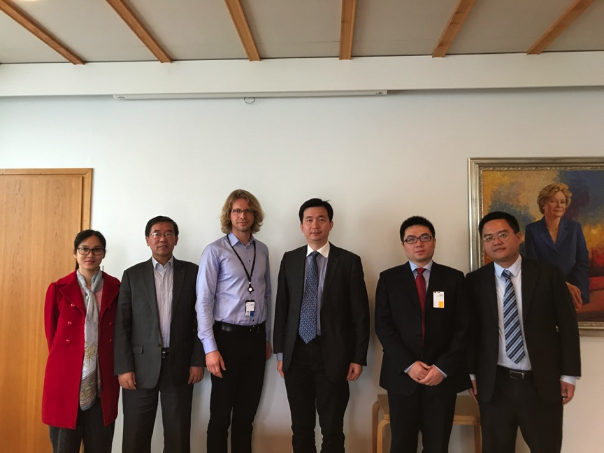
The NDRC meeting with KELA was also contributed by Prof. Li Shi, who had assisted C1 to contact the Institution and arrange the meeting.

  - Finnish Center for Pensions
Different from KELA, the Finnish Center for Pensions, ETK, mainly manages earnings-related pension in Finland. The meeting with ETK started at 12 :00, 21st September 2017.
Mr. Mika Vidlund, Liaison Manager of Planning Department, ETK, organized the meeting for the NDRC delegation, and Mr. Kaarlo Reipas, mathematician of ETK, also participated in the meeting. For the Delegation, Mr. Vidlund gave a presentation named Finnish Pension System at A Glance, which is on the general features of Finnish pension system, including the earnings-related pension and other kinds of pension. In particular, he introduced to the Delegation information on the legislation, supervision and execution of the earnings-related pension system in Finland.
Mr. Kaarlo Reipas, as a mathematician, gave a presentation on Adapting to Changes to Life Expectancy in the Finnish Eernings-related Pension Scheme. In which he introduced the basic situation on the reform 2015 and reform 2017 on Finnish pension system, the aim of which is mainly to adapt the pension system to changing life expectancy. Technological issues, such as simulation of life expectancy, were also contained in the presentation.
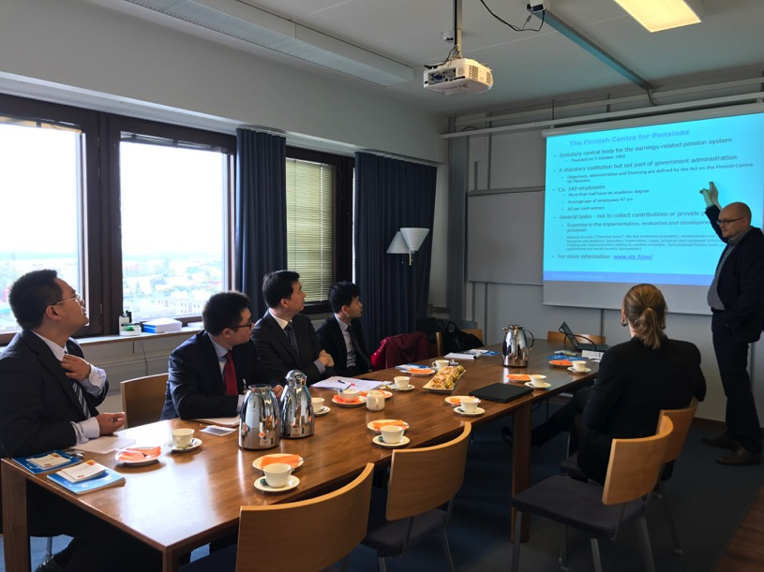

- Conclusion
As one of the key activities of C1 in 2017, the NDRC Study Visit to France, Sweden and Finland was successful, with fruitful gains from the conference and meetings, satisfying the needs of Chinese beneficiary. The Chinese delegation had also established and consolidated the foundation for further co-operation with the EU agencies, which is also one of the objectives foreseen in the EU-China SPRP.
Lin Guowang, October 2017

