Parametric Pension Reform in European Member States

Country Report
Sweden

Component 1

June 2017, v.2

The Swedish Pension Reform

Karl Birkholz

Swedish Pension Agency

Research Department

Contents
Introduction 1
Background 2
Principles of the Reform 3
The Political Process 5
The Old System 6
The New System 7
Contribution Rates 8
Guaranteed Pension 9
Inkomstpension 10
Premium Pension 12
Transition Rules 13
Details 14
Public Debate 16
Evaluation 19
References 20

Introduction
This report aims at in short describe the systemic Swedish national public pension reform that took place in Sweden roughly from 1991 to 1998 and the focus is on the earnings related pension. The background and the principles are outlined and then an overview of the previous and the current system is given. Some technical details and a few topics of public debate are also presented. For an extensive description please see the Annual Report of the Swedish Pension System [1] where the technical details are given.
Tax levels and occupational pension schemes obviously affect the individual’s pension, this is however separated from the national public pension system and will not be covered in this report. The tax levels has been changed several times since the introduction of the new pension system. Before the reform pension was taxed at a lower rate than wage earnings, the reform aimed at and achieved for a short period to have the same tax scale for wage earnings as pensions. Now the situation is somewhat complex – low pensions are less taxed than equally low wage earnings. Normal and higher pensions are taxed at a higher rate than equally high wage earnings. Occupational schemes are adapted, by the social partner, to the national pension system in that the contribution rate is set in relation to the contribution ceiling where in general a larger contribution is paid for incomes above the ceiling. For high income earners the occupational pension can be the larger part of the total pension.

Background
In 1960 the ATP system, a defined benefit pay-as-you-go supplementary pension system, was implemented. In the early 1990s the deep recession resulted in that the savings rate fell to its lowest level since post World War II. Short-term variations between pension disbursements and contribution was however not considered as the threat of the long-term financial stability of the pension system. Temporary deficits between contributions and pension disbursements could be financed through the pension buffer fund. The instability of the pension system arose from the weak link between benefits to long-term changes in the growth rate of the economy.
The pension expenses were expected to rise by 2 percent per year in real terms under the coming decades and largely independently by the growth rate of the contribution base. Consequently, the savings rate in the national pension system would be highly dependent on the growth rate of the contributions. Projections at that time (in 1993) showed that with unaltered contribution rate the savings rate would soon be negative, the pension buffer fund would shrink and eventually deplete [2].
The government’s proposal was to conduct an in-depth reform of the national pension system. The aim of which to make it more adaptable to changes in economic growth rate as well as demographics. Another goal was to achieve a closer link between contributions paid and benefits received from an individual’s perspective.
It was considered that a preservation of the current pension scheme would in the future result in drastic changes with retroactive effects. Limiting the reform to minor changes would mean that the problems to a great extent would remain. The new rules of the system was intended to be as stable as possible.
In 1991 a Commission was set up and in 1992 a draft of a new pension plan was presented. In 1994, the Riksdag (Parliament) adopted the fundamental principles of the new pension plan. The main legislation of the system passed Riksdag in 1998 and in the 21st century the first pension disbursements from the new system were made.

Principles of the Reform
This section and the opinions stated are those of the bill decided on by the Riksdag in 1994. The bill Reforming the National Pension System (Proposition 1993/94:250) [2] contains the essential features of the new national public pension system and the year 1994 became a milestone of the reform.
The government proposed that a national mandatory pension system would continue to be the foundation of the individual’s pension. By reasons of effectivity and the inability of some to properly save for themselves, a mandatory system would be the best option. The national public pension should continue to contain an economic protection for those who have had low or no incomes.
The reform should focus on the younger generations, retired and soon to be retired should not be affected. For the in-between generations the transition should be smooth. The youth should know the conditions that will be applicable for them.
Insurance risk of old age pension namely longevity is of a different sort than that of early retirement. Administration and control necessary for early retirement was also considered greater. The old age pension would therefore be more suitable for actuarial principles and the reform should strive for the creation of an independent old age pension system of which recurring decisions would not be necessary.
The old age pension should be a separate branch financed in full by a specially designed contribution rate. Elements of redistribution should be explicit and financed continually, as pension credit accrued, by contributions from the central government budget.
The government found it neither possible nor desired to reform the pension system to a fully funded scheme. Advantages with a funded system in the sense of an increased savings rate on an individual basis rather than a further growth of the pension buffer fund were put forward. The reformed pension system should largely be a pay as you go system with a complement of individual premium reserves.
Another argument was the spreading of risks; the new system would be affected of the economic growth rate as well as the development of the financial market.
According to the life income principle of the reformed pension system all incomes below a certain ceiling should carry the same weight no matter when it was earned. For administrative reasons however it is unavoidable to have a certain income threshold for earning pension credit. There should not be an upper age bound for earning pension credit.
In the life income principle proposed pension credit can be earned not only by gainful employment but also at times of sickness and parental leave as well as times of unemployment. It was however not considered a task for the pension system to compensate for the income differences in society.
The accrued pension credit should be indexed by the growth of the pensionable incomes. A pension system where benefits follow the general income development and not to a great extent be dependent of the rate of return of the financial market must be organized as a collective and mandatory scheme.

The Political Process
The following is based on the experience of Bo Könberg who was Chairman of the parliamentary Working Group on Pensions [3]. Könberg strived not to invite social partners and pensioner interest groups into the Pensions Working Group. Könberg had previous experience with tough negotiations where participants in the room were not actively engaged in the discussion but rather watching over different special interests. Another important element was to have few members from the political parties and have them appoint high profile politicians within their respective parties. Within the group Könberg strived to achieve an open discussion.
The actual people involved in the process was according to Könberg very important for the success of the reform. An important external factor was the financial crisis of the 90s in Sweden, which probably led to the political ability of making tough decisions.
The hardest issues in the process was the issue of introducing a funded part (premium pension) and the contributions above the contribution ceiling.

The Old System
The pension system now phased out consisted of two main parts; a universal minimum pension (folkpension) and a general supplementary pension (ATP). The two systems combined are also referred to as the ATP system (or supplementary pension), which was a DB (defined benefit) scheme. ATP pension also included early retirement pension as well as survivor’s pension.
The foundation of benefits paid are pension points, which are determined annually as the pensionable income reduced with the higher price-related base amount that is then divided by the higher price-related base amount.
At the year the cohort reaches the age of 65 years, pension points can no longer be credited. In order to be credited a pension point the pensionable income must be greater than the higher price-related base amount. A full pension requires a record of 30 years of pension points. If a person has 28 years of pension points the pension will be 28/30 of what it would have been if the person would have had 30 or more years.
At the time of retirement which is (and was) flexible with the anticipated age of 65 years, earned pension points are converted into a pension. The pension is determined as the average of pension points for the best 15 years multiplied by 0.6 and the price-related base amount of the current year. The folkpension is then added as 96 percent of the price-related base amount for an unmarried and 78.5 percent for a married person.
The ATP system was financed through the central government budget but had substantial funded assets in a trust fund.

The New System
The new system consists of two earnings related components inkomstpension and premium pension. The inkomstpension is a pay as you go NDC (Notional Defined Contribution) system and the premium pension is a FDC (Funded Defined Contribution) system. The earnings related pension can be claimed at the age of 61 and with no upper limit, inkomstpension and premium pension both increase for each month of postponement. There is an option of drawing part pension at 25, 50 or 75 percent.
Basic security in the form of guaranteed pension and housing supplement and maintenance support to pensioners is available from the age of 65, a postponement of these benefits will not yield a higher amount. The basic security is tax financed through the central government budget. The housing supplement and maintenance support are means tested benefits and the details of these will not be covered here.

Contribution Rates
The contribution to the national public pension is 18.5 percent of the pension base. Contribution is divided between an individual contribution and an employer’s contribution.
The pension base is maximum 7.5 income-related base amounts. The individual’s contribution is 7 percent of his or hers income and it is not included in the pension base and the pension base is therefore 93 percent of the individual’s income. Contributions on incomes up to 8.07 income-related base amounts is thus paid together with the withholding tax on earnings.
The insured pays an individual pension contribution of earnings and any benefits received from the social insurance and/or unemployment insurance schemes. Annual earnings are pension-qualifying when they exceed the minimum income for the obligation to file a tax return, which as from 2003 is 42.3 percent of the current price-related base amount. When an individual’s income has exceeded this threshold, it is pension-qualifying from the first krona.
The total employer’s contribution is 31.42 percent of the individual’s earnings, out of this the old age pension contribution is 10.21 percentage points. This contribution is also paid on earnings exceeding 8.07 income-related base amounts. Since there is no pension credit for earnings above 8.07 income-related base amounts, these contributions are in fact a tax, and such contributions are transferred from the pension plan to the government budget. For recipients of pension-qualifying social insurance or unemployment insurance benefits, the central government pays a contribution of 10.21 percent of these benefits to the pension system.
The total pension contribution is thus 17.21 percent of the individual’s earnings, whereas the pension credit and the pension contribution are 18.5 percent of the pension base.
For persons credited with pension-qualifying amounts, the central government pays a contribution of 18.5 percent of the pension-qualifying amount to the pension system. These central government contributions to the old-age pension system are financed by general tax revenue.

Guaranteed Pension
The guaranteed pension provides basic social security for individuals with little or no income and is financed through the central government budget. Residents of Sweden are eligible for a guaranteed pension beginning at age 65. The qualifying criteria is primarily years of residence. Guaranteed pension is financed through the central-government budget.
The indexation of the guaranteed pension follows the price indexation. The amounts received differs between a single and married pensioner, where the former receives 2.13 price-related base amounts and the latter 1.90 price-related base amounts.
The guaranteed pension is reduced in respect to the earnings-related pension. For (low) earnings related pension the guaranteed pension is reduced by the full amount up to 1.26 price-related base amounts and is then reduced by 48 percent in the span between 1.26 and 3.07 price-related base amounts for a single pensioner. The corresponding numbers for a married pensioner are 1.14 and 2.72, for a graphic illustration see Figure 1.
When calculating the guaranteed pension the premium pension is excluded from the earnings-related pension, instead the inkomstpension is calculated as if it had been earned at 18.5 percent of the pension base, rather than 16 percent.
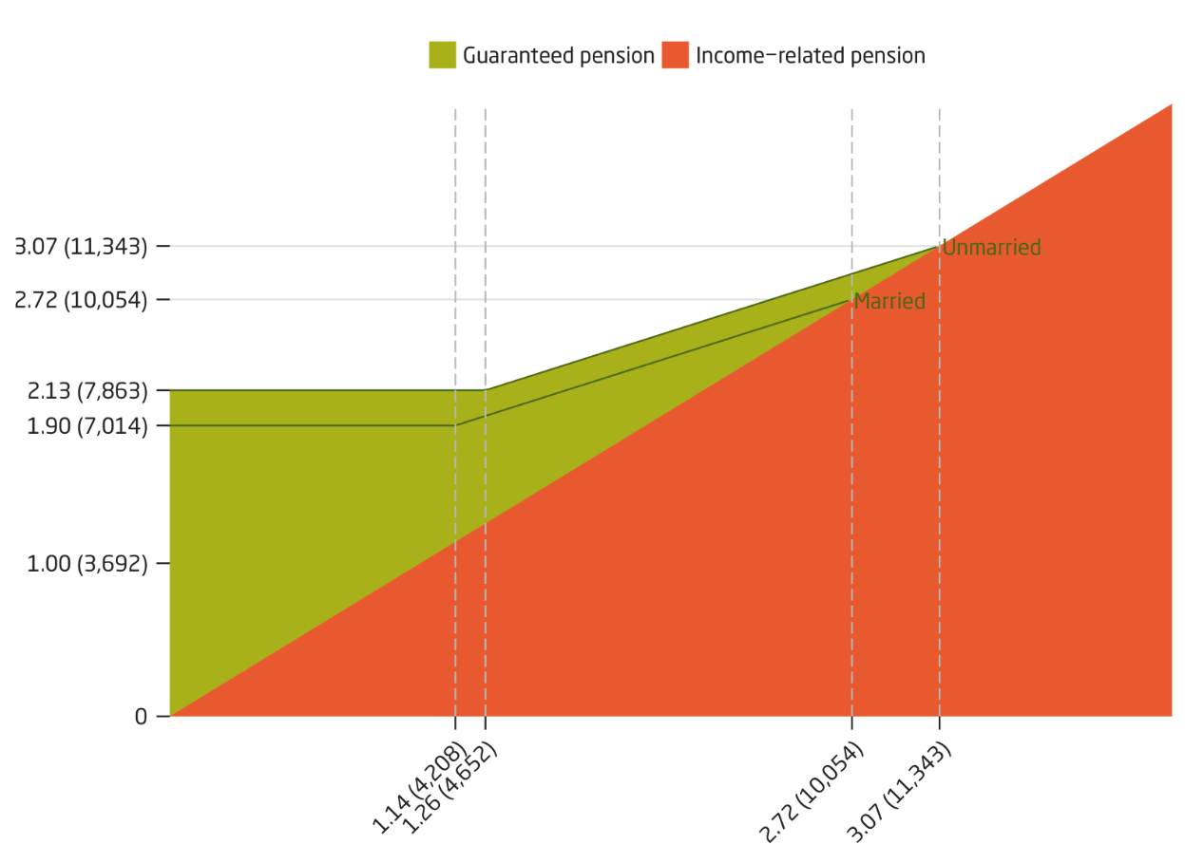
Figure 1. The figure shows the reduction of guaranteed pension in relation to income-related pension. Values represent price-related base amounts and (monthly pension in SEK, 2016). Source: Orange Report 2016.

Inkomstpension
The inkomstpension is the largest part of the income related pension and it is a NDC (Notional Defined Contribution) scheme. From the contribution of 18.5 percent of the income base, 16 percentage points are deposited into the buffer fund. The monthly pension payments of the inkomstpension come from this fund.
Pension credit earned is registered on the individual’s account in the same way as in a funded scheme with the difference being that the contribution is used to finance today’s pension disbursements.
Each year (in December) pension credit is accredited to the individual’s personal notional account. Before new pension credit is added, the previous year’s value is multiplied with an inheritance gains factor. The inheritance gains factor redistributes capital of the deceased to the survivors of the same cohort. For ages up to the age of 60 it is the actual accumulated capital that is redistributed whereas it from the age of 60 and above is based on the life expectancy of the total Swedish population, which is the same data used for the calculation of the annuity divisors.
Total capital is indexed with the change of the income index (balance index in a balancing period) over the year-end. To cover administrative costs an administrative-cost factor is applied to the account balance. For pensioners no administrative cost is deducted. These statements are distributed to each individual each year in the Orange Envelope.
Upon retirement, the accumulated notional capital is converted into a monthly pension by the usage of the annuity divisor. The annuity divisor is the life expectancy at the given age with consideration given to the advance interest of 1.6 percent. The application of the advance interest rate raises the initial pension payment at the expense of a reduced indexation. At the year the individual turns 65 the annuity divisors for that cohort will be fixed for all ages. Increases in longevity will therefore put a strain on the system. The annuity divisors are calculated on period data for the latest five-year period available and it is unisex.
Indexation is normally the growth of the average income measured by the income index. As of 2017, the income index of year t measures the change in average income between years t-2 and t-1. If assets are less than liabilities the indexation is reduced and pensions and account balances are then indexed by the balance index. Adjustment indexation is used for pensions, which is indexation with the reduction of the advance interest of 1.6 percent.
The quotient between assets and liabilities is termed the balance ratio and a ratio less than unity results in reduced indexing. A balance ratio less than unity triggers the automatic balancing mechanism and a balancing period is activated and remains until the balance index reaches the income index. During this period the indexing will be greater than that of the income index when the balance ratio is greater than one and reverse if it is lower. As of 2017 (calculated in 2016 based on data up until the year 2015) a damped balance ratio was introduced which mitigates the impact to one third.
Liabilities are divided into economically active and pensioners, for the active the liabilities are the summation of their account balances at the year-end. The liability of the pensioners are estimated as the lifelong value of current pensions, this is done by multiplying the pension disbursements of December with the economic annuity divisor of the same cohort and the factor 12 (number of months). An estimation of earned pension credit during the year (which is not yet known) is also added to the liability.
Assets are divided into funded assets (buffer fund) and the contribution asset. The value of the buffer fund is the market value per 31 December of the five AP-funds. The contribution asset is the contribution revenue multiplied by the turnover duration. The contribution revenue is the total pension contributions paid to the pay as you go system during the year. The turnover duration reflects the expected time from the earnings of pension credit to the time of pension disbursement.

Premium Pension
The allocation to the premium pension is 2.5 percentage points of the 18.5 percent of the pension base. The credit is invested in interest-bearing assets until the final tax settlement, when each individual’s credit is known.
The first pension credit for the premium pension was earned in 1995 but was invested in funds in the autumn of 2000. At the time, the importance of making an active choice was conveyed. Consequently about two thirds made an active choice of the about 450 funds available.
The premium pension is a fully funded premium savings scheme. Each person has his or her own personal savings account and each year (in December) new pension credit is deposited into the account. The individual can choose up to five funds at a time for investment of their capital. Placement changes are free of charge for the individual and can be made at any time. A default state-owned fund is available (AP7 Såfa). The Pensions Agency acts as the owner of fund shares and is a single client in respect to the fund.
The capital is once a year multiplied with an inheritance gains factor (just like in the inkomstpension). The application of the inheritance gains factor redistributes the capital of the deceased to the survivors, the computation is different from the one used in the inkomstpension but with the same concept. An administration fee is deducted from all accounts. The fee is proportional and the average fee of 2015 was 0.07 percent with a ceiling of 120 SEK.
The individual also indirectly pays a fee to the fund management; this fee is taken from the fund and thus lowers the rate of return of the fund. The Pensions Agency has a fee ceiling for the funds, which is 0.89 percent for equity funds, 0.62 for mixed and generational funds and 0.42 percent for bond funds. If the fund fee is larger than the ceiling (which is not uncommon) the fund management will have to reimburse the Pensions Agency which in turn distributes the capital to the fund savers the following year. The average capital weighted management fee as of 2016 was gross 0.72 percent and net 0.23 percent.
At retirement the accumulated capital is divided by an annuity divisor, the divisor is computed in a different way than in the inkomstpension and it is recalculated each year for all cohorts. The pension can be drawn as either traditional insurance with profit annuity or fund insurance. Except for the guaranteed amount in the traditional insurance, there are no guarantees within the premium pension system. The individual bears the full risk in terms of longevity and the rate of return on capital.

Transition Rules
The introduction of the new system also led to changes in the ATP system. The indexation of pensions is the same for ATP and inkomstpension. The adjustment indexation is a consequence of the advance interest in the annuity divisor used in the inkomstpension, which does however not affect the ATP-pension.
The ceiling for earning pension points in the ATP system is the same as the ceiling for earning pension credit in the new system. The maximum number of pension points per year used to be 6.5 but with the income indexation of the ceiling, this number is no longer fixed.
Pension credit has been credited retroactively as far back as 1960, this also applies for childcare years. Pension credit for compulsory national service and for studies has been retroactively calculated back to 1995. These conversions were made in the year 2000 [4].
The income index also had to be retroactively calculated in order to index pensionable incomes.
With the separation of the old age pension from the state budget costs of early retirement is still financed through the central government budget. As a consequence financial transfers from the AP-fund to the central government budget were made.
For the transitional generations a special guarantee rule also applies, ensuring that they will not receive a pension lower than the one they earned in the ATP system up to 1994. The transitional generations are cohorts 1938-1953, where those born in 1938 have 4/20 in the new system, this proportion is increased by 1/20 per cohort and consequently cohort 1953 have 19/20 and the rest in the ATP system.

Details
In an autonomous system, which in principle is self-regulating according to set rules largely based on data and formulas, the details are important (and interesting). The following is just some of the details that can be of interest.
Indexation of contributions and benefits are an obvious such case after the principle has been set as to what the index is to mimic. The method for calculating the income index was changed for the computation of the index of 2017. Extensive research on how the previous index had performed especially in terms of volatility found that a simplification of the formula improved the result in that respect [5] (DS2015:6).
In the premium pension system the resolution is daily (transactions and valuation of assets) whereas it is monthly or yearly in the inkomstpension system. Indexation is a yearly operation in the inkomstpension. The date of the indexation is in some respect fictional but basically the indexation occurs over the year-end. The valuation of the liability will therefore be different whether it be measured prior to or after the indexation and it could still be considered to have been measured at the year-end. In fact the valuation of the liability for the economically active was measured after the indexation up to and including 2014 when it was changed to be measured prior to indexation. The change also led to that the liability in respect to the economically active and the retired were inline in terms of indexation.
The exchange rate for one SEK to one pension credit was originally one-to-one and still is except under a balancing period. Under a balancing period, the one SEK will get less than one pension credit because of the “accelerated” indexing that will follow (given that, the balance index reaches the income index). This was a known fact from the beginning but was not implemented until 2015 [6] (SFS 2014:1548).
How should the buffer fund be valued? Initially the market value was based on the 31 of December, this was then changed to be an average over the last three years in order to mitigate the balancing effects for the calculation of the balance ratio of 2010 [7] (proposition 2008/09:219). This was changed to the previous definition for the balance ratio of 2017 [5] (DS2015:6).
Life expectancy can be measured in many ways and within the national public pension system there are three types of measures in terms of annuity divisors. In the inkomstpension and premium pension there are different formulas as well as underlying data for annuity divisors used in order to determine the benefits. There is also an economic annuity divisor used for determining the liability in the inkomstpension system. The contribution asset is also affected by the change in life expectancy. In the premium pension the underlying data is based on a prognosis whereas historical data is used within the inkomstpension.

Public Debate
The existence and the form of the premium pension have been a topic for debate over the years. Common topics and criticism have regarded the large number of funds (currently more than 800), the low level of activity and interest from the average person and the exploitation of a compulsory saving system by some companies. The premium pension is more volatile but have in general (up until now had) a higher return on invested capital; in Figure 2 the average rate of return on invested capital in comparison to if the capital had instead been invested in the income/balance index is presented.
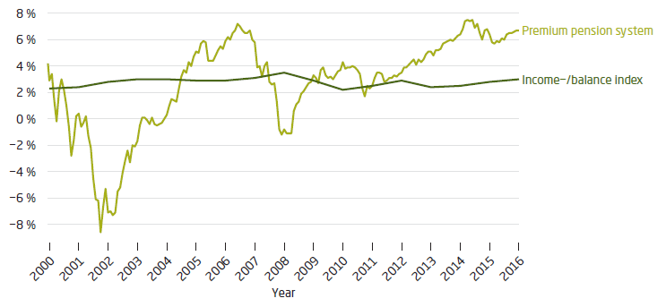
Figure 2. Average Capital-Weighted Rate of Return for All Premium Pension Savers up to Different Points in Time during the Years 2000–2016. Each point on the curve shows the average annual internal rate of return (after 1995) until the time concerned. Source: Orange Report 2016.

Over the years some companies have specialized in premium pension telemarketing often with high fees. Currently there are even criminal investigations and over a billion SEK is currently missing in the Falcon Funds case. Over the years there have been several reports on the premium pension and the most recent Official Report of the Swedish Government was published in 2016 [8] (SOU 2016:61). The report did not cover the more recent problems such as Falcon Funds and more work in this area can be expected [9].
Recently (March 1, 2017) the prime minister of Sweden Stefan Löfven said that no one should risk being deceived within the public pension system [10]. He continues to suggest that the premium pension system is in need of changes. Usually these statements are not that common and discussions are kept within the Pension Group.
The automatic balancing mechanism (the “brake” as it is commonly referred to) have been a topic of debate and is generally disliked by pensioner interest groups. In a report from 2013, five major pensioner interest groups publicized a report with a suggestion of how to abolish the mechanism while maintaining financial stability [11]. A dismantling of the premium pension is the main suggestion of how to achieve this and the full contribution should be credited to the inkomstpension. There are however support of the mechanism as well and as a general statement Robert Holzmann have written “Any reserve fund smoothes the impact of shocks across cohorts and generations but does not eliminate the need of a well designed balancing mechanism working through the notional interest rate and indexing mechanism.” [12].
In the comprehensive report The pension system in Sweden [13] by Nicholas Barr from 2013 a number of interesting aspects of the pension system is covered. The author’s view of the system is in general positive but possible improvements and topics of discussion are brought up. It is pointed out that financial stability have precedence over adequacy of benefits in the current system and that this may have been a natural choice at the time of the reform but it may not be the optimal solution today.
The possibility of drawing only a part of pension is praised and the benefit tie to longevity (annuity divisor) is considered necessary in terms of sustainability, the author however mention concerns on adequacy. There is international experience that many people retire as soon as possible whether or not it is in their own long-run best interest or not, therefore a raise of the earliest eligible age of pension withdrawal need to be considered. This work is currently ongoing and possibly a riktålder will be introduced which will be connected to changes in life expectancy and which will gradually raise the age of earliest pension withdrawal (currently 61), the minimum age for guarantee pension (currently 65) and the age of protection of employment (currently 67) [14]. In Figure 3 the proportion of individuals who for the first time are granted full national pension per age and cohort is shown. As can be seen the age 65 still dominates but the spread over ages have increased.
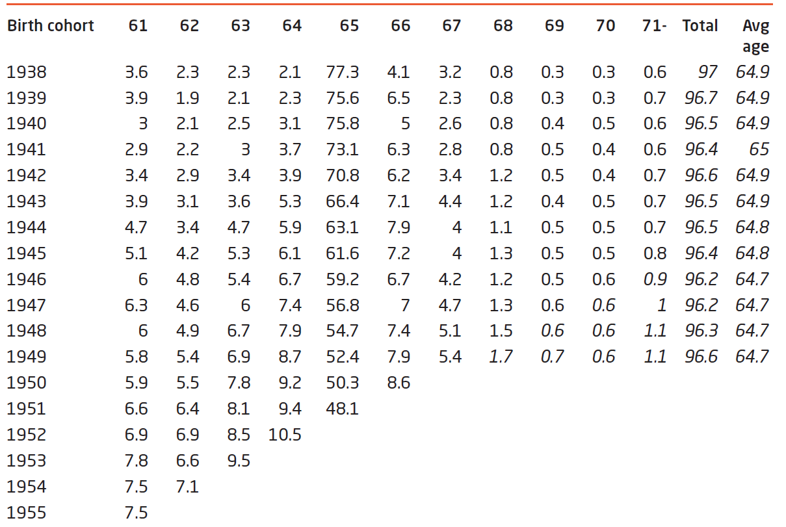
Figure 3. Proportion Granted a National Pension at Ages 61–75. The proportions are for new retirees in relation to the potential number of retirees as of December 2016. Ages are as of December 31 of the year when the pensioner began drawing an inkomstpension/guaranteed pension. Forecast for the highest age groups, forecast in italics. Source: Orange Report 2016.

It is pointed out that the balancing mechanism may be too sharp and that a balancing period may benefit the active population. These areas have been remedied by the introduction of the damped balance ratio and by reducing the pension credit earned during a balancing period as described under the section Details.
Barr points out indexation as a topic of debate, and he argues that the risk exposures of the retirees is too great by facing the full yearly variation of wage changes in the economy reduced by the advance interest rate of 1.6 percent. A mixture of price and wage indexation is presented as a possible alternative. In Figure 4 the price indexation is shown together with income and balance indexation as well as adjustment indexation that is used for economically active and pensioners respectively.
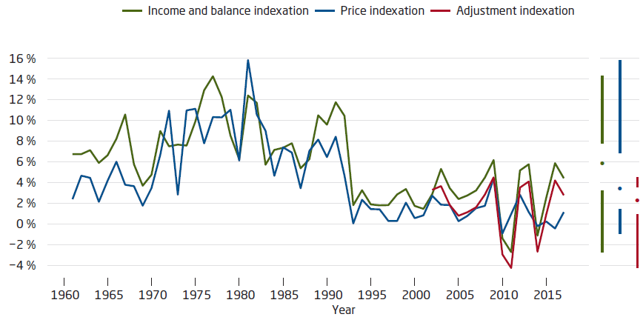
Figure 4. Yearly indexation. The point between the vertical lines is the median value. The starting point for the upper vertical line is the 75th percentile; the ending point is the maximum value. The starting point for the lower vertical line is the 25th percentile; the ending point is the minimum value. Source: Orange Report 2016.

Evaluation
Quite some time has passed since the reform and there has been changes since but the basic design of the system remains. The idea of a self-regulating system is largely true even though there have been changes in tax levels for pensions, which can be seen as political interference (a negative indexation can be compensated by a lower tax rate).
A negative indexation of the inkomstpension system will reduce the liability and thus strengthen the autonomous system, the central government budget will however bear some of the burden as the guaranteed pension will limit the decrease for those with lower pensions.
In a recent report [15] from 2017 the transitional generations with benefits from both system are analyzed. The ATP system have for most been more beneficial and especially for women. The change in life expectancy is a main source as it did not affect benefits of the old system. When the life expectancy at the time of the reform is used (cohort 1930) both systems provide approximately the same for men whereas the old system is still more beneficial for women. The rise in life expectancy is not unexpected.
Short-term financial forecasts can be found on the Swedish Pensions Agency’s webpage currently up until 2021, the balance ratio is predicted to be slightly above one but the risk of a new balancing period remains [16]. Long-term scenarios where demographic development, change in income and rate or return and its effect on the financial stability of the system is published in chapter 7 of the Annual Report of the Swedish Pension System [1].
Since the reform there have been changes in the pension system and perhaps evaluation and modification will be an ongoing process. It is hard to foresee the issues that can arise in the future.

References
[1] Pensionsmyndigheten. Orange Report - Annual Report of the Swedish Pension System 2015
[2] Regeringen. proposition 1993/94:250 Reformering av det allmänna pensionssystemet; 1994
[3] Könberg. Först i världen med nytt pensionssystem Hur gick det till?. Frisinnad Tidsskrift
[4] Socialdepartementet. The Swedish Pension Agreement and Pension Reform: Translation of Ds 2009:53; 2010
[5] Socialdepartementet. DS 2015:6 En jämnare och mer aktuell utveckling av inkomstpensionerna; 2015
[6] Socialdepartementet. SFS 2014:1548; 2014
[7] Socialdepartementet. Prop.2008/09:219 Utjämnat värde för buffertfonden vid beräkning av balanstalet; 2009
[8] Thomsson, Billberg. SOU 2016:61 Fokus premiepension; 2016
[9] Pensionsmyndigheten. Remissvar på betänkandet Fokus premiepension (SOU 2016:61); 2017
[10] Svenska Dagbladet. Efter skandalerna: S redo överge premiepensionen. https://www.svd.se/s-redo-overge-premiepensionen; 2017
[11] Sibbmark et al. En modell för finansiering av pensionssystemet utan automatisk balansering; 2013
[12] Holzmann. Toward a Pan-European Pension Reform Approach: The promises and perspectives of unfunded individual account systems; 2007
[13] Barr. The pension system in Sweden. Report to the Expert Group on Public Economics; 2013
[14] Socialdepartementet. Ekonomiska effekter av ett längre arbetsliv Långsiktiga ekonomiska effekter av Pensionsåldersutredningens förslag; 2014
[15] Granbom, Pensionsmyndigheten. Jämförelse i utfall av inkomstgrundad allmän pension i det nya och gamla pensionssystemet för födda 1938-1945; 2017
[16] Pensionsmyndigheten. Anslagsbelastning och prognos för anslag inom Pensionsmyndighetens ansvarsområde budgetåren 2016–2021; 2017

