Strengthening cooperation
From 6 to 15 July, a delegation from NDRC Employment and Income distribution department led by Inspector Zhu Yingjuan visited partner organisations in Italy, Spain (see picture) and at the European Union Headquarters in Brussels. During the visits, the delegation held bilateral talks on employment promotion and social security reform, including challenges caused by population ageing. At the same time, ties for future technical and policy bilateral cooperation were further strengthened.
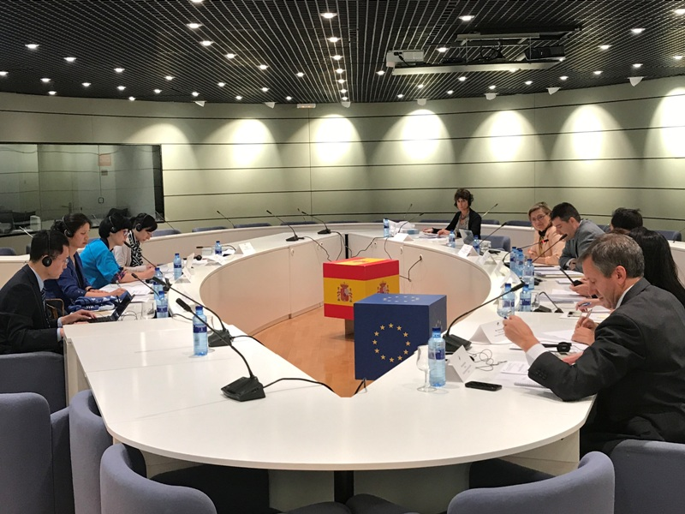
就业司赴意大利、西班牙和欧盟开展“中欧社会保障改革合作项目”对话与研讨

2017年7月6日至15日，国家发展改革委就业和收入分配司巡视员朱英娟率团赴意大利、西班牙和欧盟总部开展《中欧社会保障改革合作项目》对话和交流活动。出访期间，代表团分别与意大利社会保障署、西班牙就业和社会保障部、欧盟委员会就业总司举行双边对话，围绕推进供给侧结构性改革、促进就业创业、健全社会保障体系、应对人口老龄化挑战等相关议题进行深入交流和讨论。同时，还就进一步深化中西、中欧在就业、社会保障和收入分配领域的双边合作进行了磋商。

